|  |  |
| --- | --- |
| A picture of a winding road and trees  javascript tutorial | Web application development series  JavaScript tutorial  Shikhin Misra |

Table of Contents

Javascript prereqisites for React and Node (ES6 features) 4

JavaScript Basics 4

**Data Types** 8

**let, const and var** 8

Converting strings to numbers 10

Strings in JavaScript 12

Substrings in JavaScript 15

JavaScript substring example 18

Conditional statements in javascript 19

Switch statement in JavaScript 21

Ternary operator in JavaScript 23

Loops in JavaScript 25

do while loop in JavaScript 27

For loop in JavaScript 28

Arrays in JavaScript 29

JavaScript array push and pop methods 31

JavaScript array mutators 33

JavaScript array filter method 35

Creating two dimensional array in javascript 37

Functions in JavaScript 39

Methods 40

Different ways of defining functions in JavaScript 41

Arrow functions 44

Local and global variables in javascript 46

Closures in JavaScript 49

JavaScript closure example 51

JavaScript arguments object 52

Callback function 54

Recursive function in JavaScript 56

Error handling in JavaScript 57

JavaScript window.onerror event 60

Objects in Javascript 61

this keyword 62

Working with dates in javascript 64

JavaScript timing events 67

How to create image slideshow using JavaScript 70

Events in JavaScript 71

Assigning event handlers in JavaScript using DOM object property 73

addeventlistener and removeeventlistener in JavaScript 76

JavaScript event object 79

Event bubbling in JavaScript 82

Image gallery with thumbnails in JavaScript 85

JavaScript event capturing 87

Preventing browser default action 89

JavaScript to detect which mouse button is clicked 91

JavaScript mouse events 93

JavaScript popup window 94

Using regular expressions in JavaScript 96

Tools for writing regular expressions 97

JavaScript strings and regular expressions 99

JavaScript RegExp object 101

Client side validation using regular expression 104

JavaScript Minification 105

JavaScript and object oriented programming 106

Object literal vs object constructor 109

Global namespace pollution in JavaScript 110

Namespaces in JavaScript 111

Private members in JavaScript 113

Properties in JavaScript 116

Static members in JavaScript 118

Prototype in JavaScript 121

Overriding JavaScript functions 123

Inheritance in JavaScript 125

Abstract classes in JavaScript 128

Polymorphism in JavaScript 130

Object reflection in JavaScript 132

Strict Mode in JavaScript 137

JavaScript Cookies 141

JavaScript cookie attributes 144

Store multiple key value pairs in a cookie 147

Set and get multiple cookies in JavaScript 149

Update and delete cookies 151

How to check if cookies are enabled 152

How to check if JavaScript is enabled 154

window location in JavaScript 156

Debugging JavaScript in chrome 158

# Javascript prereqisites for React and Node (ES6 features)

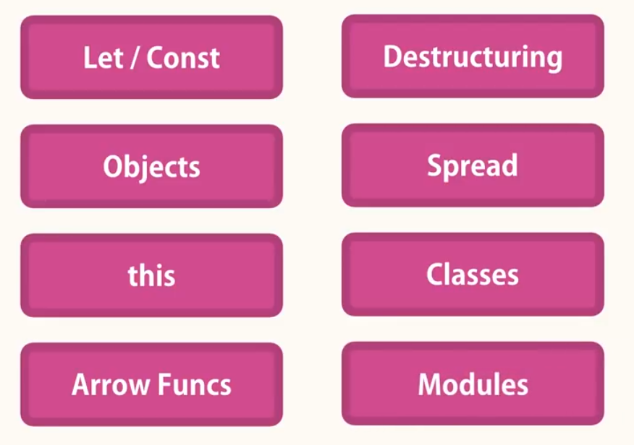

# JavaScript Basics

To display something in console:

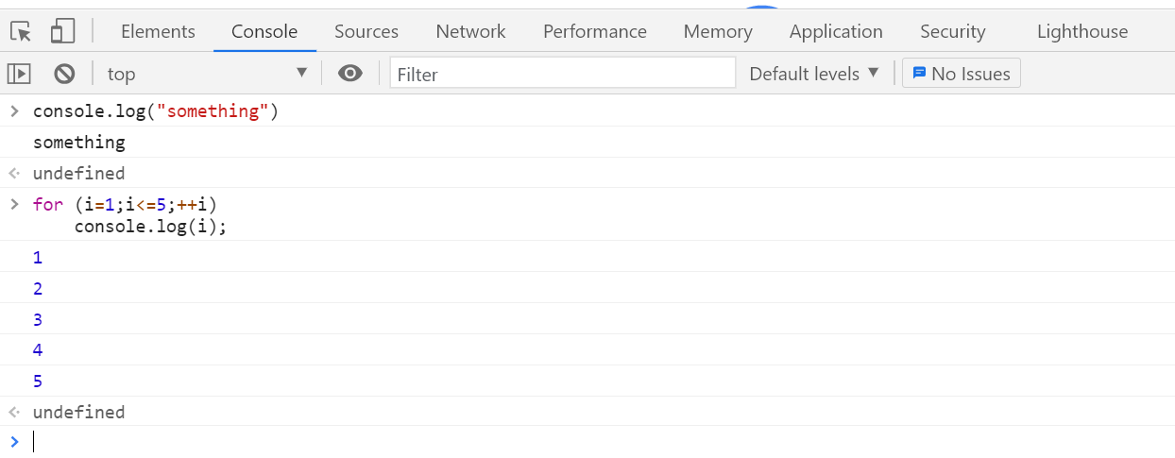

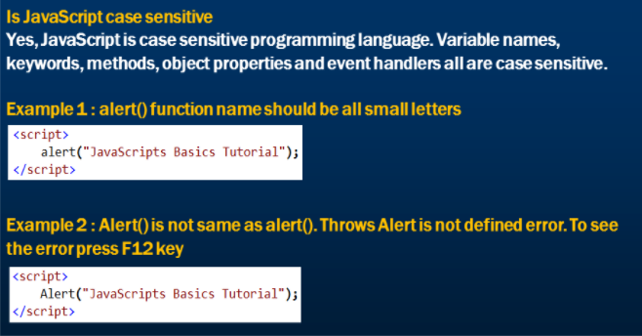

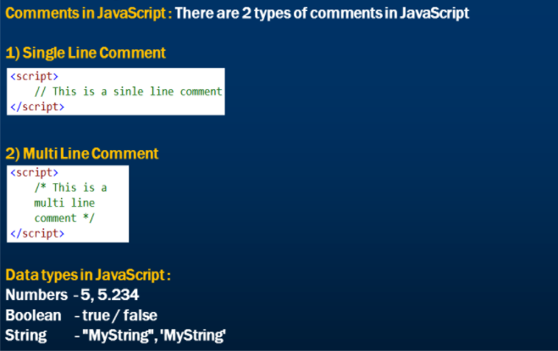

Instead of var, we now use “let”.

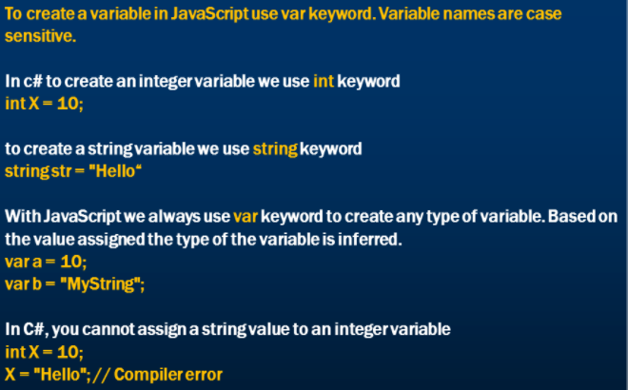

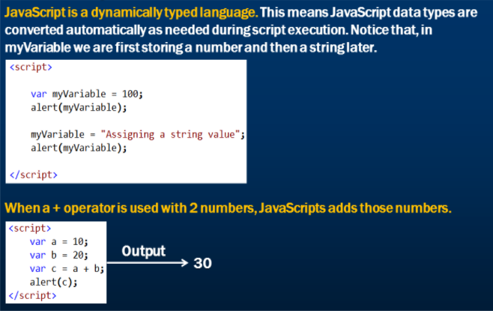

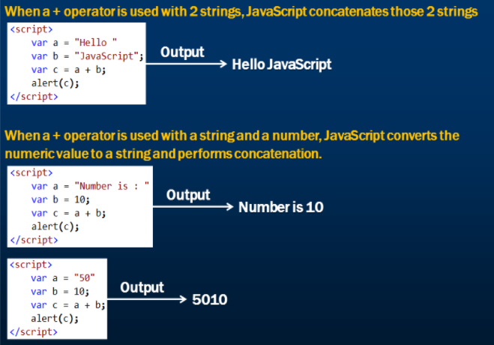

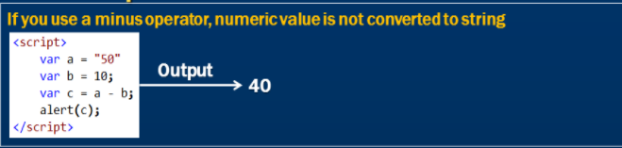

## **Data Types**

let javascriptIsFun = true;

console.log(javascriptIsFun);

// console.log(typeof true);

console.log(typeof javascriptIsFun);

// console.log(typeof 23);

// console.log(typeof 'Jonas');

javascriptIsFun = 'YES!';

console.log(typeof javascriptIsFun);

let year;

console.log(year);

console.log(typeof year);

year = 1991;

console.log(typeof year);

console.log(typeof null);

## **let, const and var**

Variable declared with var keyword are accessible in the entire function. In the below eg, if we define i as var it will be accessible outside for loop as well.

let keyword solves this issue. It is accessible within the for loop only.

Similarly, constants defined with const keyword are accessible within the block.

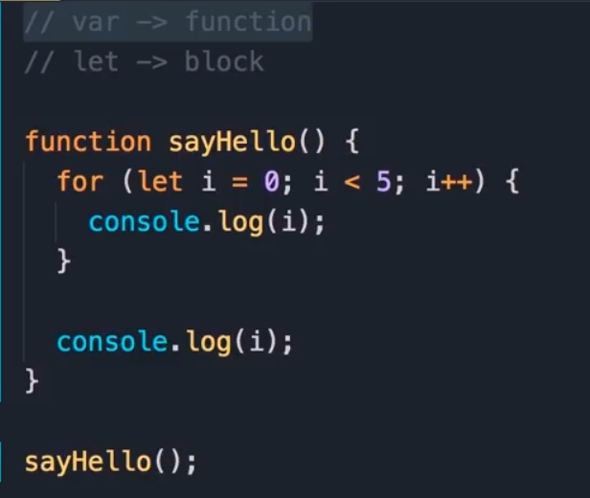

If we reassign another value to a const, we will get an error.

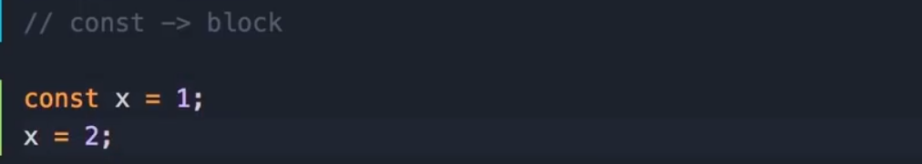

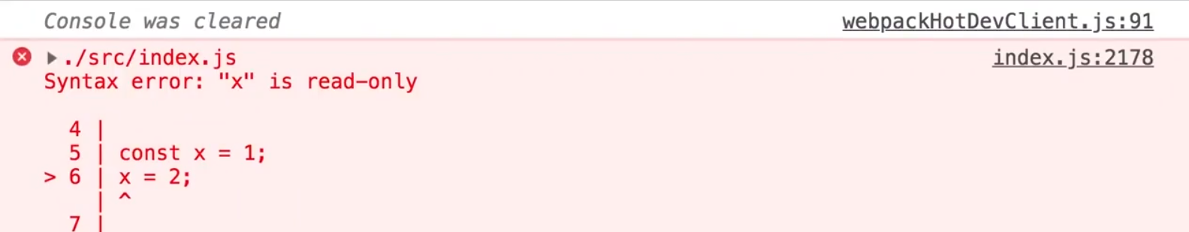

# Converting strings to numbers

Use “Number()” function for both integer and decimal values. To add two variables, each variable has to be converted using Number() function.

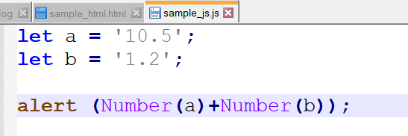

OR

Let a = ’10.5’;

Let b=’1.2’;

Let c = Number(a)+Number(b);

alert(c);

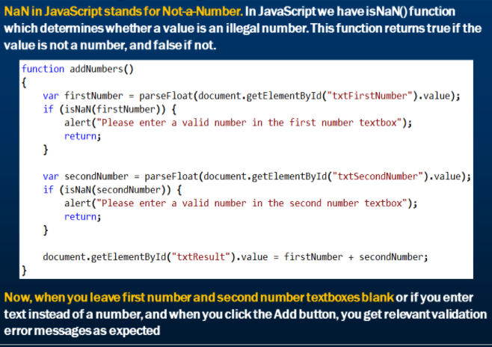

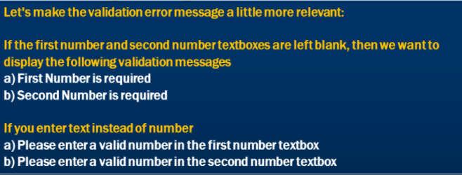

# Strings in JavaScript

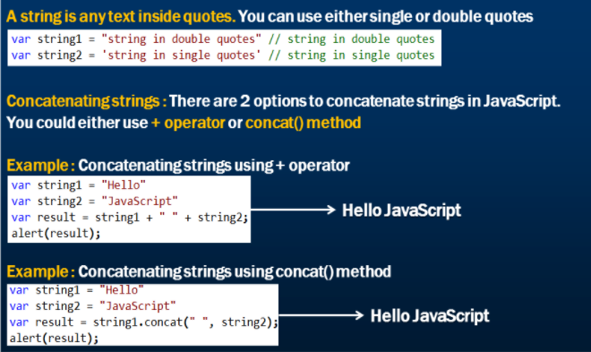

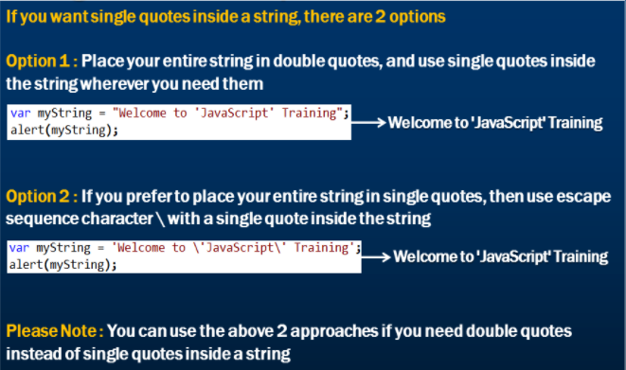

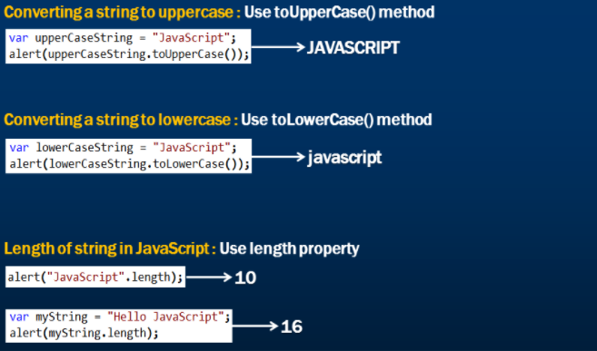

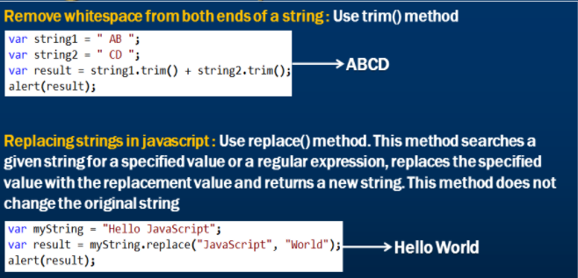

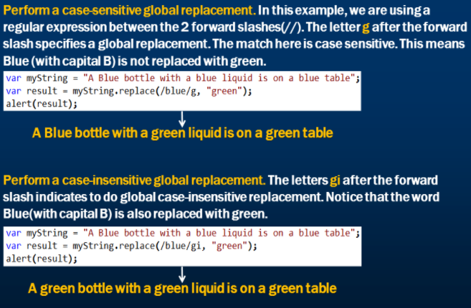

Count number of times a particular character appears in a string



# Substrings in JavaScript

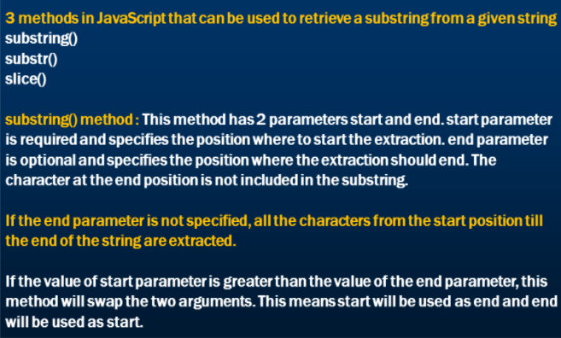

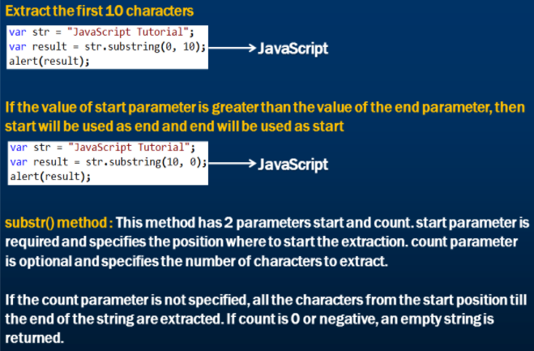

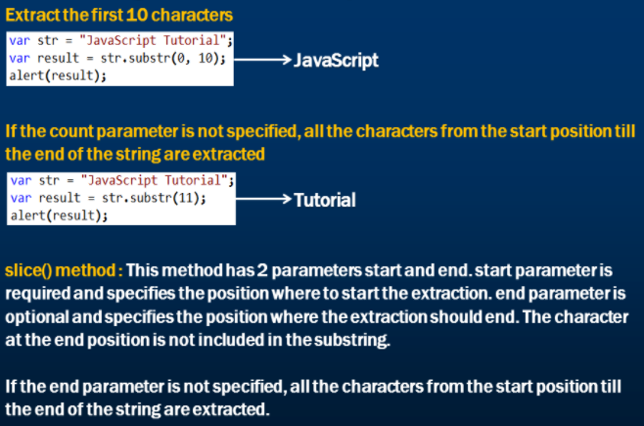

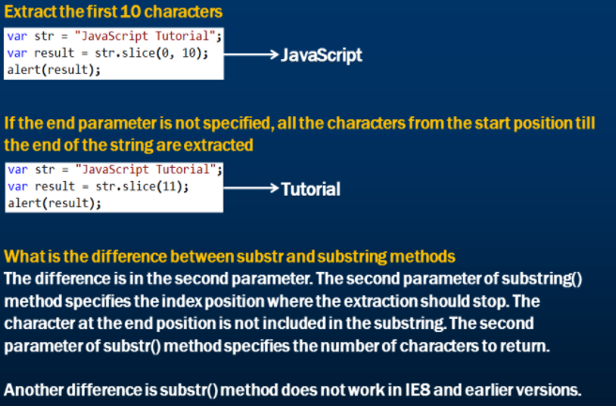

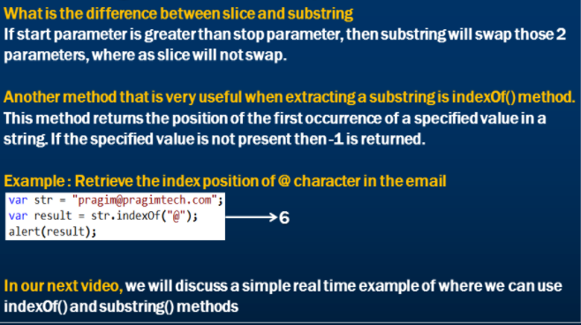

# JavaScript substring example

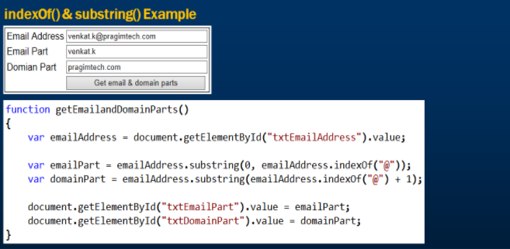

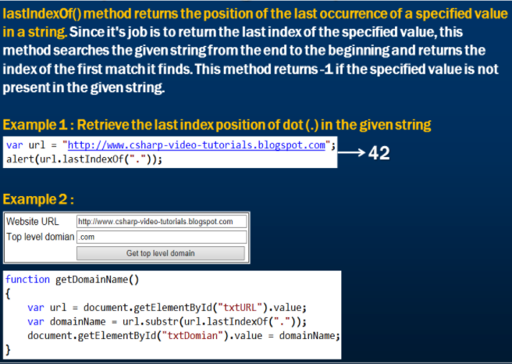

# Conditional statements in javascript

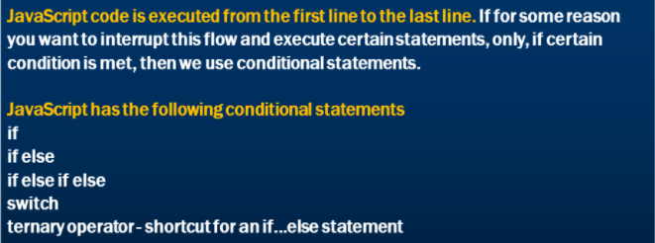

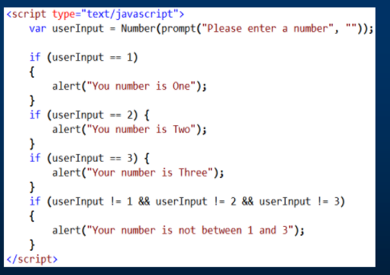

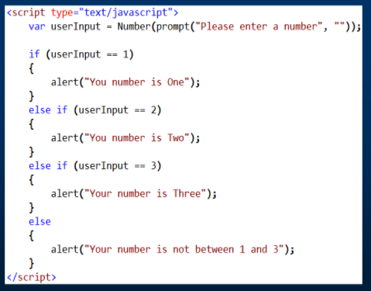

# Switch statement in JavaScript

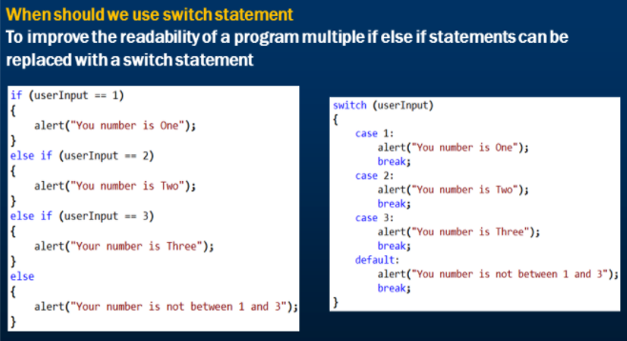

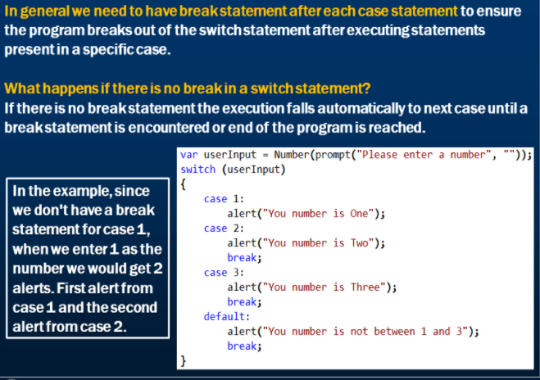

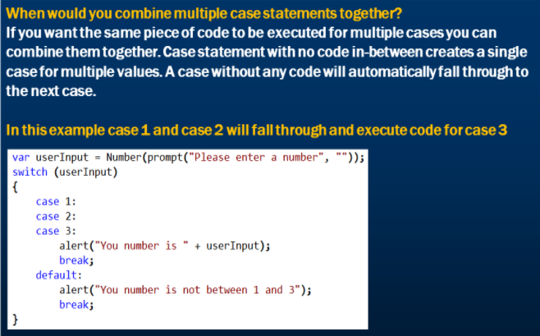

# Ternary operator in JavaScript

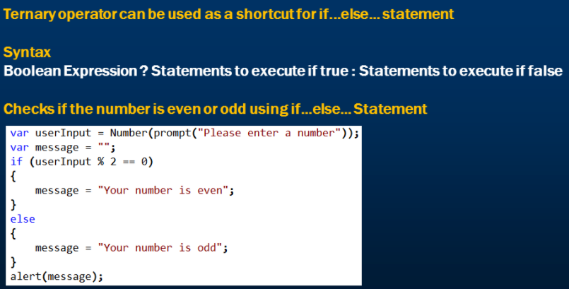

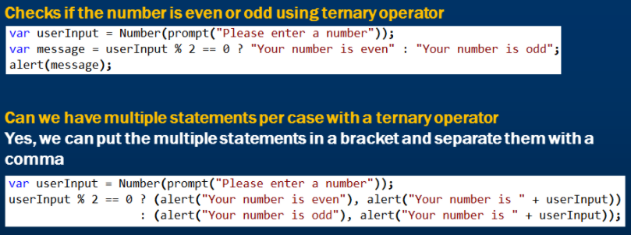

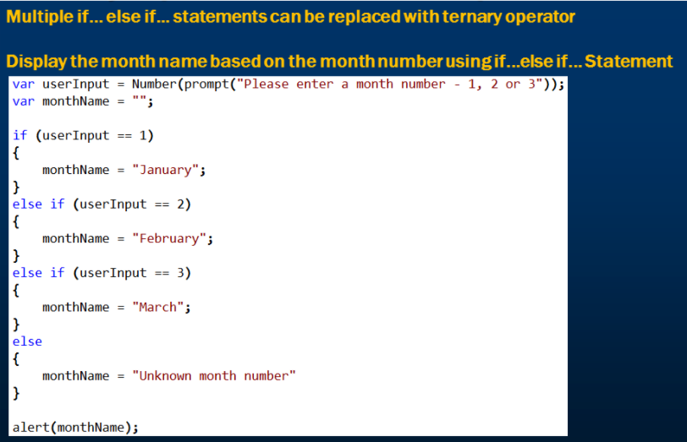

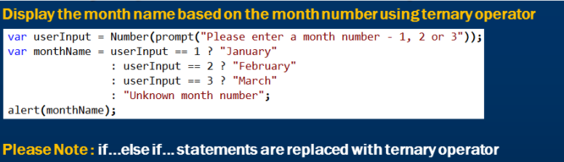

# Case study: Check for valid email id

We will ask user to input an email id and check if it is a valid email id. Below is the code doing this work.

let validInput = prompt('Enter a valid email Id');

if((((validInput.length)-(validInput.replace(/@/g,'').length))=== 1)

&& validInput.substring(0,1)!== '@'

&& validInput.substring(0,1)!==' '

&& ((validInput.substring(validInput.lastIndexOf('.')+1).length)>1)

&& ((validInput.substring(validInput.lastIndexOf('@')+1).length)-(validInput.substring(validInput.lastIndexOf('@')+1).replace(/\./g,'').length)===1))

{

alert('Valid email id');

}

else

{

alert('Invalid email id');

}

Below we will break these “&&” conditions into individual functionalities.

1. (validInput.length)-(validInput.replace(/@/g,'').length))=== 1)

This condition checks for number of times ‘@’ exists in the email-id. There should be only one ‘@’ in the email-id.

Note the use of equality operator(===)

1. && validInput.substring(0,1)!== '@'

This condition checks that the first character should not be ‘@’.

1. && validInput.substring(0,1)!==' '

This condition checks that the first character should not be empty space.

1. && ((validInput.substring(validInput.lastIndexOf('.')+1).length)>1)

This condition check that the number of characters after last dot should be more than 1.

Eg: [nishi.joshi1@gmail.c](mailto:nishi.joshi1@gmail.c) is not a valid id because it has only 1 char after last dot.

1. && ((validInput.substring(validInput.lastIndexOf('@')+1).length)-(validInput.substring(validInput.lastIndexOf('@')+1).replace(/\./g,'').length)===1))

This condition check that there should be only one dot (.) after ‘@’.

We need to focus on the characters after ‘@’ ([nishi.joshi1@gmail.com](mailto:nishi.joshi1@gmail.com)). To achieve this, we write this expression: validInput.substring(validInput.lastIndexOf('@')+1).

Then we are applying the replace function to find the number of dots (.) after ‘@’.

# Loops in JavaScript

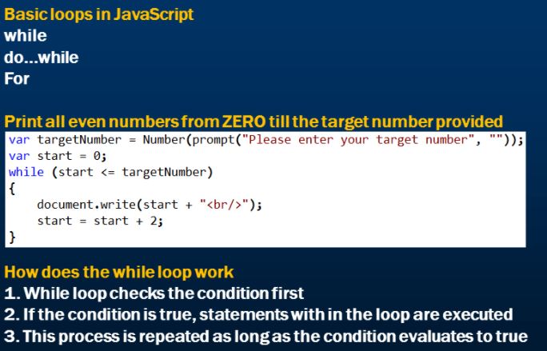

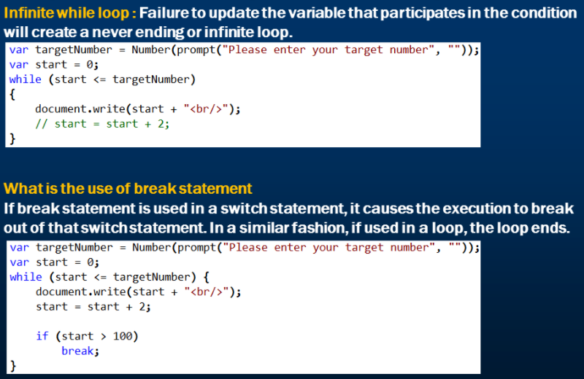

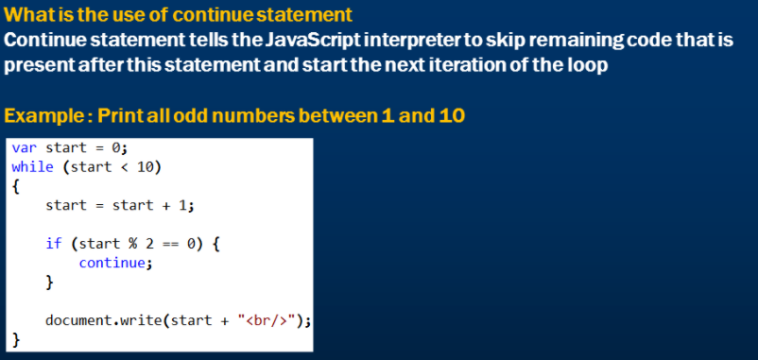

# Case study: Check for valid email id

We will ask user to input an email id and check if it is a valid email id. Below is the code doing this work.

let validInput = prompt('Enter a valid email Id');

if((((validInput.length)-(validInput.replace(/@/g,'').length))=== 1)

&& validInput.substring(0,1)!== '@'

&& validInput.substring(0,1)!==' '

&& ((validInput.substring(validInput.lastIndexOf('.')+1).length)>1)

&& ((validInput.substring(validInput.lastIndexOf('@')+1).length)-(validInput.substring(validInput.lastIndexOf('@')+1).replace(/\./g,'').length)===1))

{

alert('Valid email id');

}

else

{

alert('Invalid email id');

}

Below we will break these “&&” conditions into individual functionalities.

1. (validInput.length)-(validInput.replace(/@/g,'').length))=== 1)

This condition checks for number of times ‘@’ exists in the email-id. There should be only one ‘@’ in the email-id.

Note the use of equality operator(===)

1. && validInput.substring(0,1)!== '@'

This condition checks that the first character should not be ‘@’.

1. && validInput.substring(0,1)!==' '

This condition checks that the first character should not be empty space.

1. && ((validInput.substring(validInput.lastIndexOf('.')+1).length)>1)

This condition check that the number of characters after last dot should be more than 1.

Eg: [nishi.joshi1@gmail.c](mailto:nishi.joshi1@gmail.c) is not a valid id because it has only 1 char after last dot.

1. && ((validInput.substring(validInput.lastIndexOf('@')+1).length)-(validInput.substring(validInput.lastIndexOf('@')+1).replace(/\./g,'').length)===1))

This condition check that there should be only one dot (.) after ‘@’.

We need to focus on the characters after ‘@’ ([nishi.joshi1@gmail.com](mailto:nishi.joshi1@gmail.com)). To achieve this, we write this expression: validInput.substring(validInput.lastIndexOf('@')+1).

Then we are applying the replace function to find the number of dots (.) after ‘@’.

Example of While:-

In the below example, note that in order to exit from the loop you need to enter ‘No’ in the prompt (validInput) which is highlighted in yellow below.

let validInput = prompt('Enter a valid email Id');

while (validInput != 'No')

{

if((((validInput.length)-(validInput.replace(/@/g,'').length))=== 1)

&& validInput.substring(0,1)!== '@'

&& validInput.substring(0,1)!==' '

&& ((validInput.substring(validInput.lastIndexOf('.')+1).length)>1)

&& ((validInput.substring(validInput.lastIndexOf('@')+1).length)-(validInput.substring(validInput.lastIndexOf('@')+1).replace(/\./g,'').length)===1))

{

alert('Valid email id');

}

else

{

alert('Invalid email id');

}

validInput = prompt('Enter a valid email Id');

}

# do while loop in JavaScript

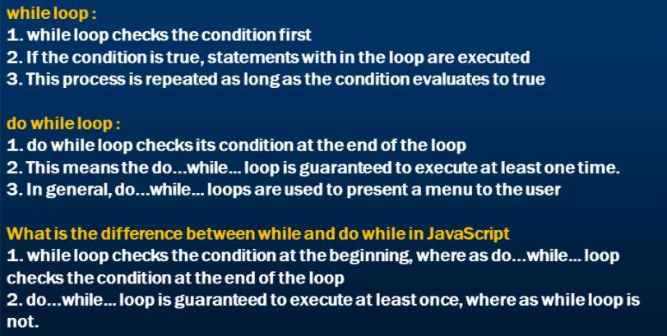

# For loop in JavaScript

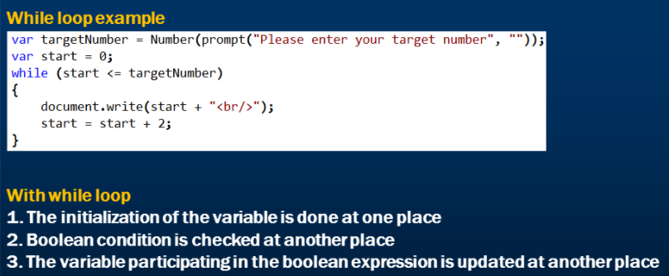

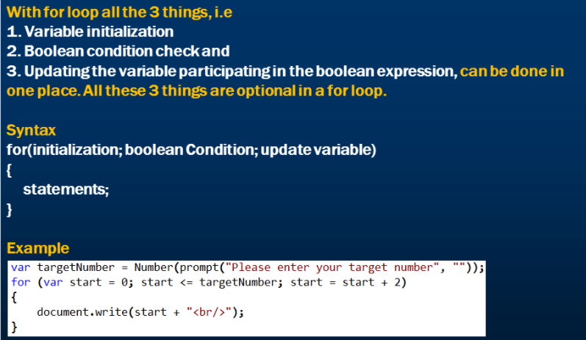

# Arrays in JavaScript

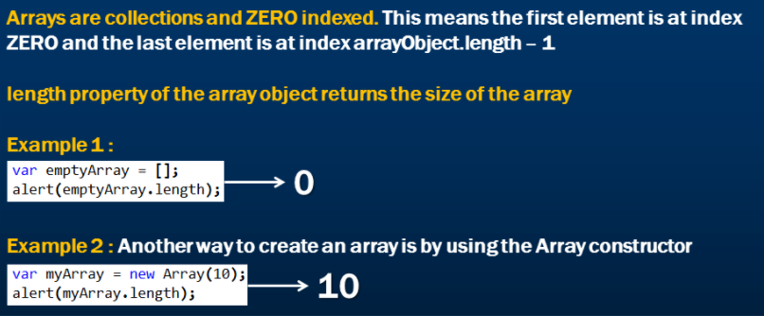

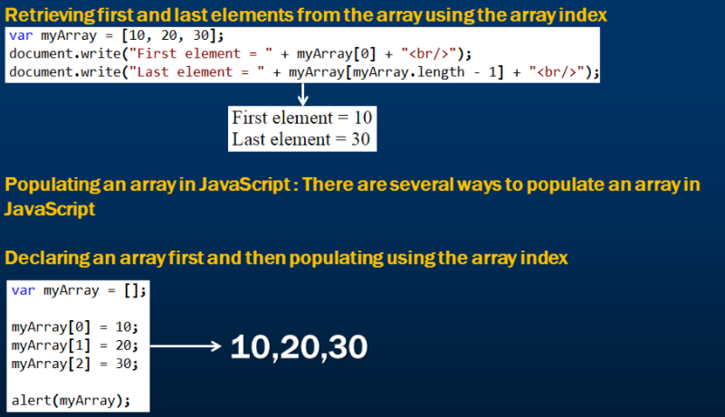

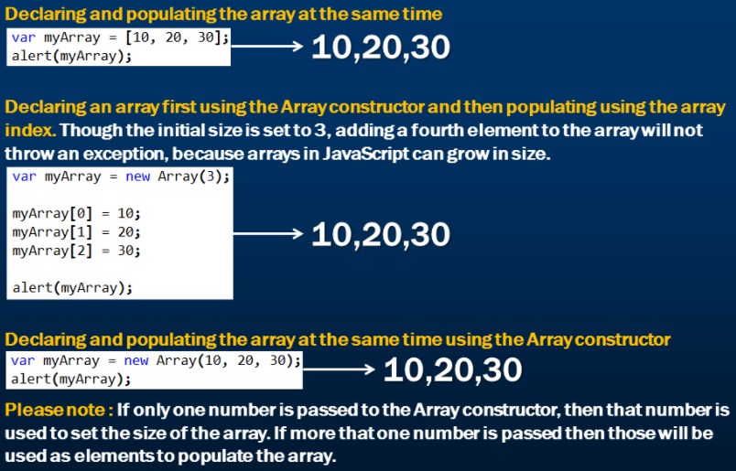

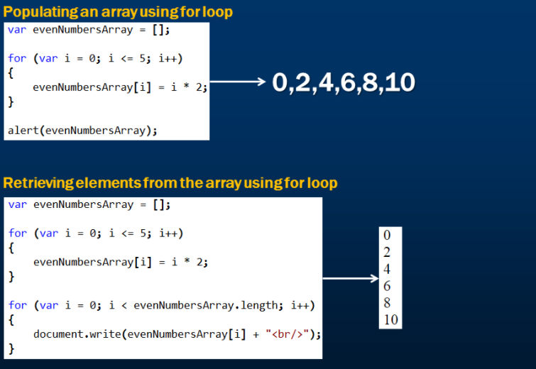

# JavaScript array push and pop methods

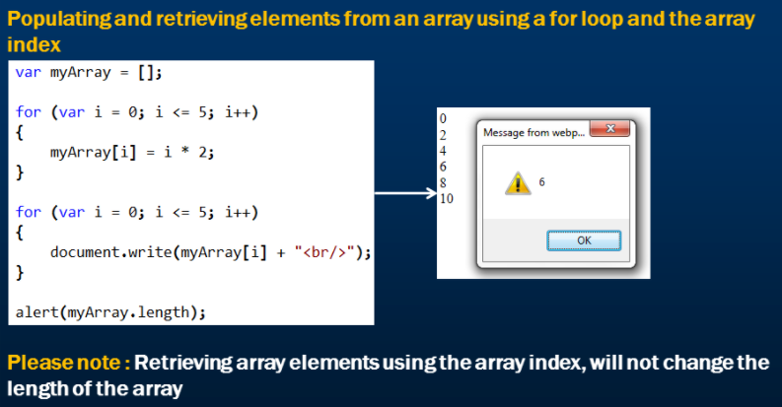

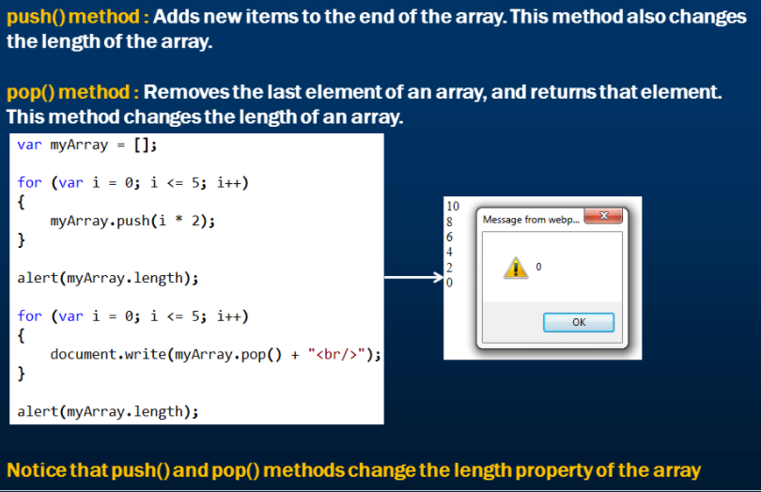

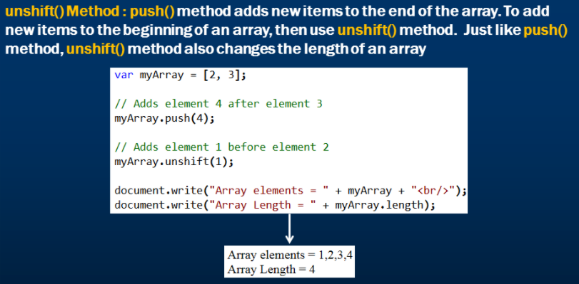

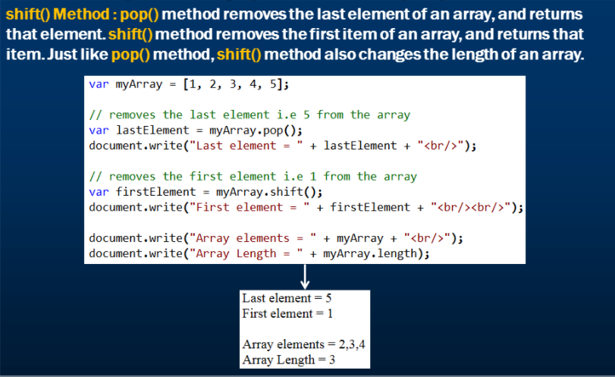

# JavaScript array mutators

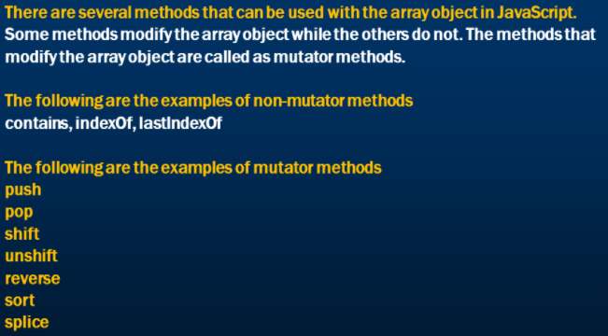

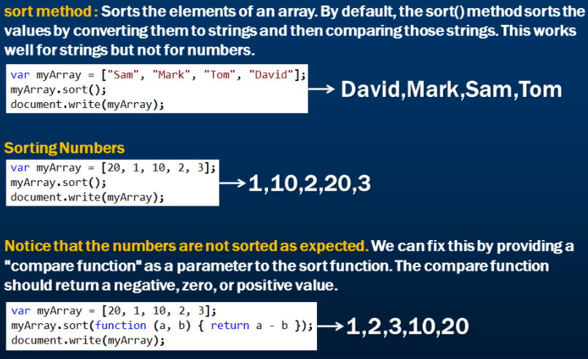

Firstly (20 and 1) will be passed to the function and sorted based upon the result (+ve, -ve or 0) Then (20 and 10) will be passed and like this the entire array is sorted.

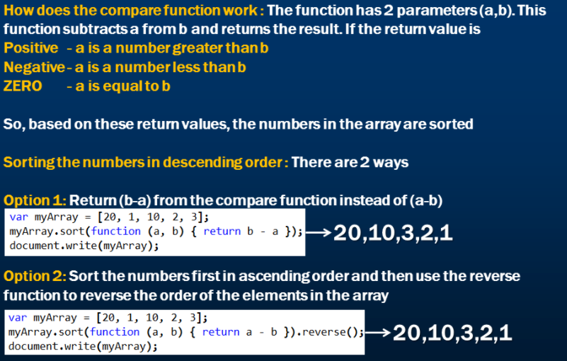

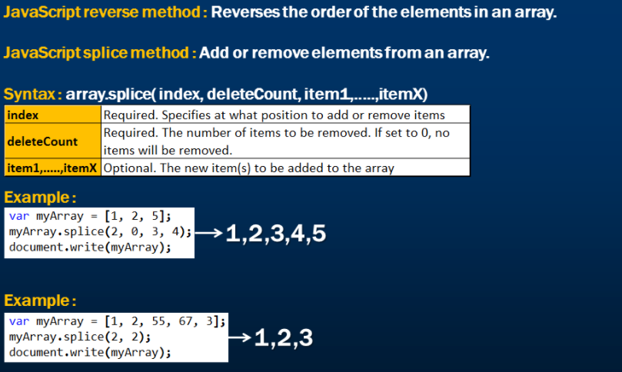

# JavaScript array filter method

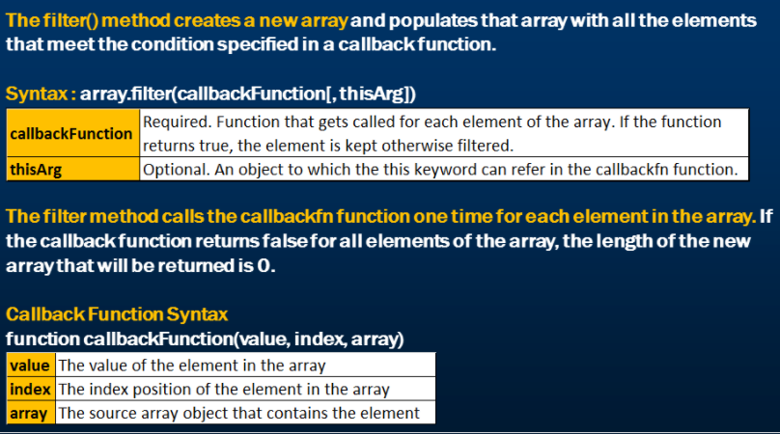

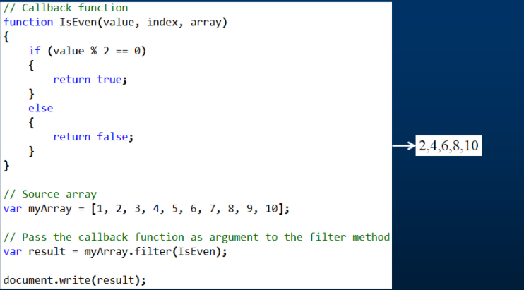

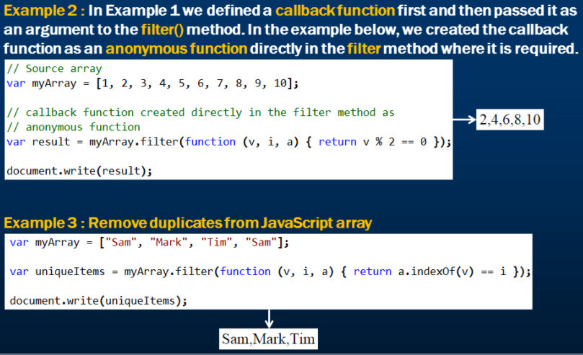

# Creating two dimensional array in javascript

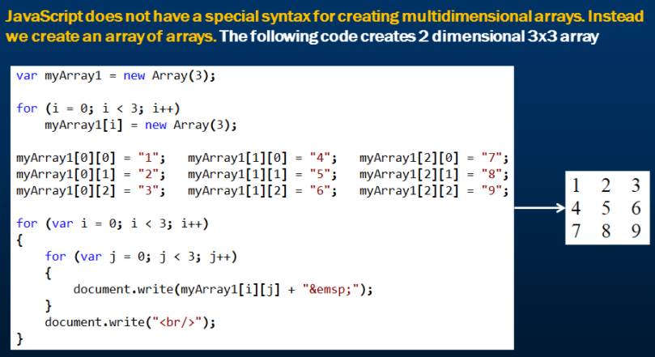

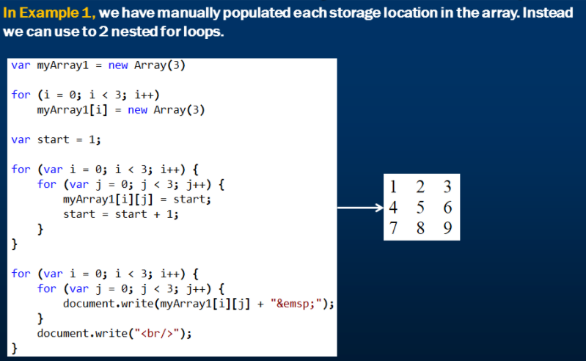

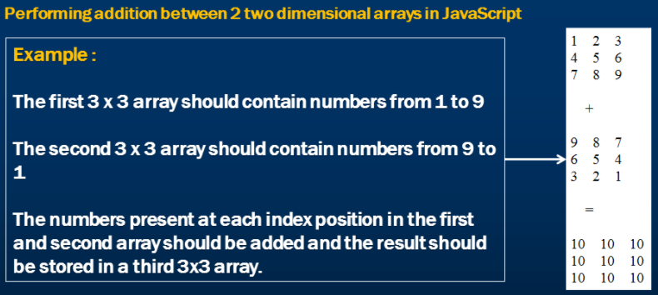

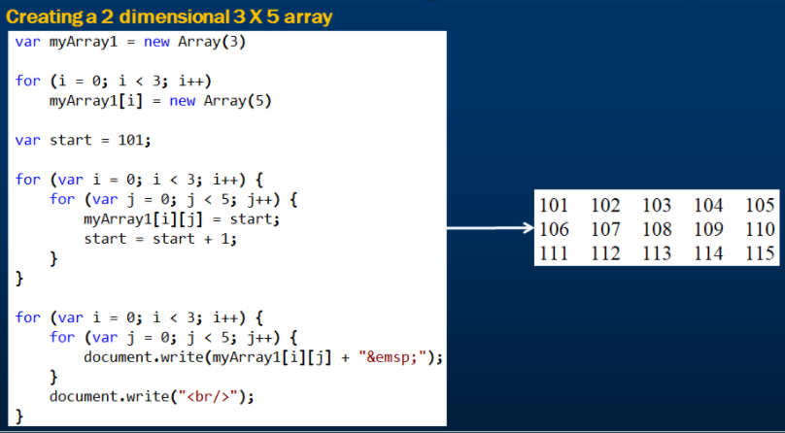

# Functions in JavaScript

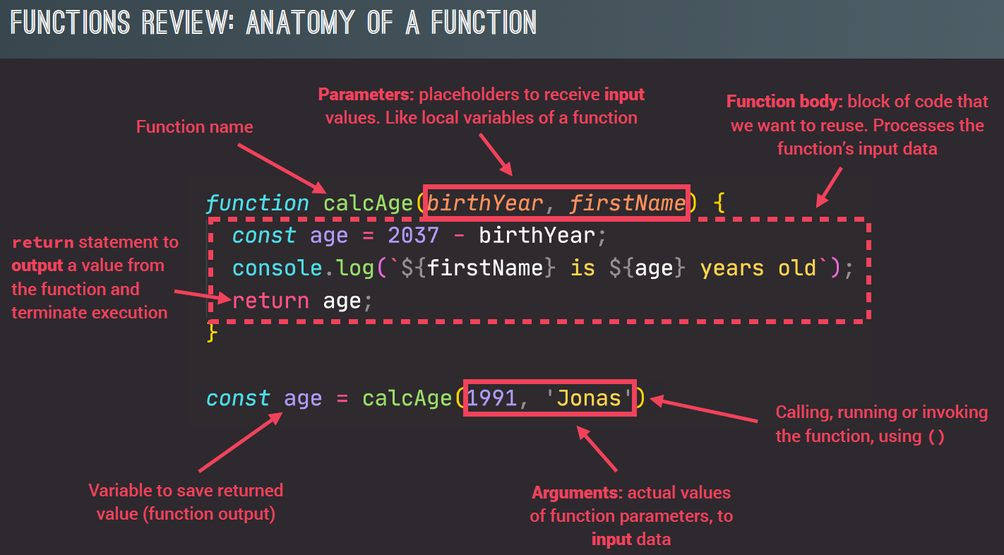

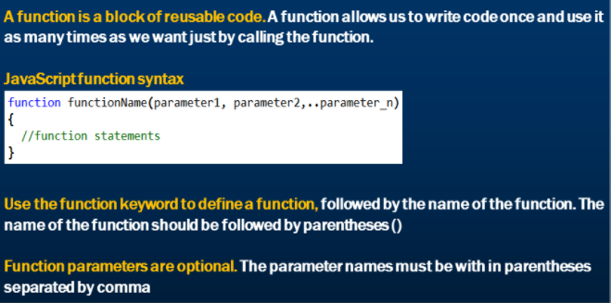

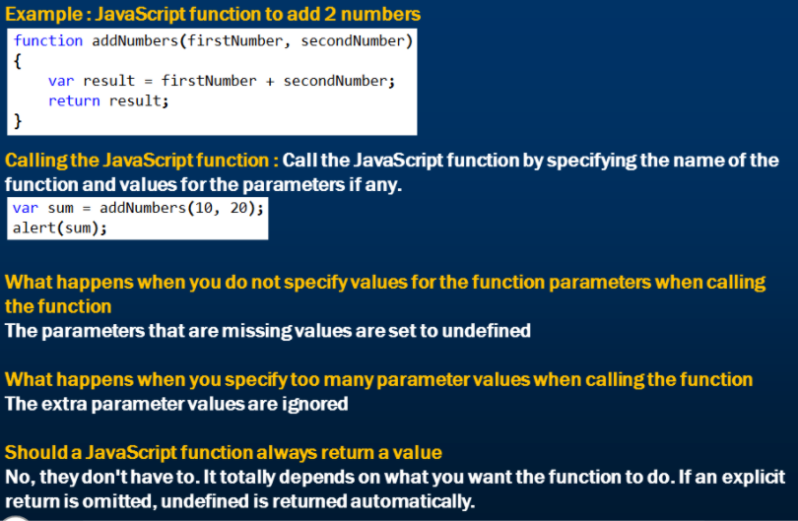

# Methods

Methods are defined on datatypes or objects. They cannot exist independently like functions. “toUpperCase()” is a method. We have a lot of methods like this to ease various tasks in javascript. The push() and pop() array methods that we will see below are methods. Similarly we have filter(), map() and reduce() methods on arrays.

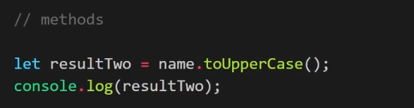

# Different ways of defining functions in JavaScript

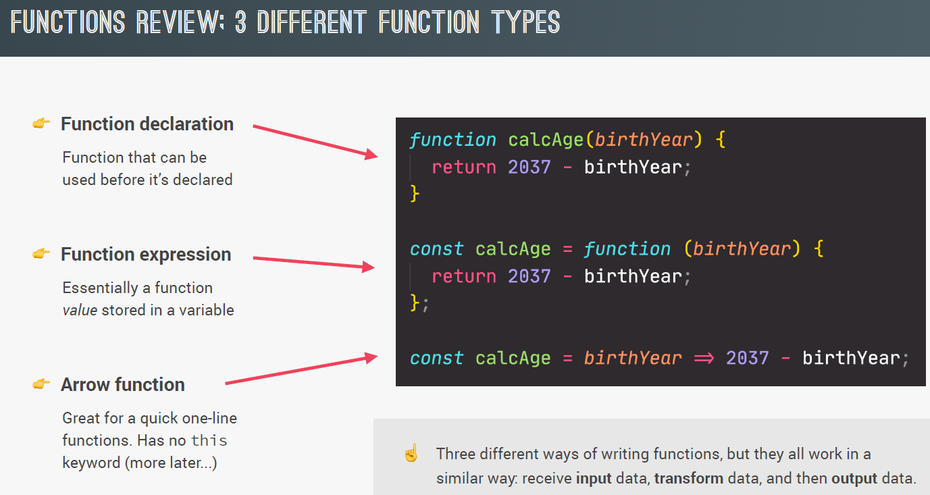

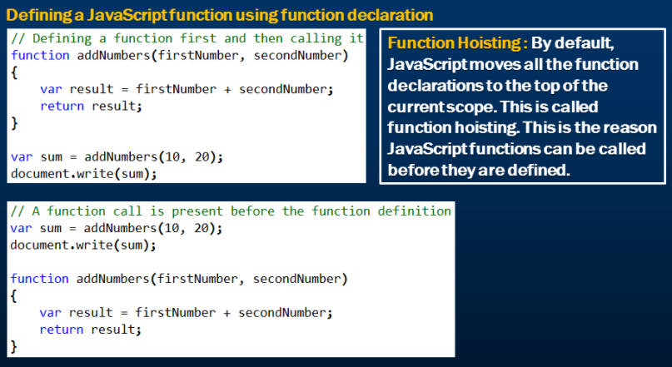

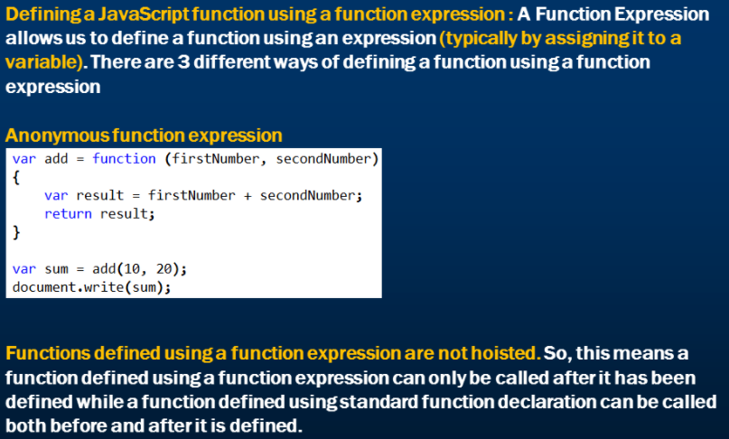

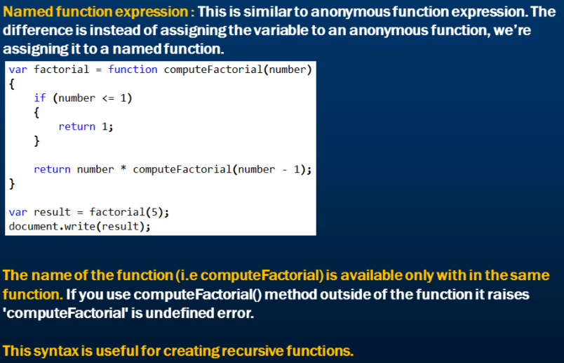

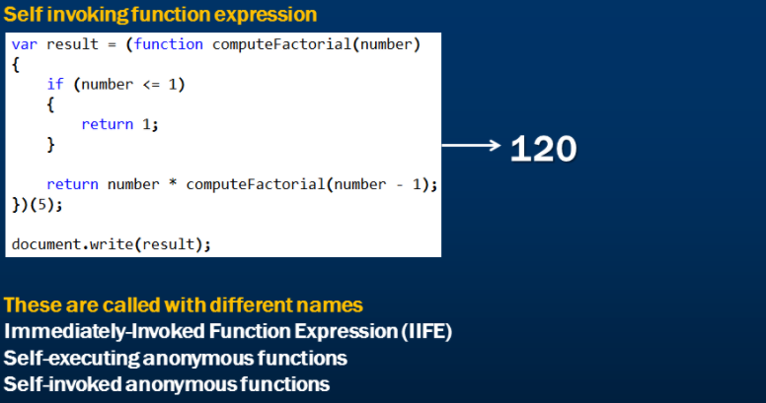

# Arrow functions

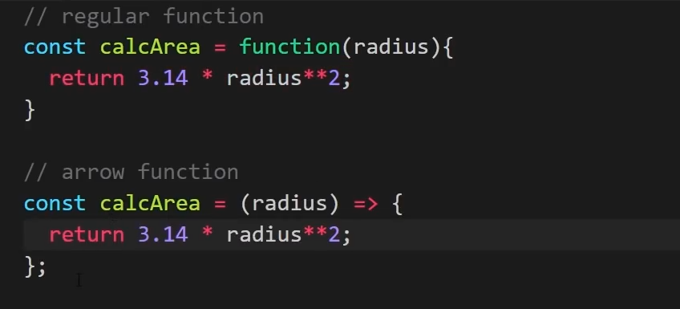

If we have exactly one parameter, we can remove the parenthesis. Note that “radius” is now without parenthesis.

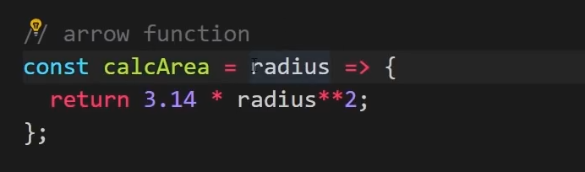

However, if we have zero or more than one parameter, we need parenthesis like below.

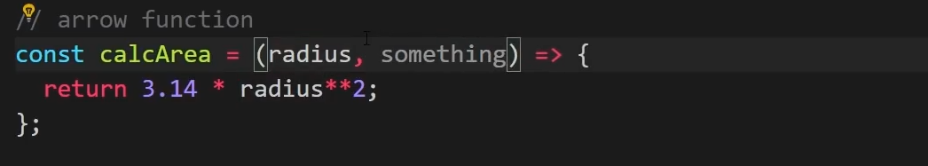

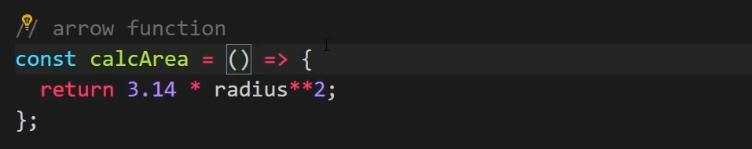

If we have just a return statement in our function, we can take away the curly brackets, remove the “return” statement and write the entire function as a single line.

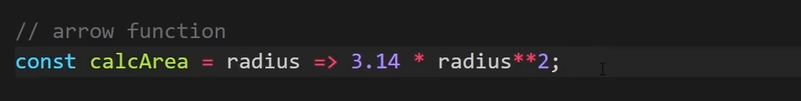

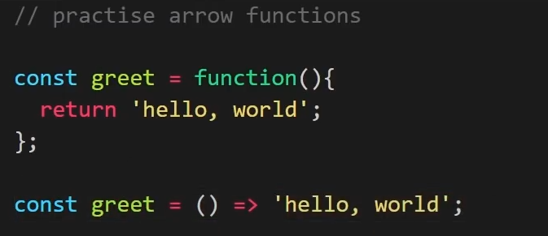

In the below example you can see that the arrow function does not have much differences from a regular function.

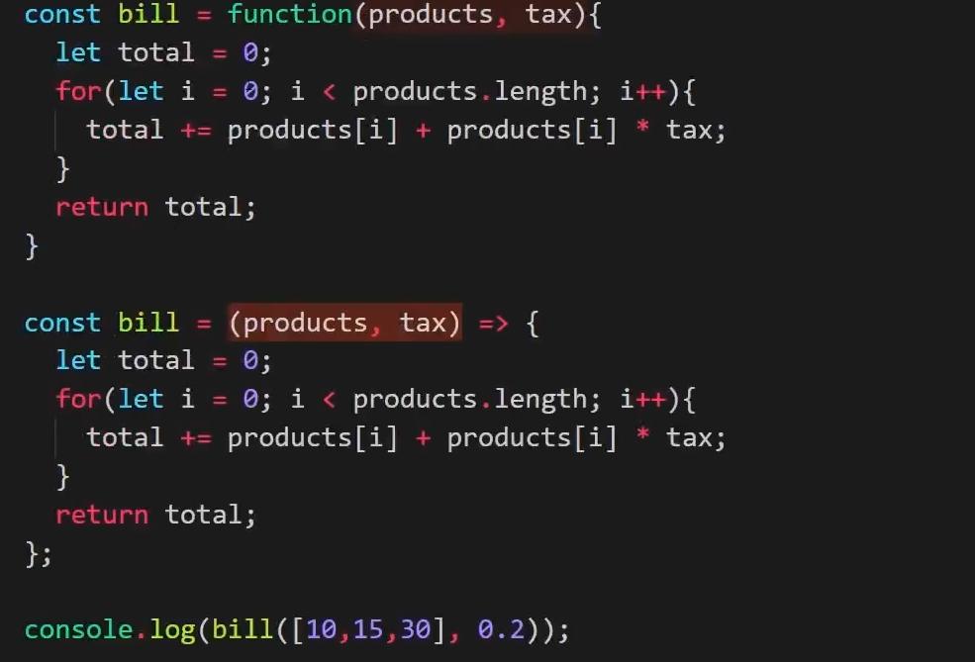

# Local and global variables in javascript

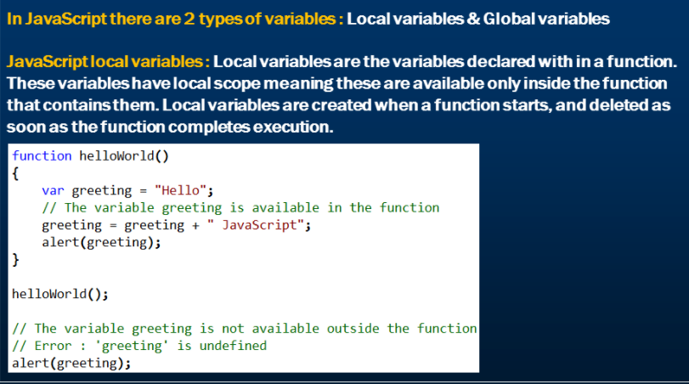

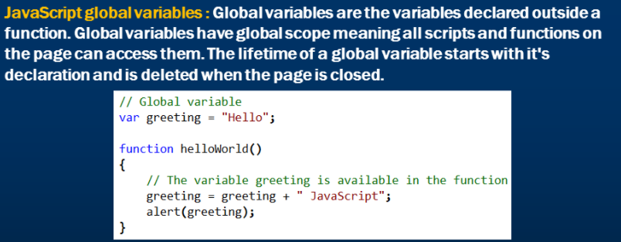

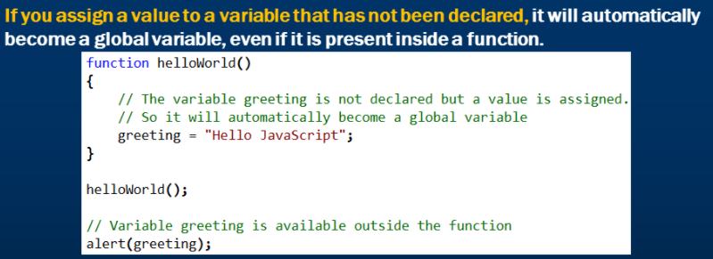

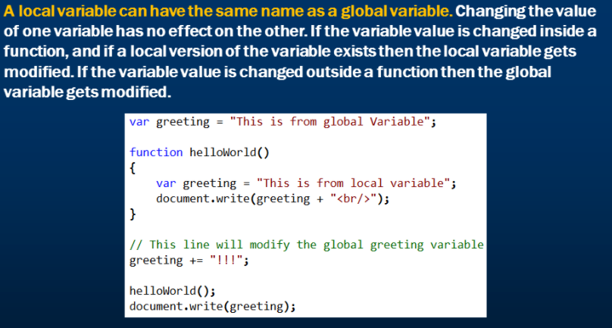

Similar to the function hoisting we have “variable hoisting”. The variable defined within the function is hoisted at the top by javascript.

Below, we have declared a local variable which we use before declaring. This works well in javascript due to “variable hoisting”.

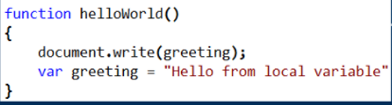

The above function is converted to below during runtime.

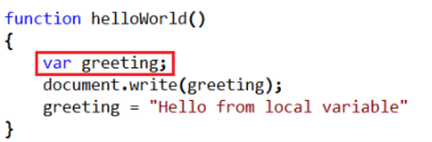

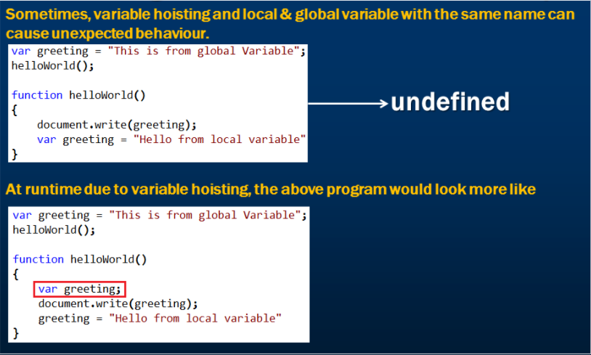

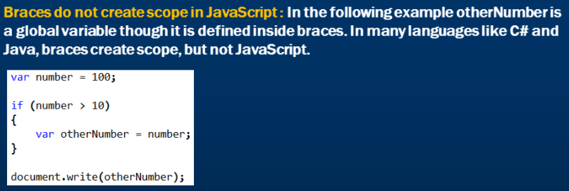

# Closures in JavaScript

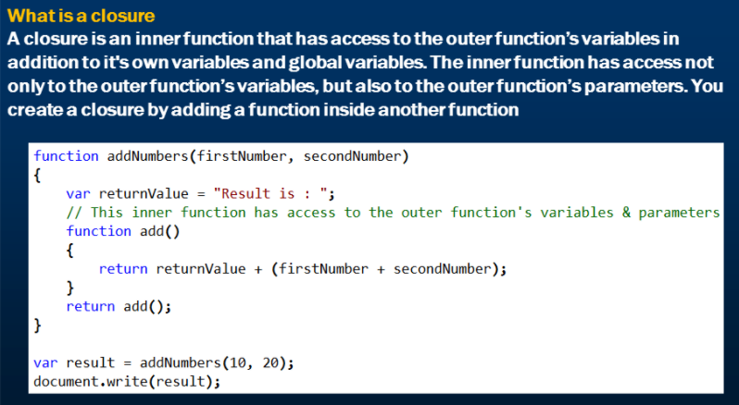

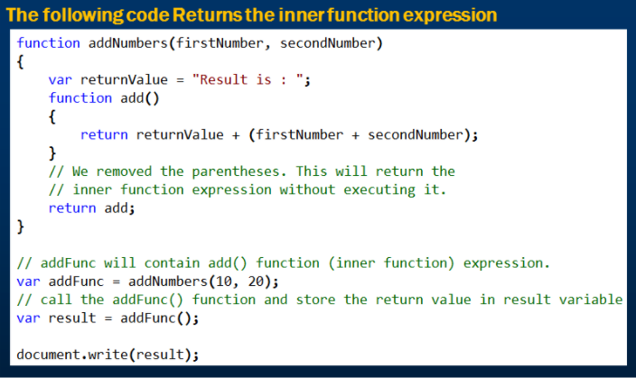

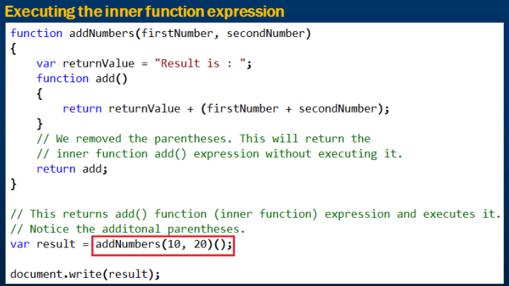

# JavaScript closure example

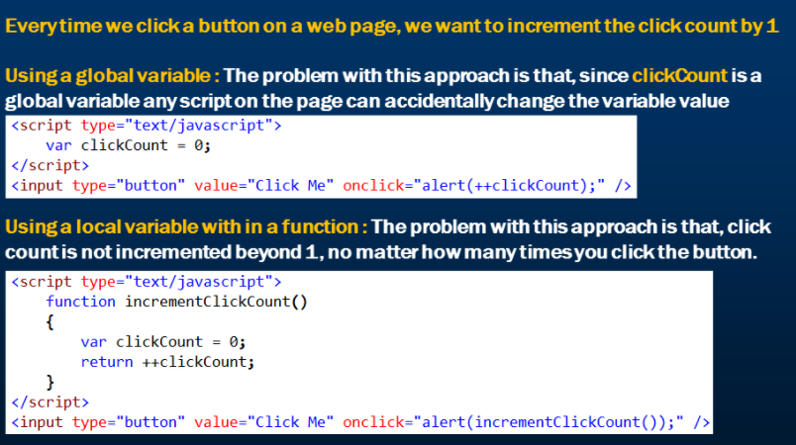

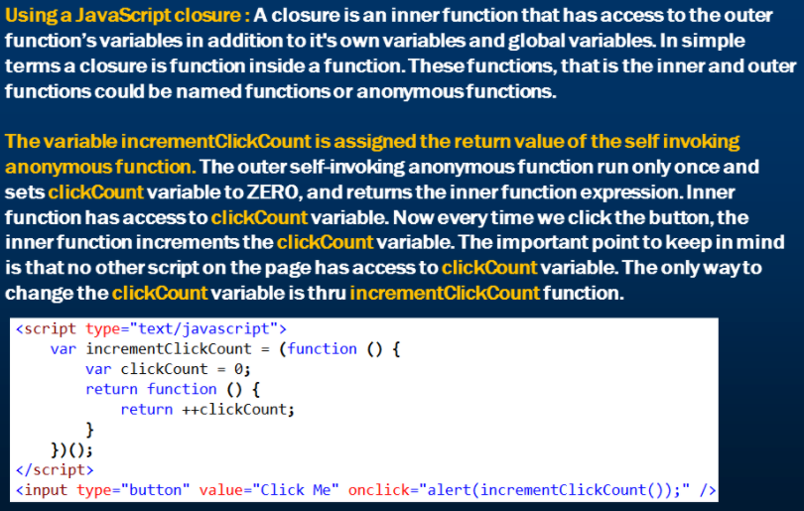

# JavaScript arguments object

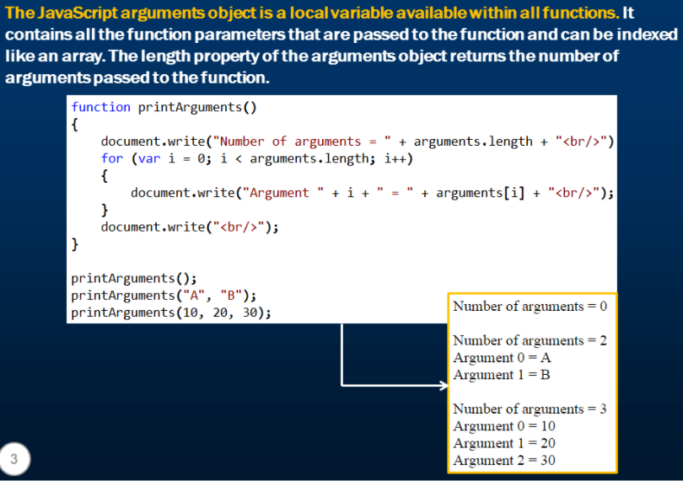

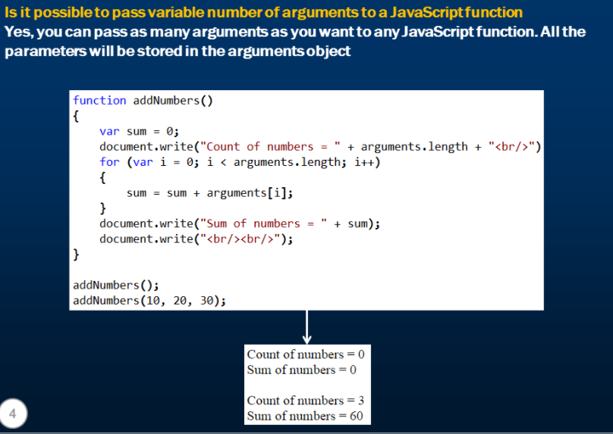

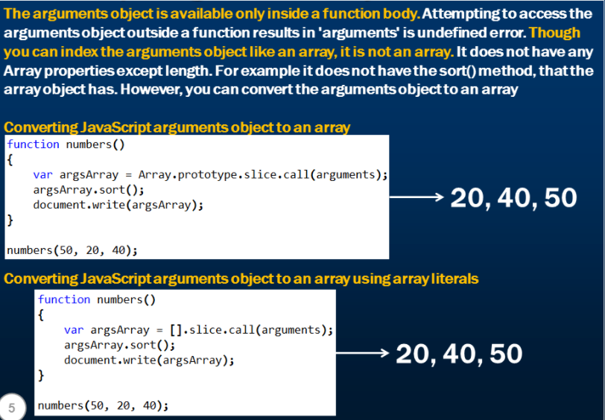

# Callback function

When we pass a function as an argument to a function, it is called a callback function.

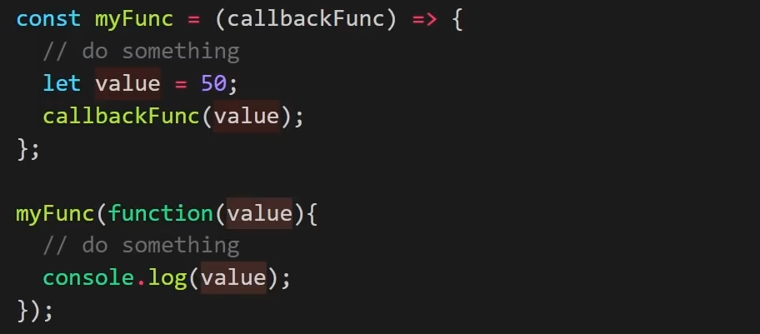

In the above example we are passing a function as an argument to myFunc(). Notice that we are also passing a “value”. This value is later used by the callback function.

Now, we will convert the function (passed as argument) to an arrow function. And this is how callback functions are generally defined.

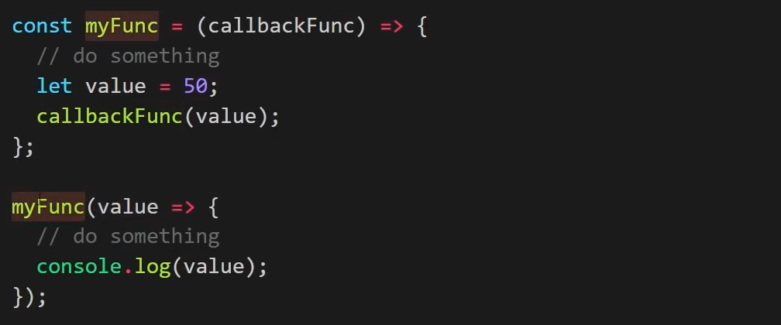

Using foreach:

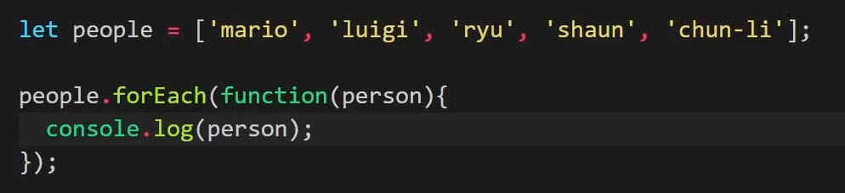

Now lets convert this to an arrow function.

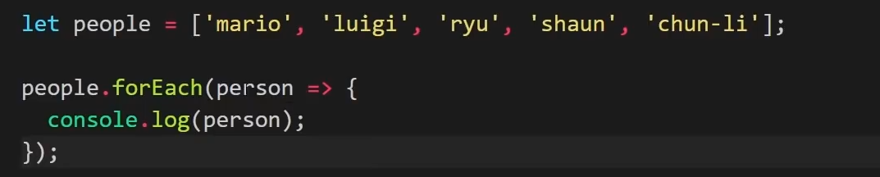

We can also pass the index as an argument to forEach. In the below example we have created a callback function that we are passing to forEach.

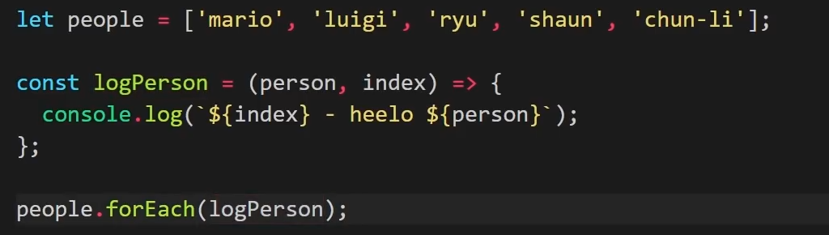

# Recursive function in JavaScript

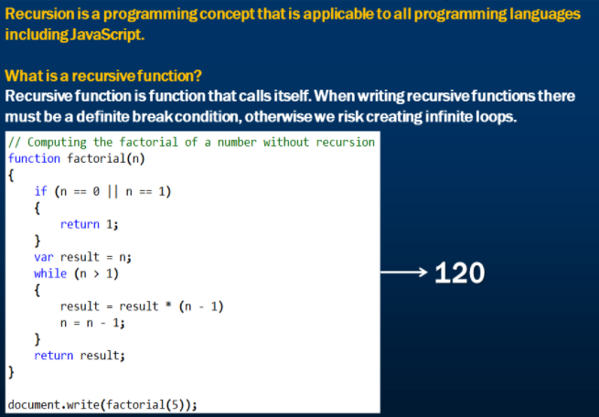

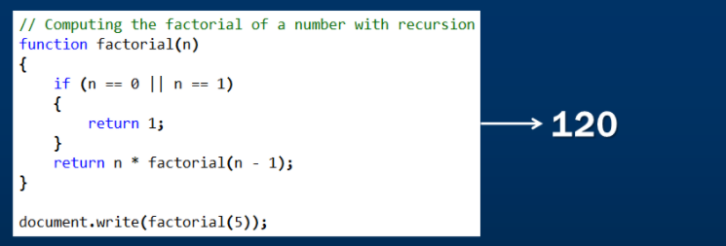

# Error handling in JavaScript

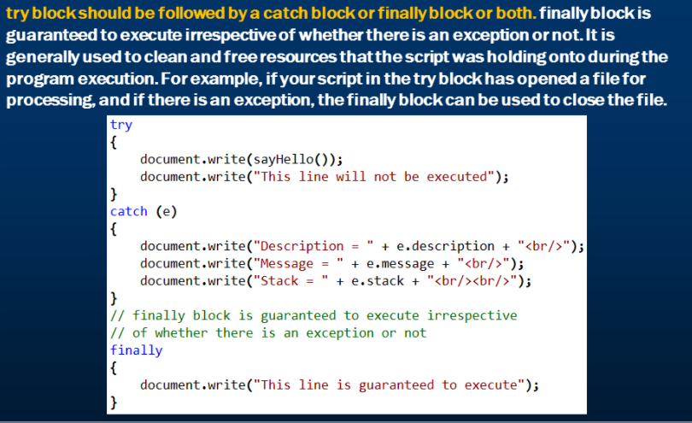

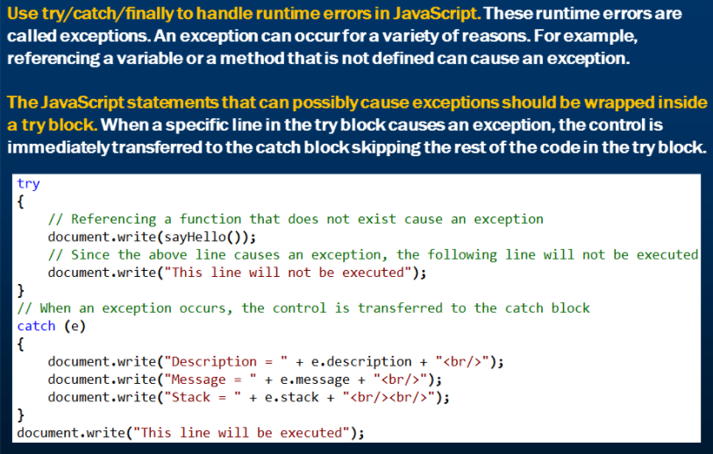

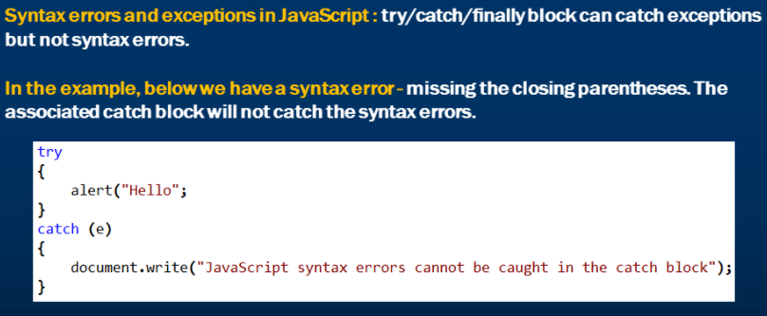

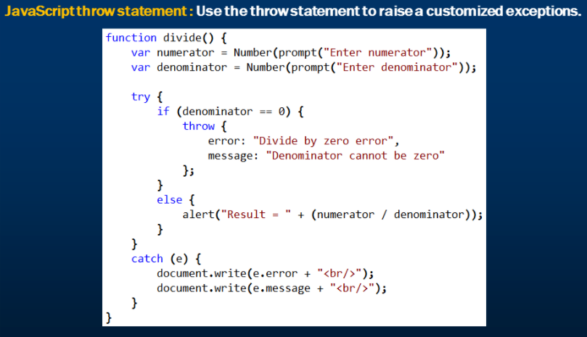

# JavaScript window.onerror event

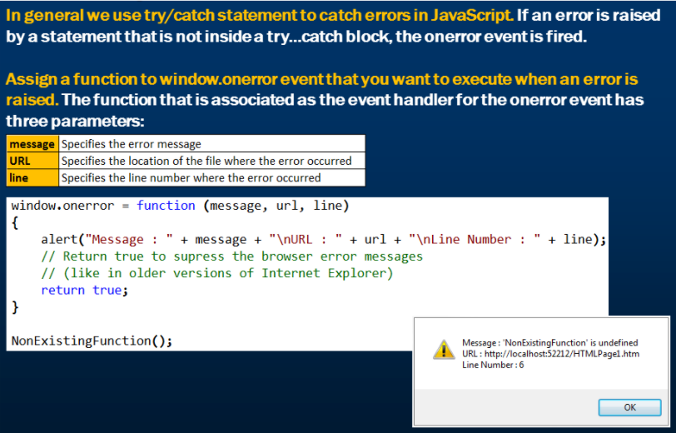

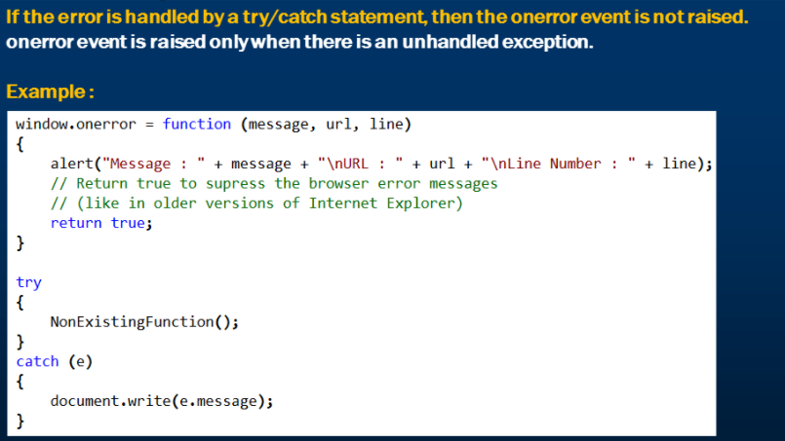

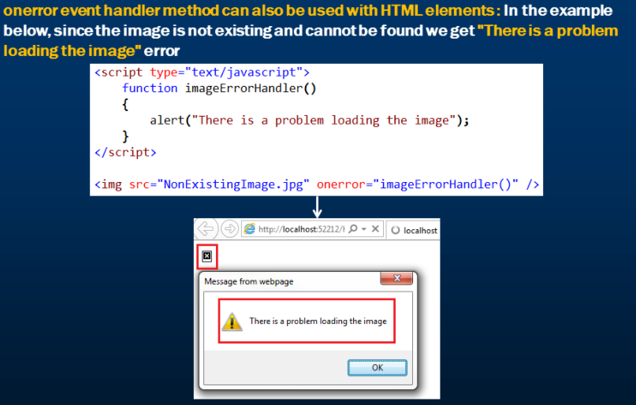

# Objects in Javascript

Objects in javascript are a key-value pair.

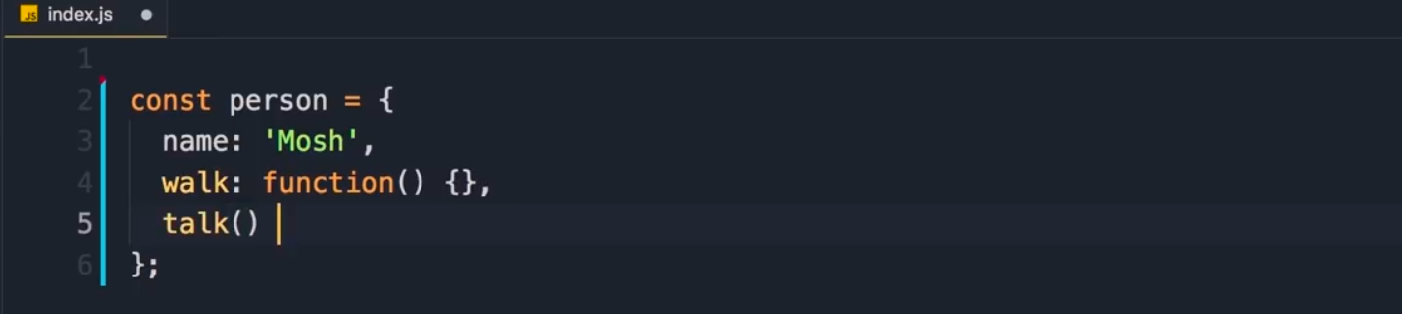

When we define a function inside object, we call it a method. The method in ES6 is defined as talk ().

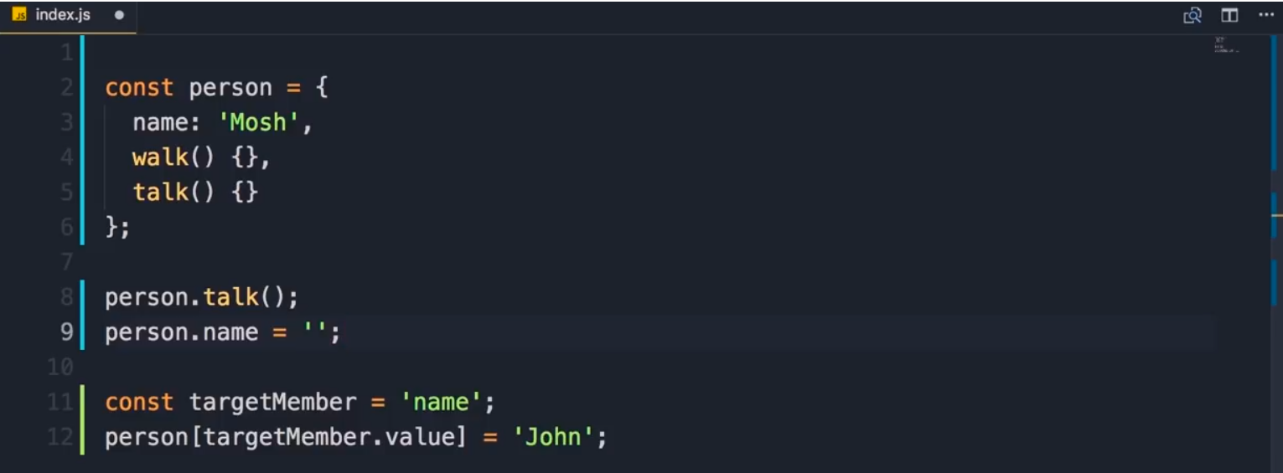

We use the bracket notation when we do not know the value of an object member ahead of time. Above, **name** is defined using both dot and bracket.

# this keyword

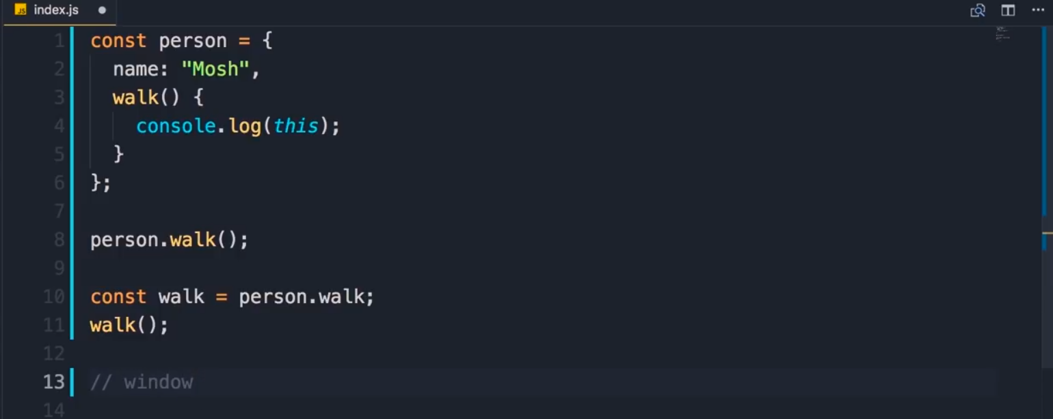

When the walk() function is called as a **member** of the person object, it returns the reference to that object (similar to OOP languages such as java)

When the walk() function is called as a **standalone function**,it returns the reference to the window object which is the global javascript object. However, if the **strict** mode is enabled, it returns **undefined**.

This issue can be fixed by **binding this** to the object.

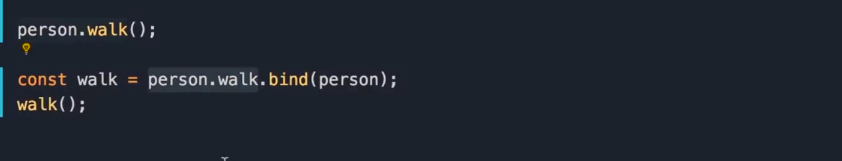

One thing to note is that the functions in javascript are actually objects. Below, the walk function presents the object methods.

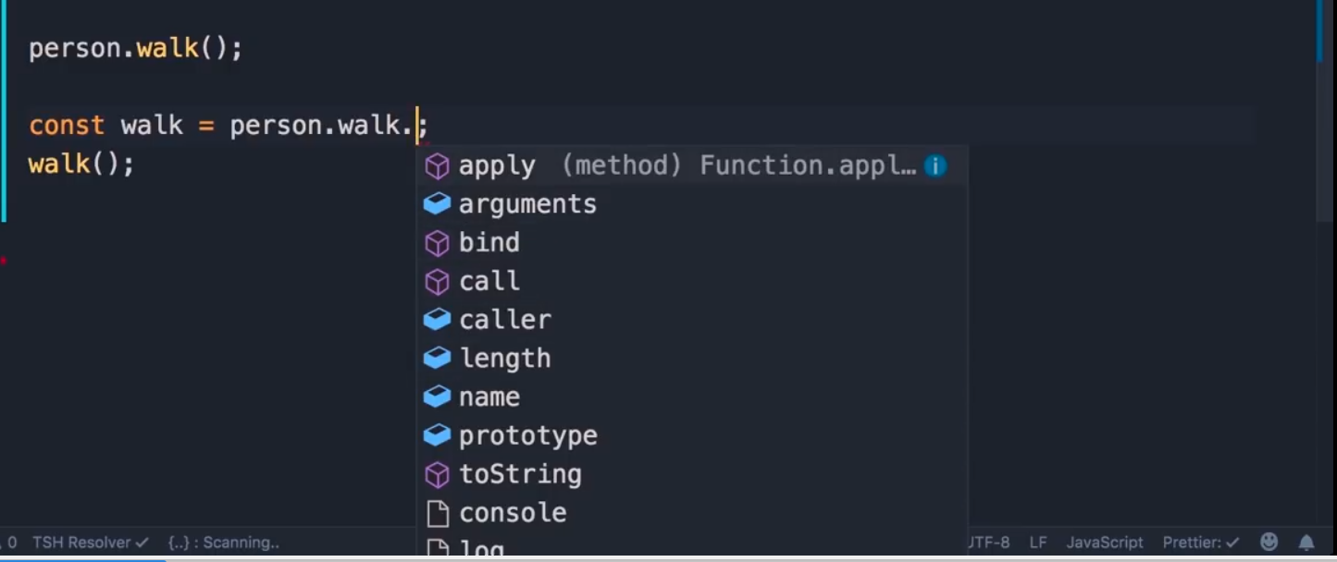

# Working with dates in javascript

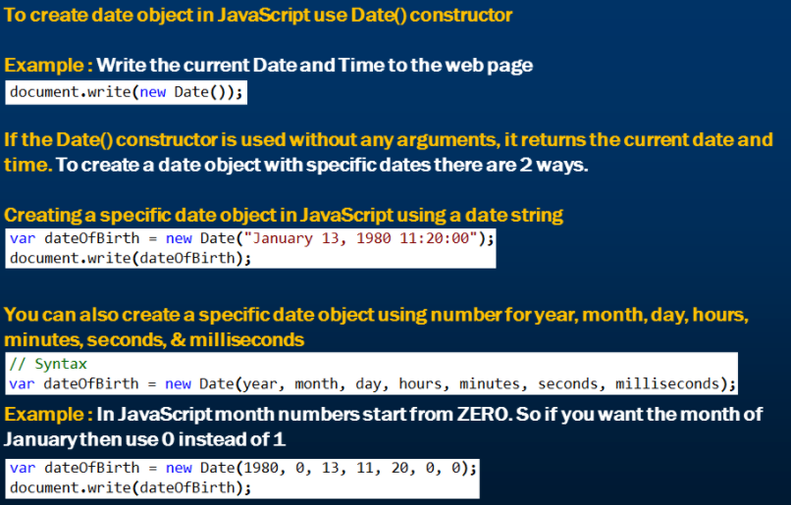

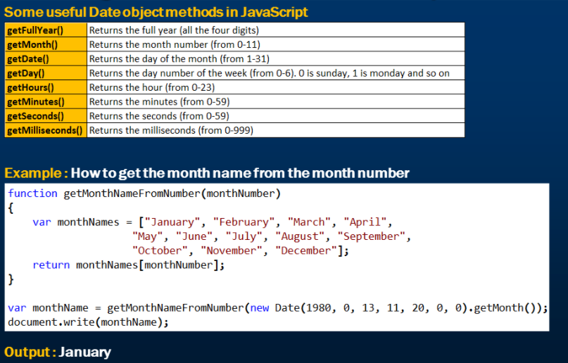

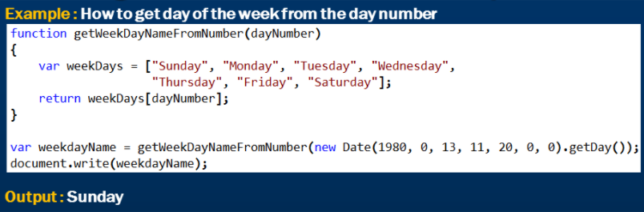

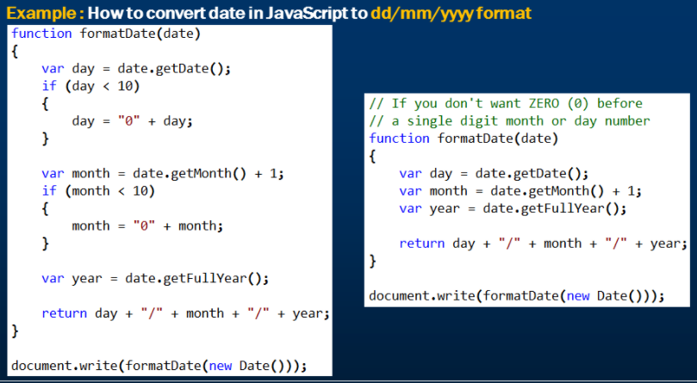

# JavaScript timing events

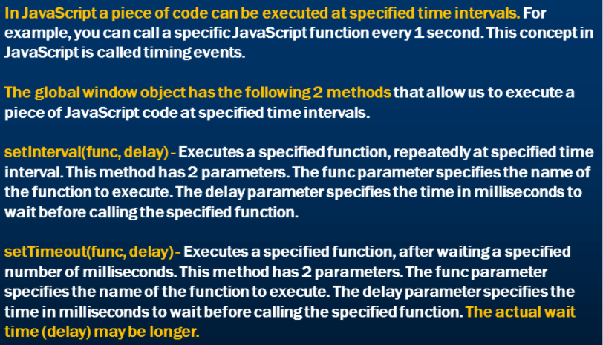

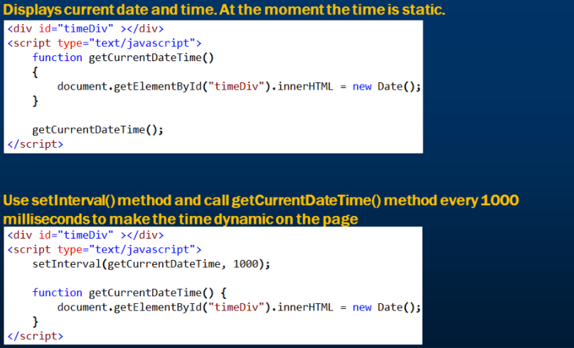

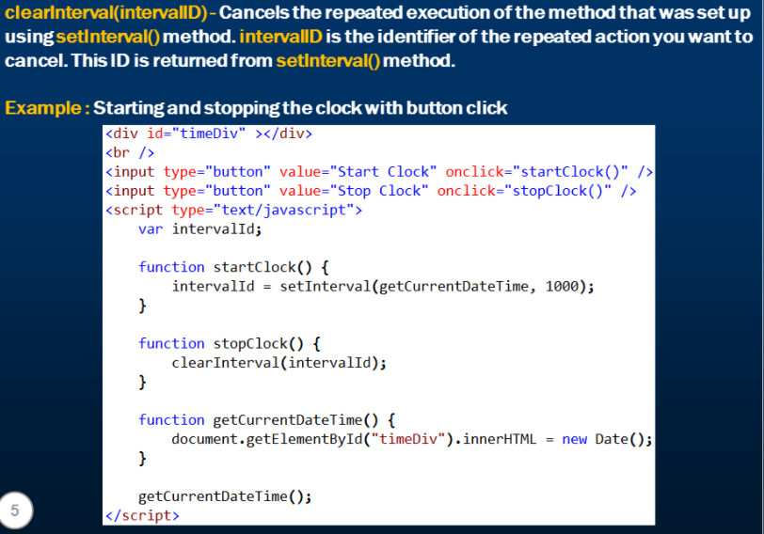

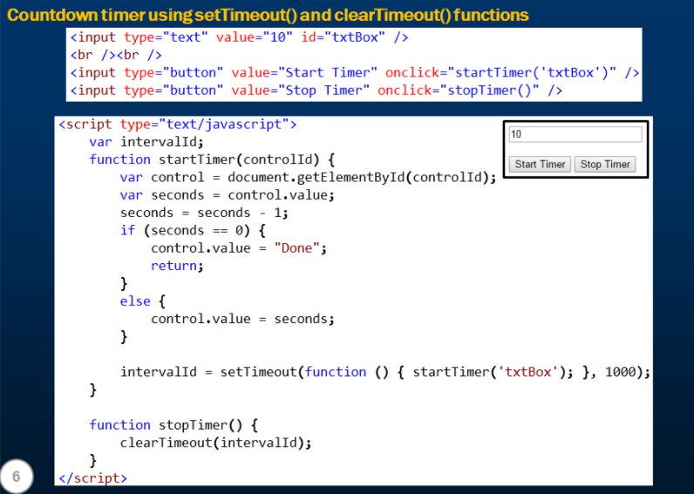

# How to create image slideshow using JavaScript

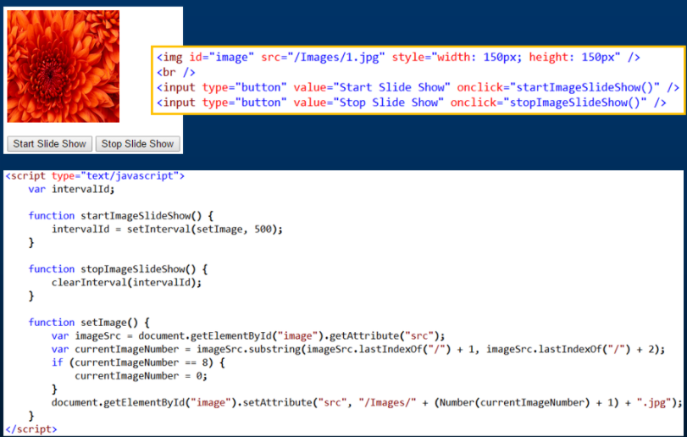

# Events in JavaScript

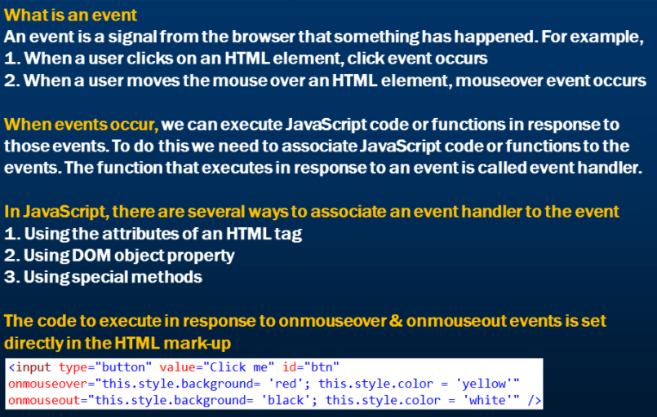

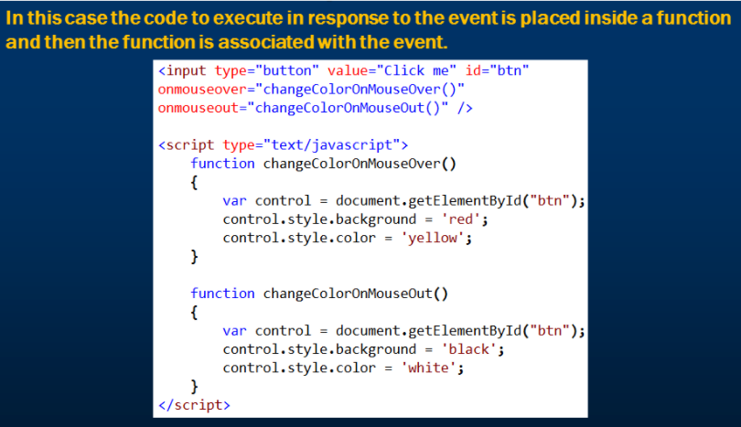

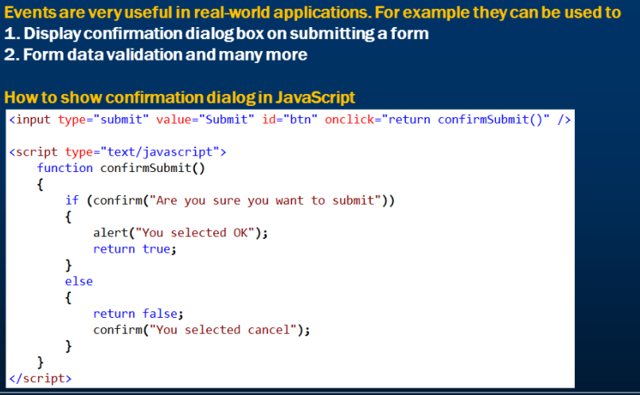

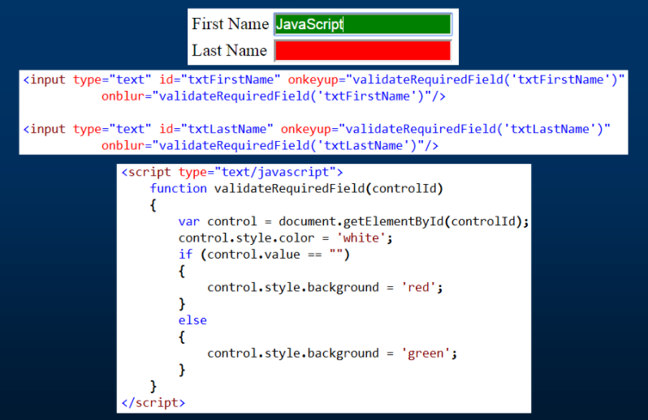

# Assigning event handlers in JavaScript using DOM object property

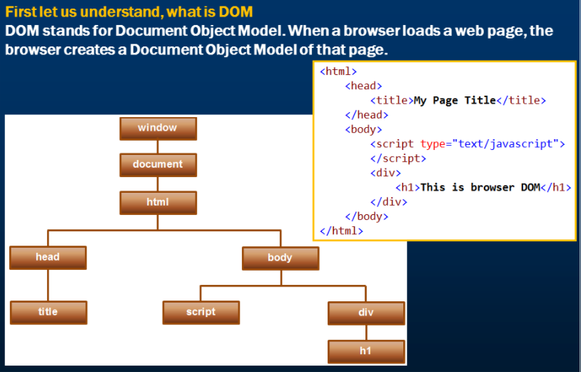

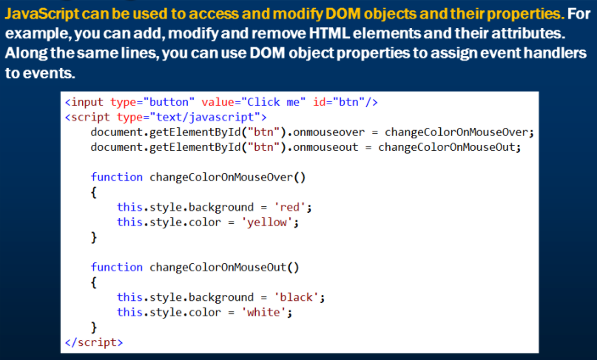

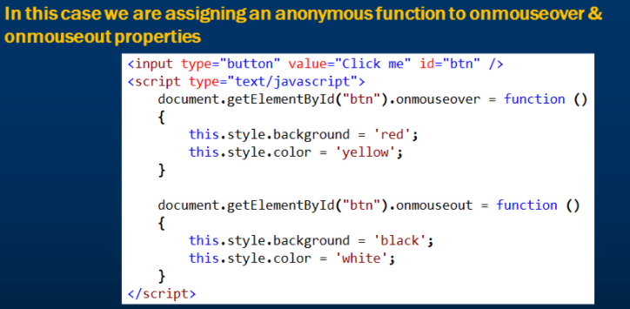

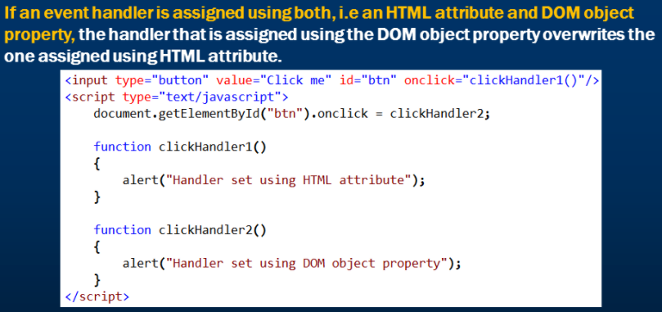

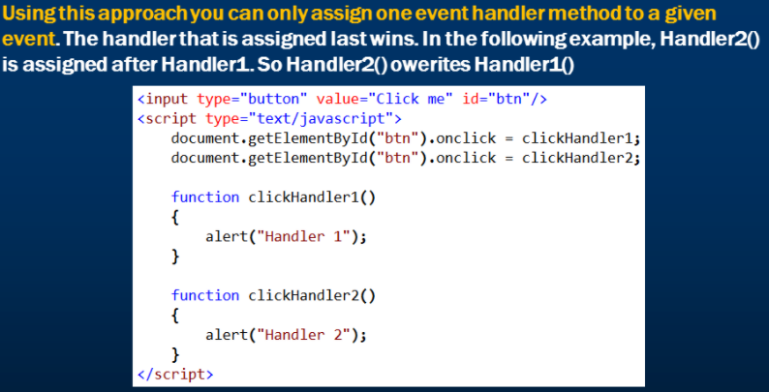

# addeventlistener and removeeventlistener in JavaScript

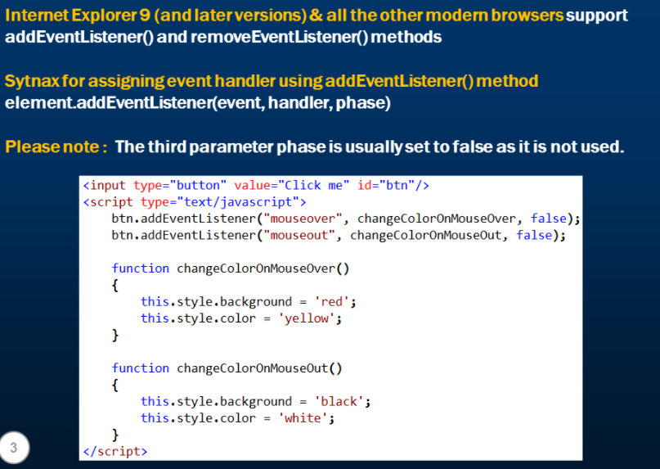

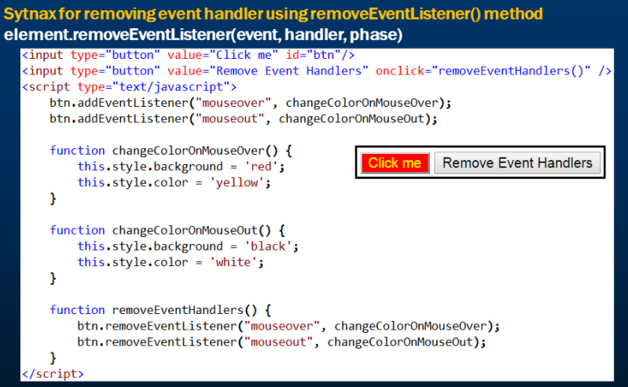

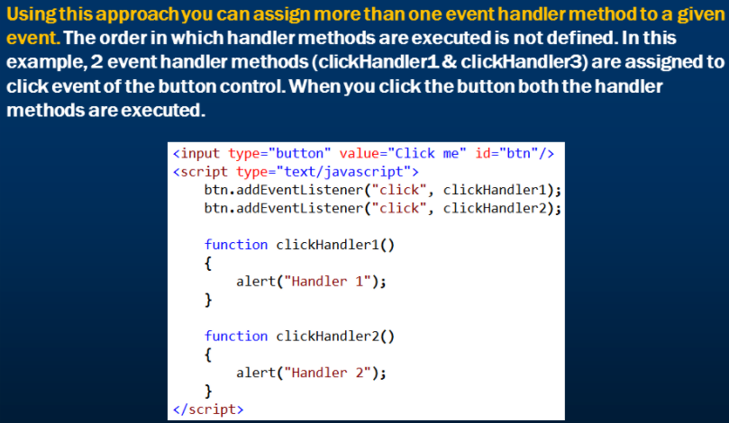

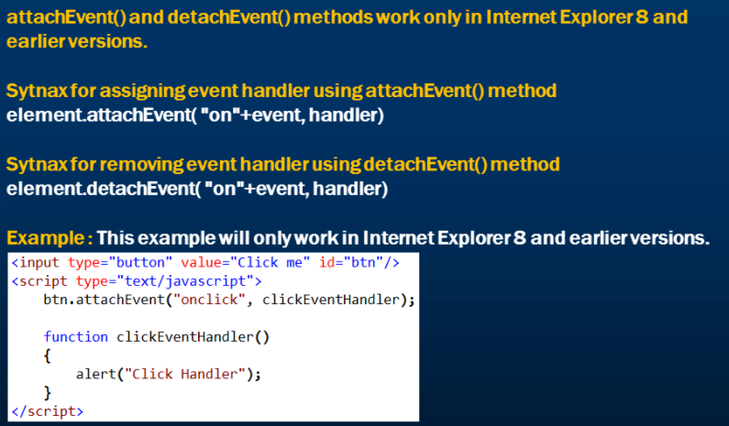

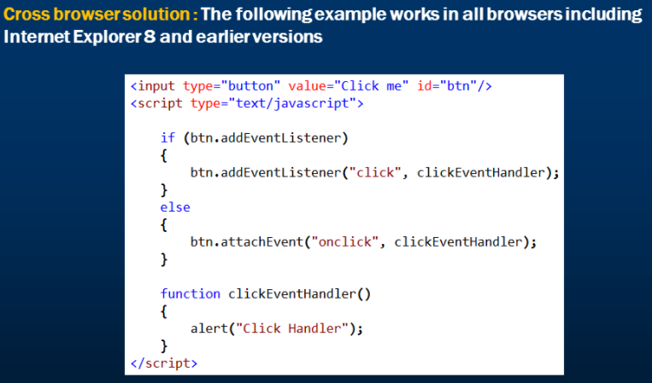

# JavaScript event object

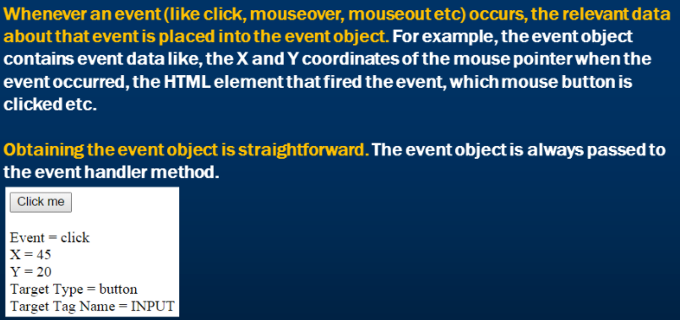

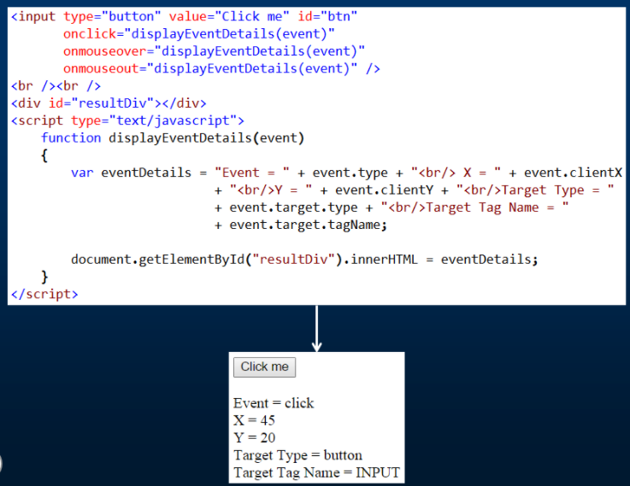

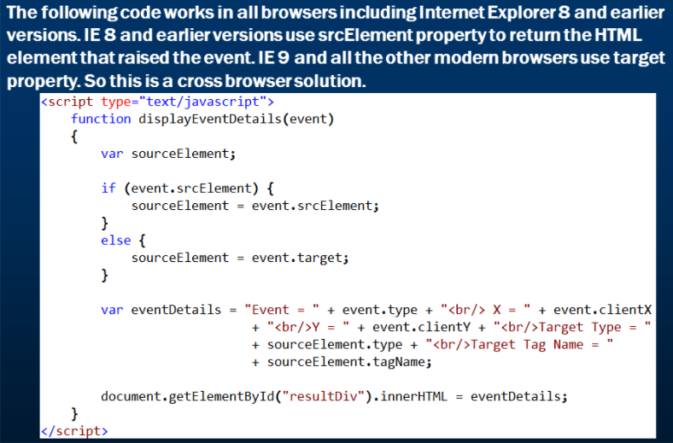

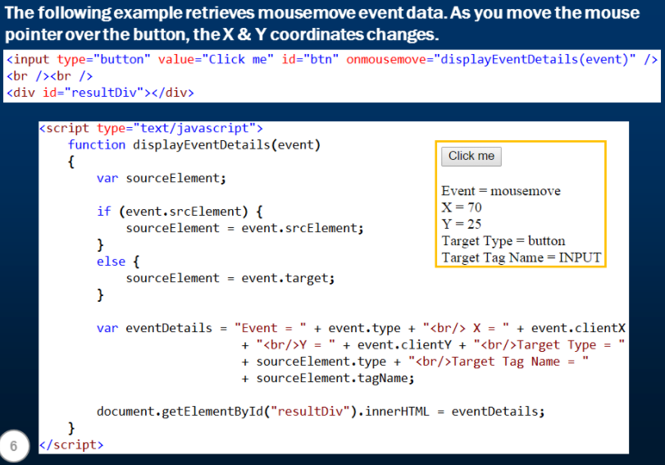

# Event bubbling in JavaScript

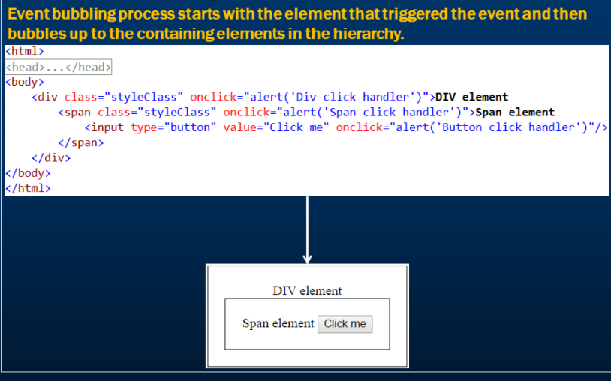

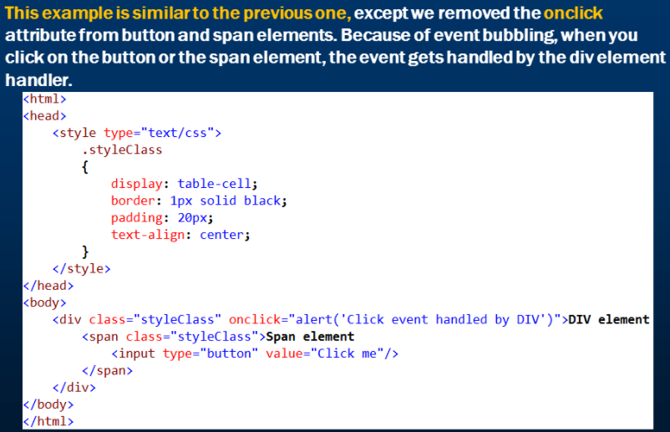

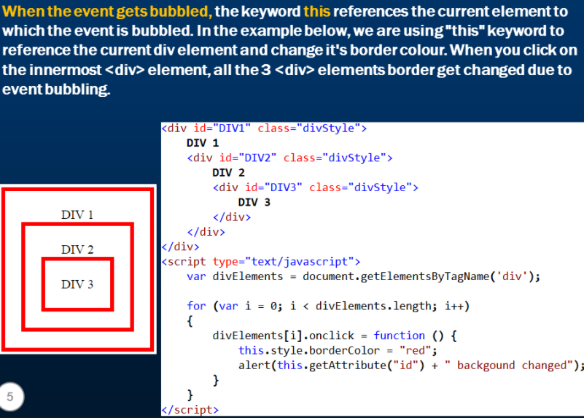

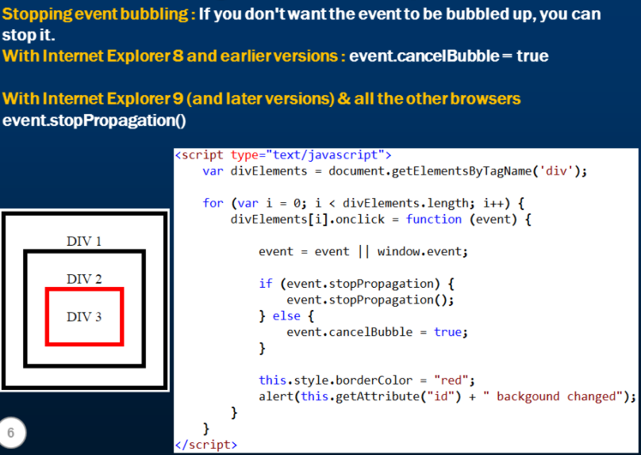

# Image gallery with thumbnails in JavaScript

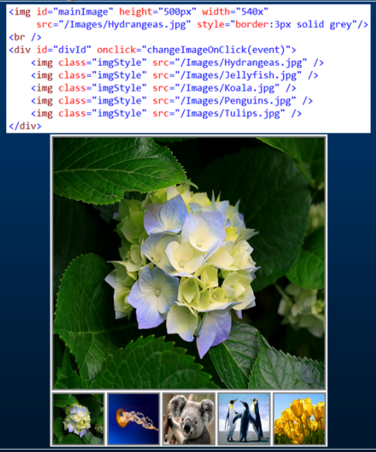

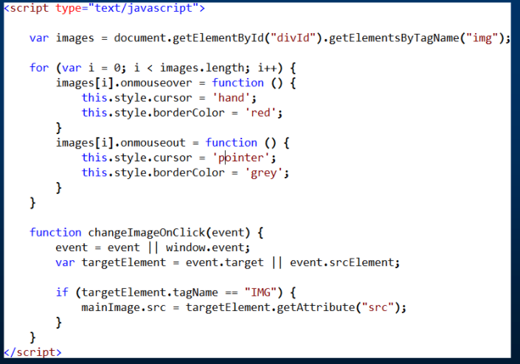

# JavaScript event capturing

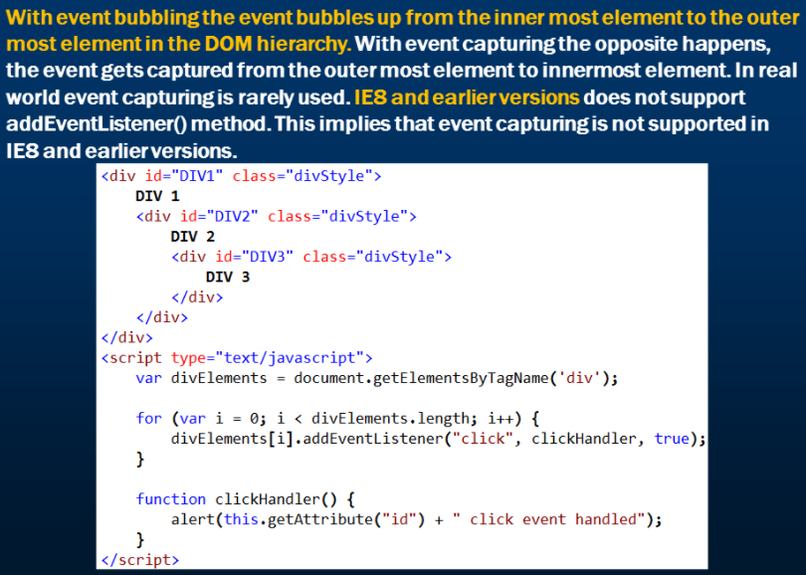

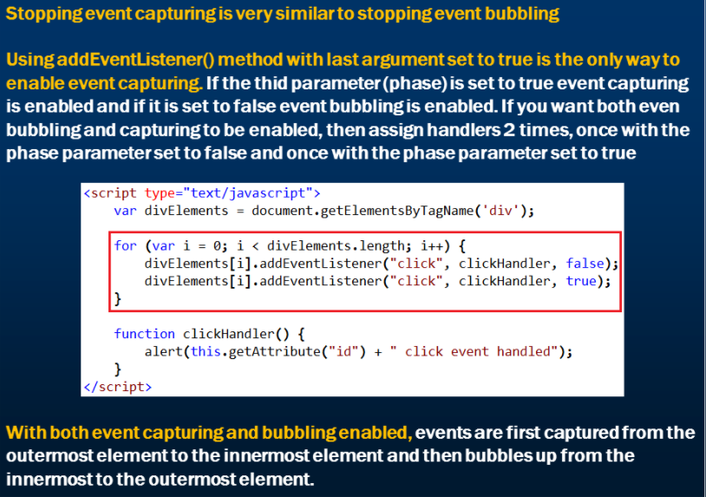

# Preventing browser default action

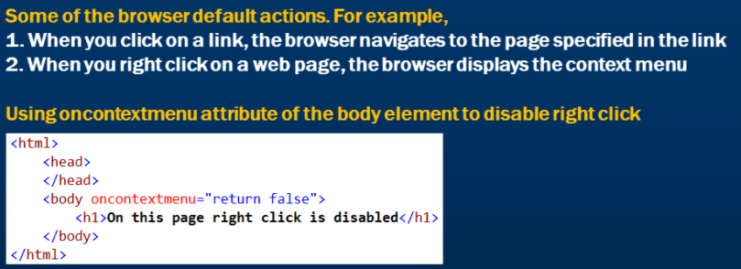

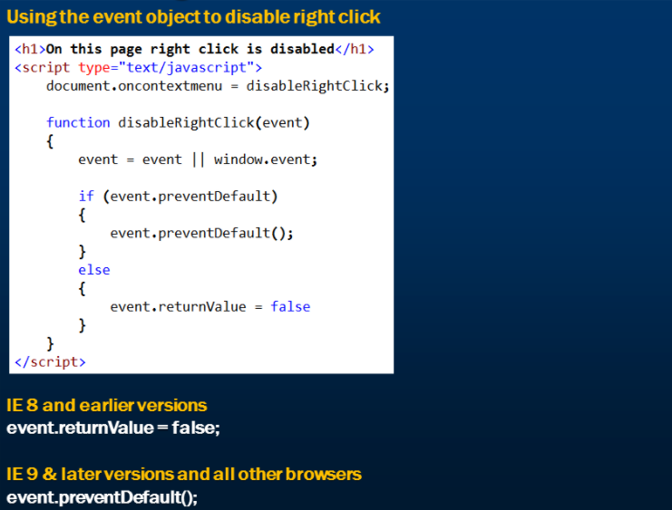

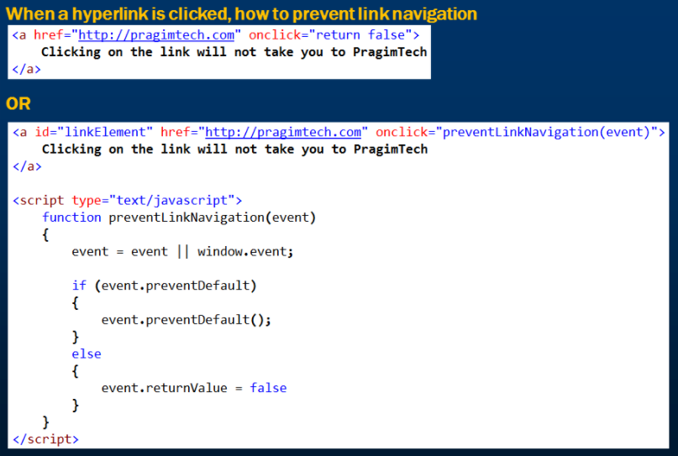

# JavaScript to detect which mouse button is clicked

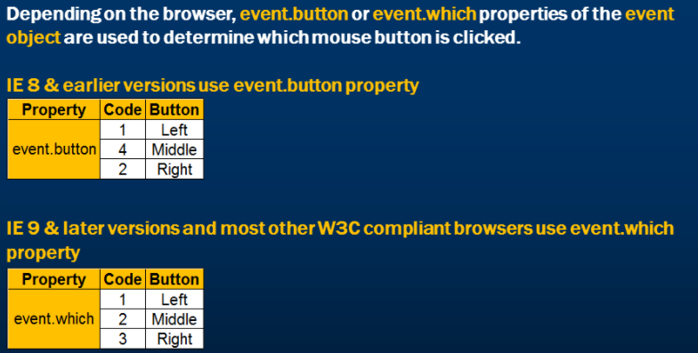

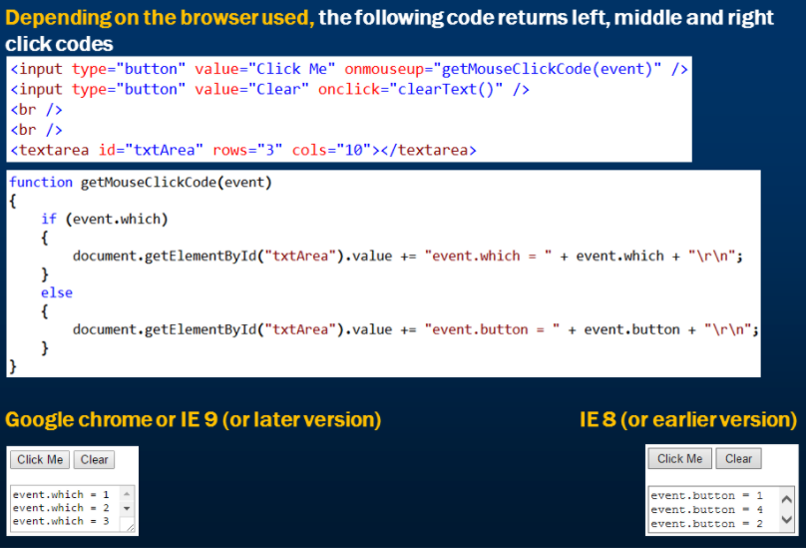

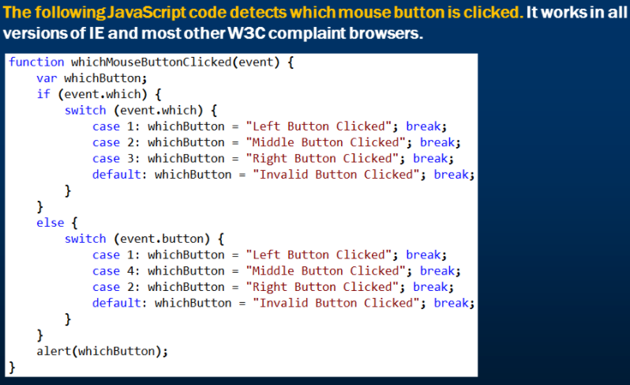

# JavaScript mouse events

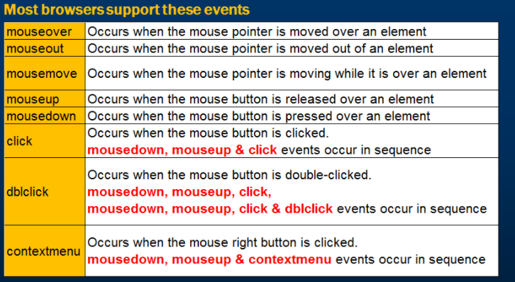

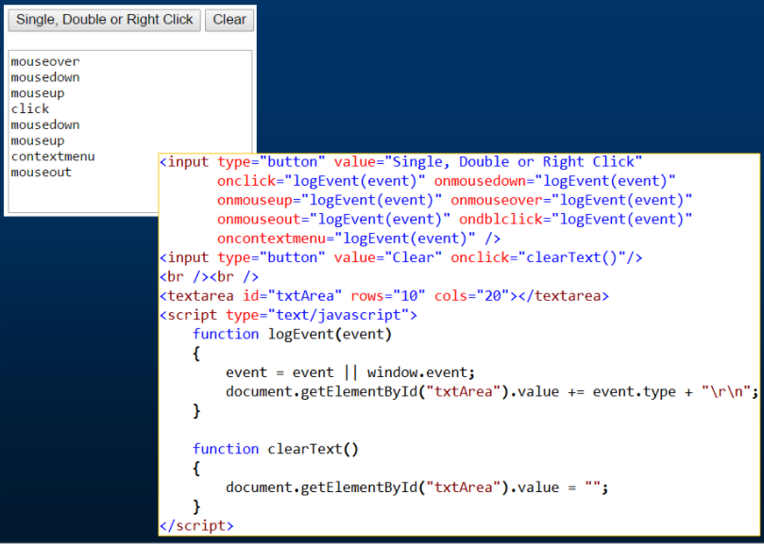

# JavaScript popup window

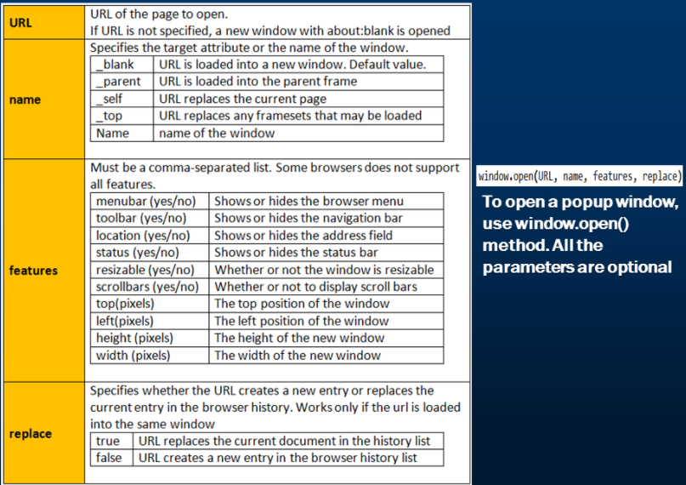

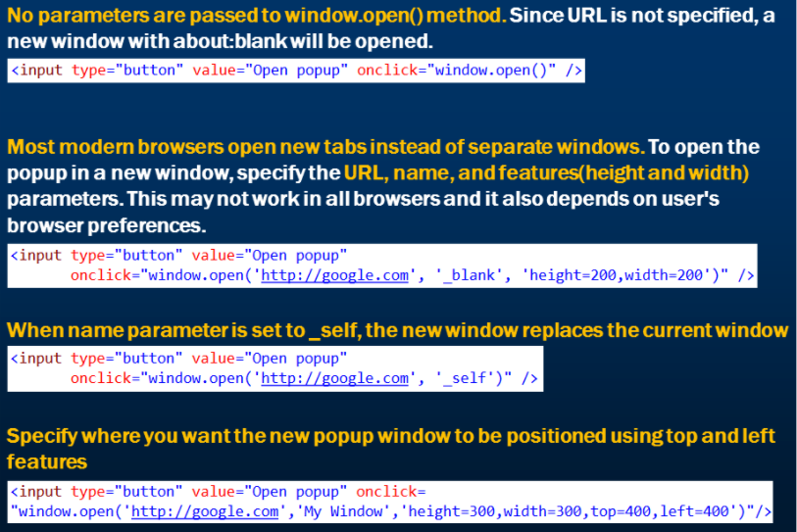

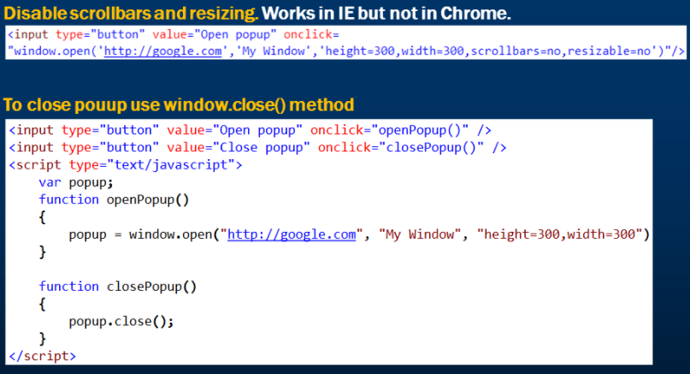

# Using regular expressions in JavaScript

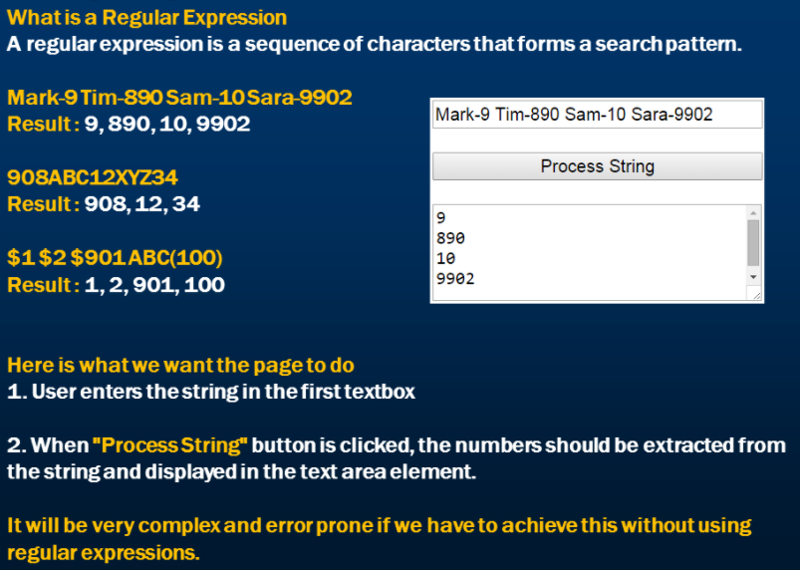

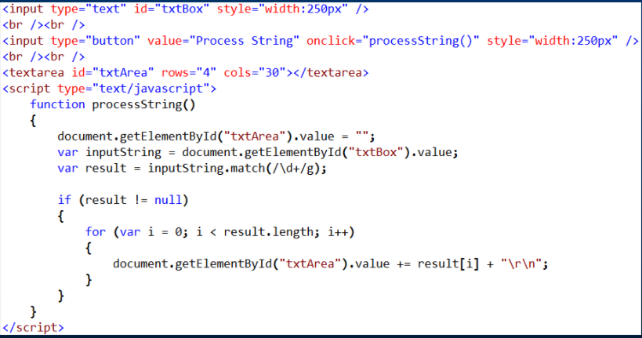

# Tools for writing regular expressions

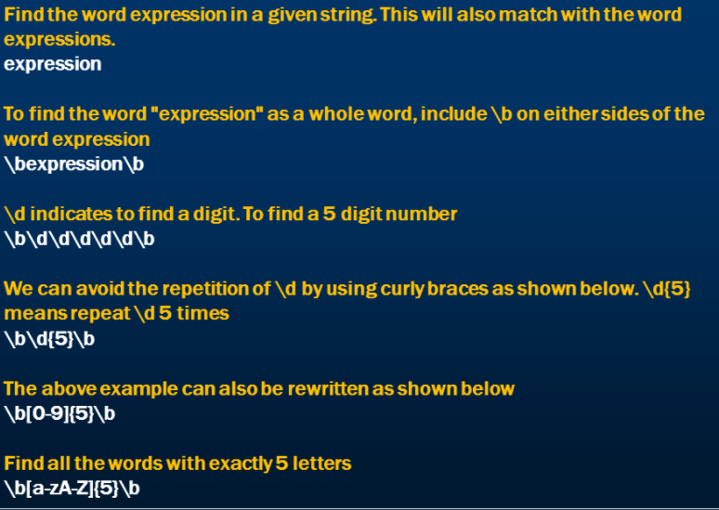

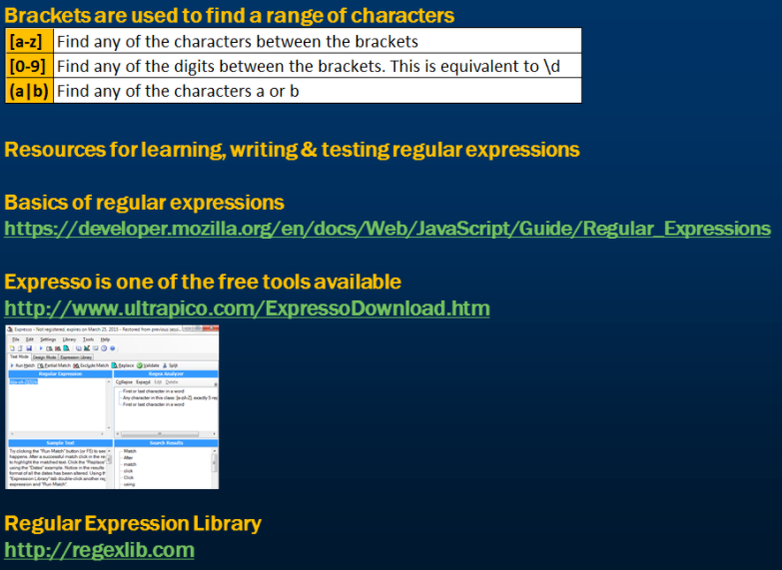

# JavaScript strings and regular expressions

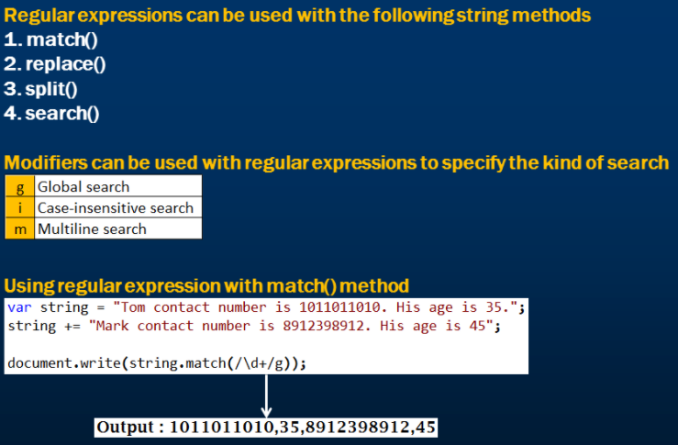

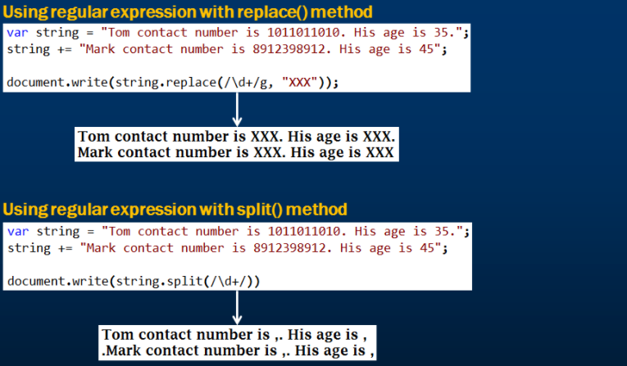

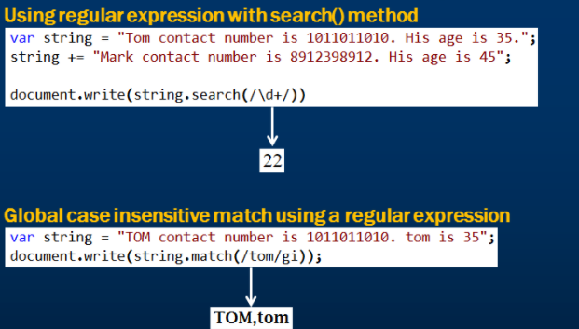

# JavaScript RegExp object

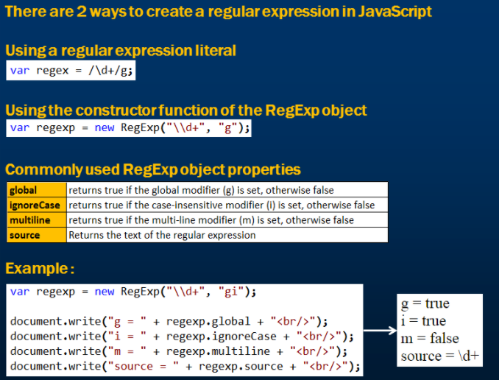

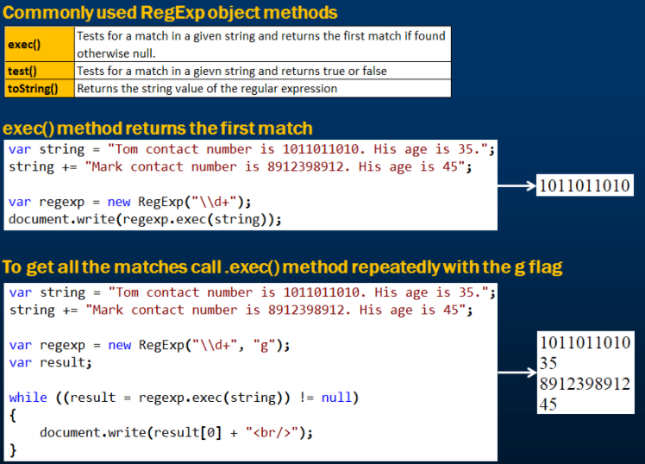

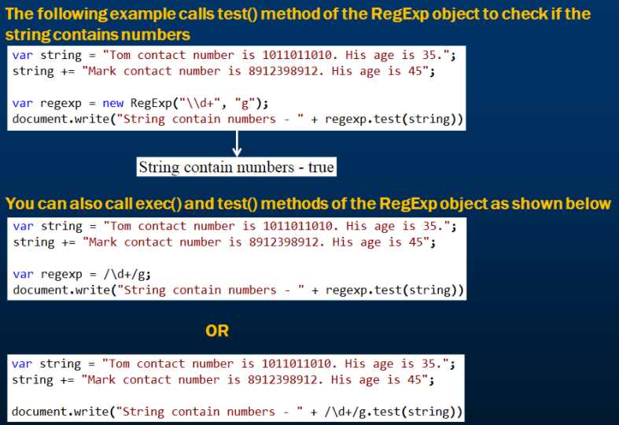

# Client side validation using regular expression

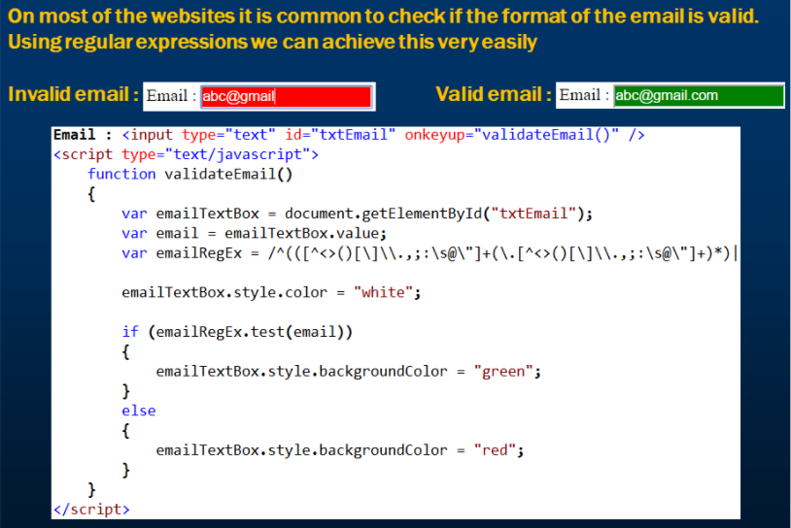

# JavaScript Minification

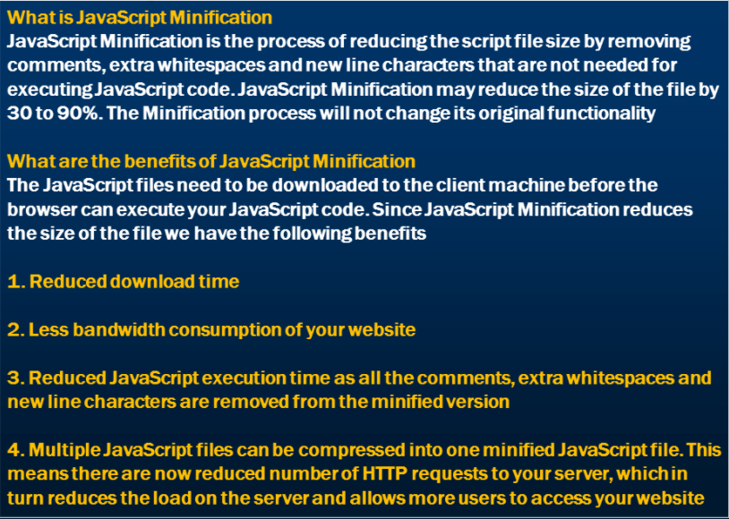

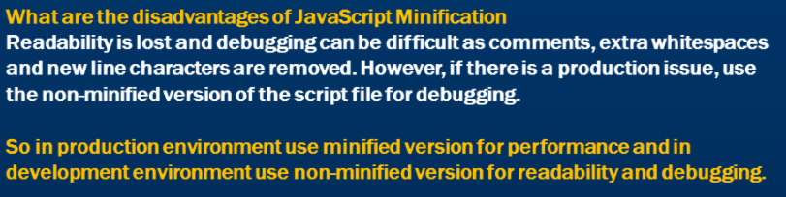

# JavaScript and object oriented programming

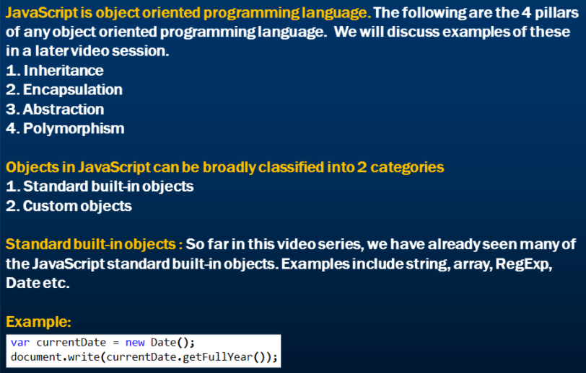

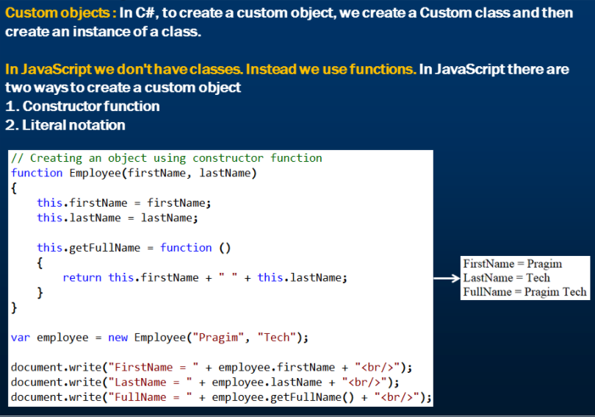

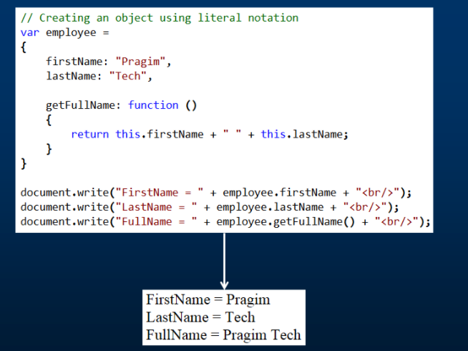

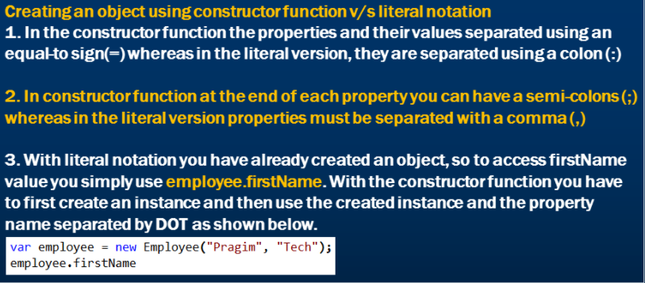

# Object literal vs object constructor

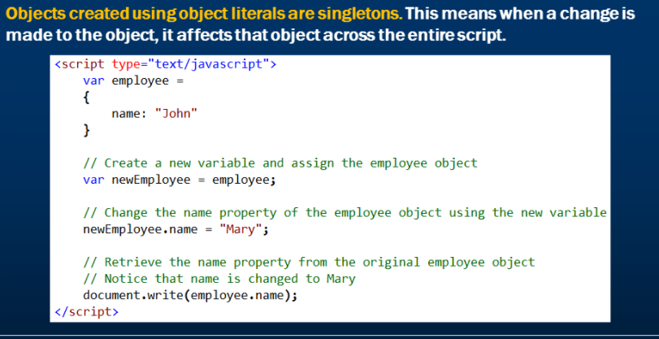

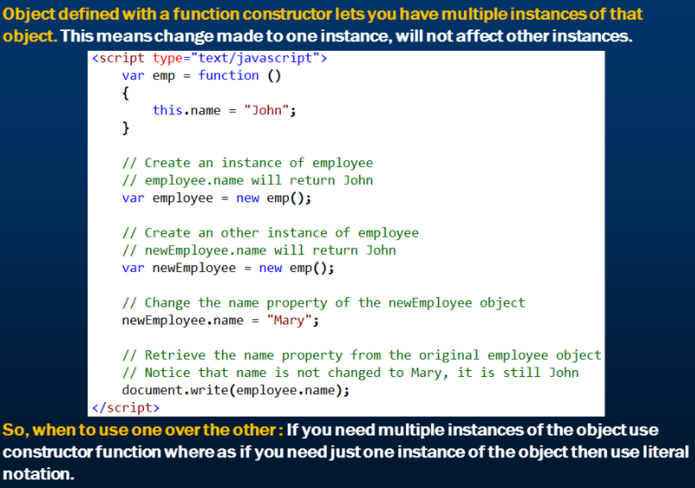

# Global namespace pollution in JavaScript

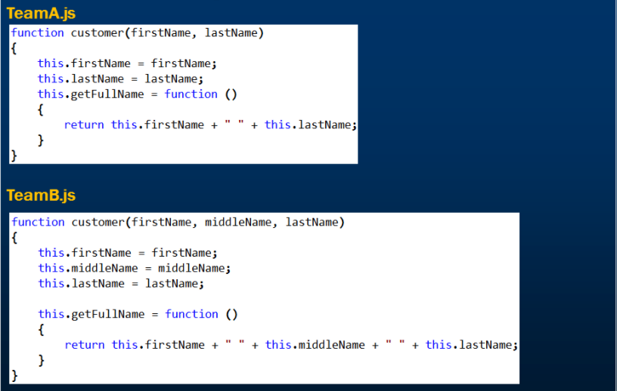

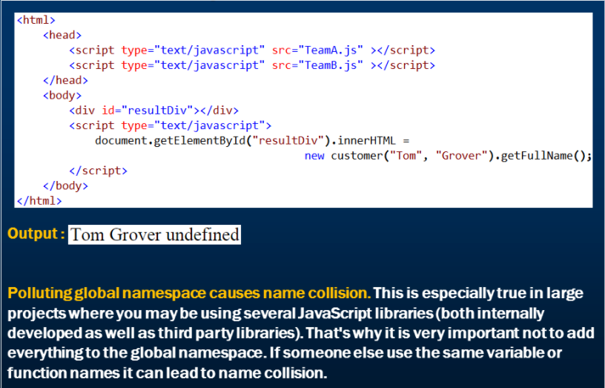

# Namespaces in JavaScript

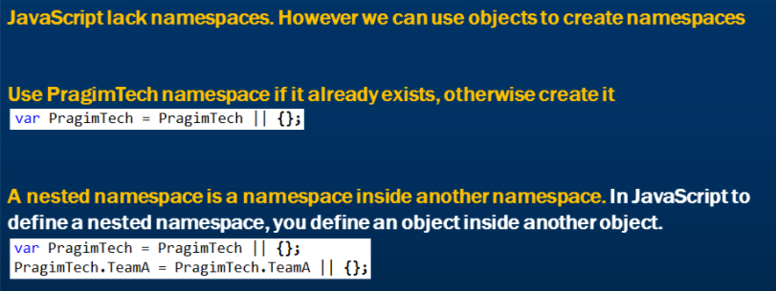

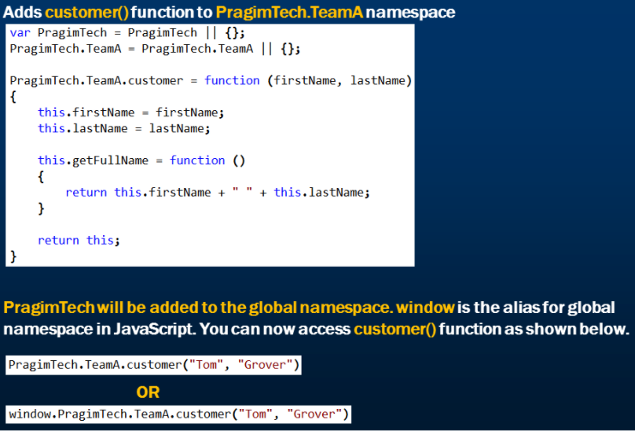

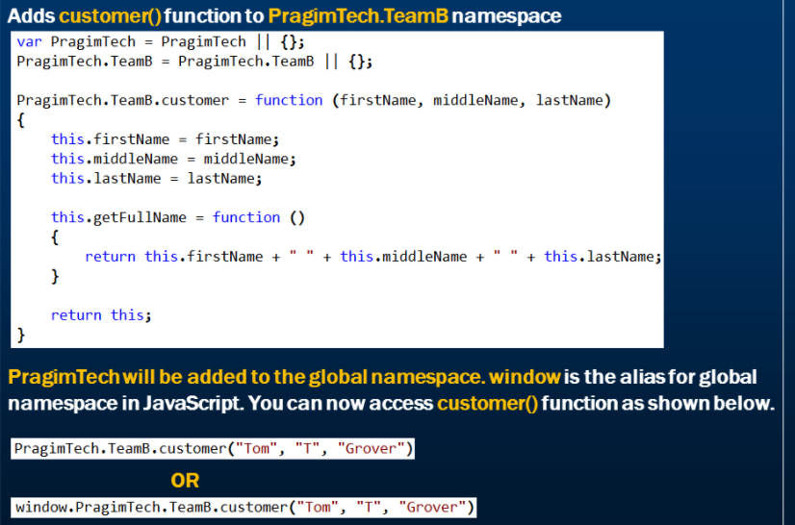

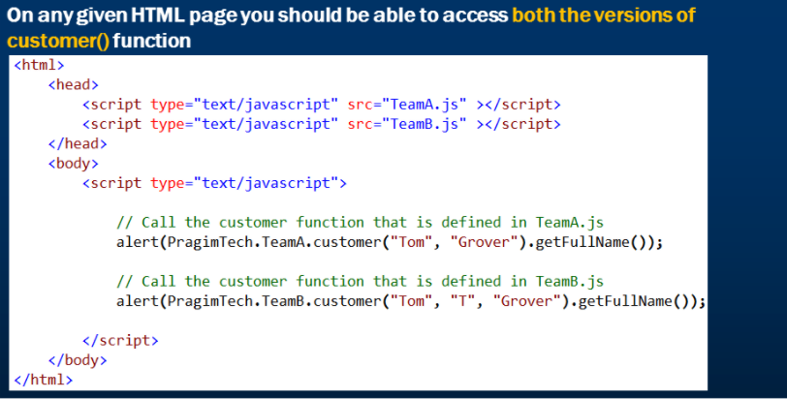

# Private members in JavaScript

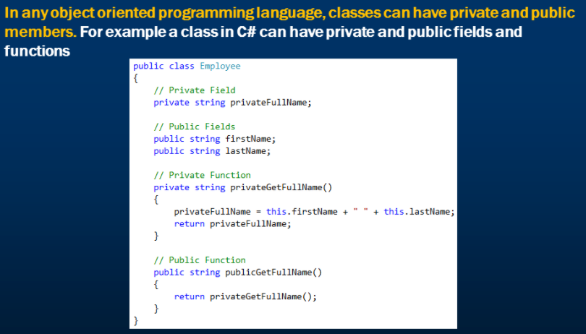

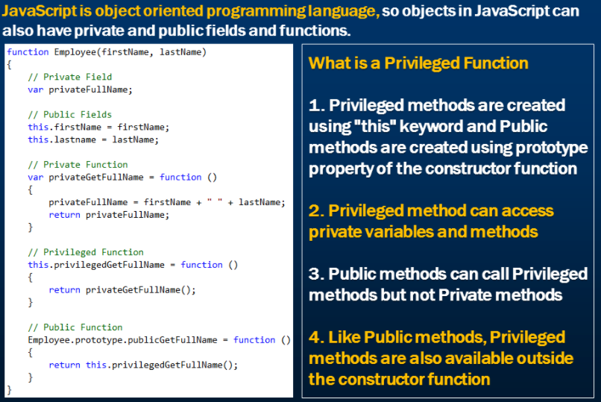

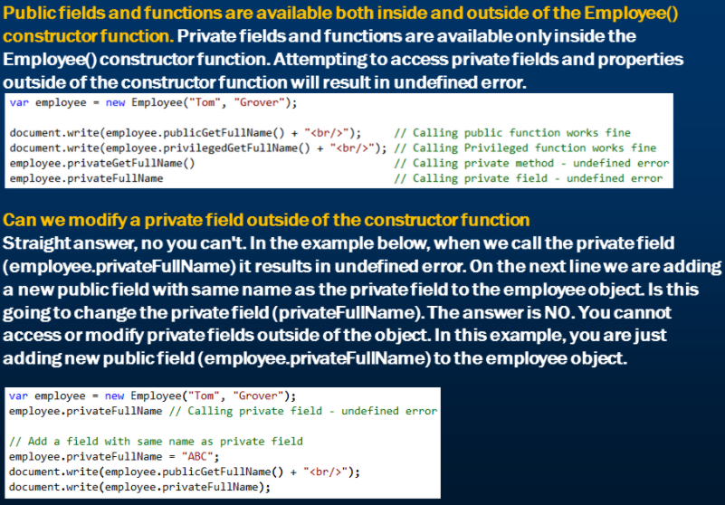

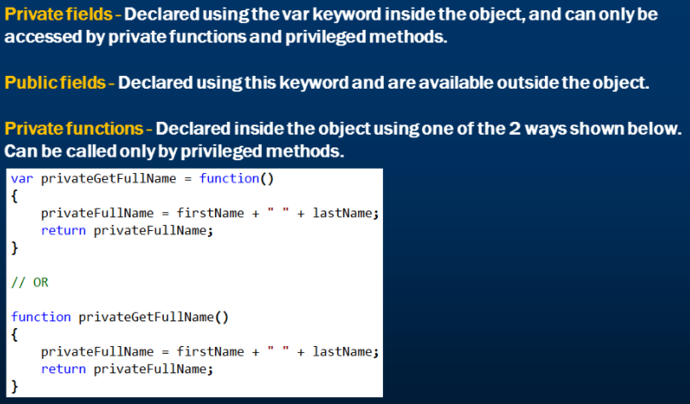

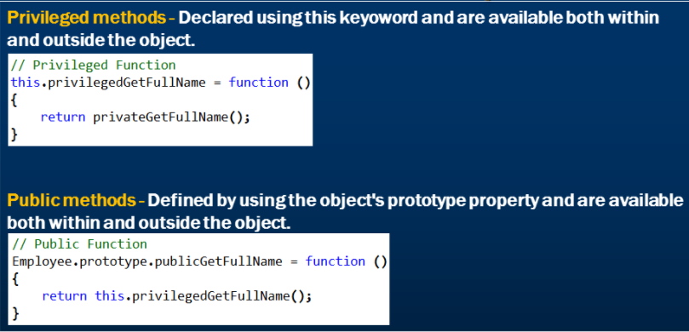

# Properties in JavaScript

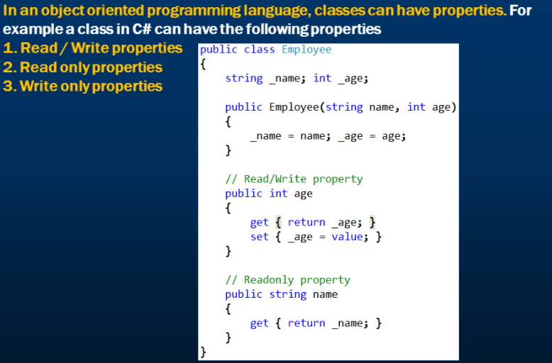

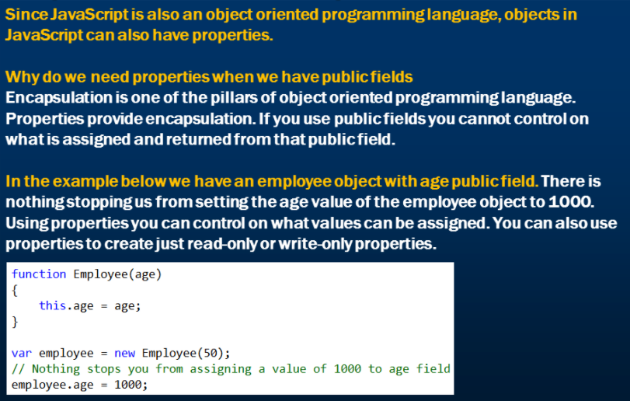

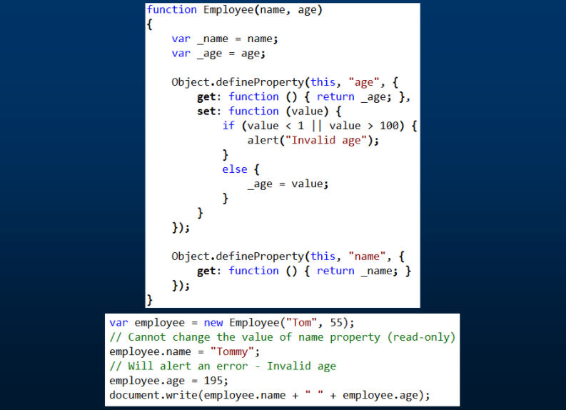

# Static members in JavaScript

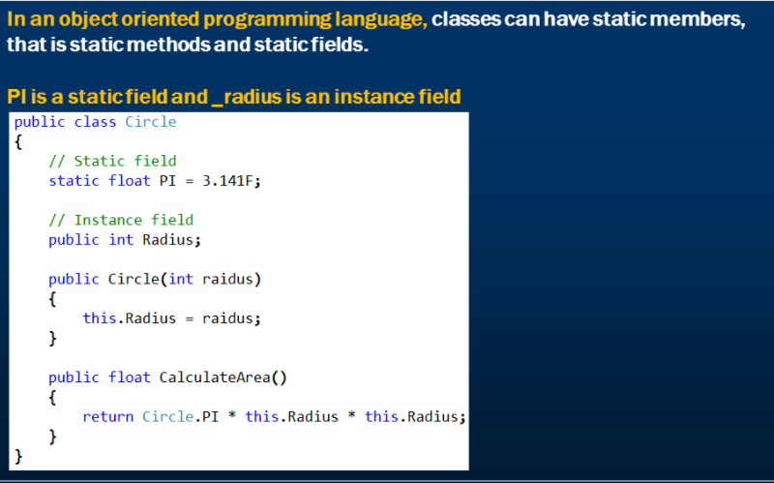

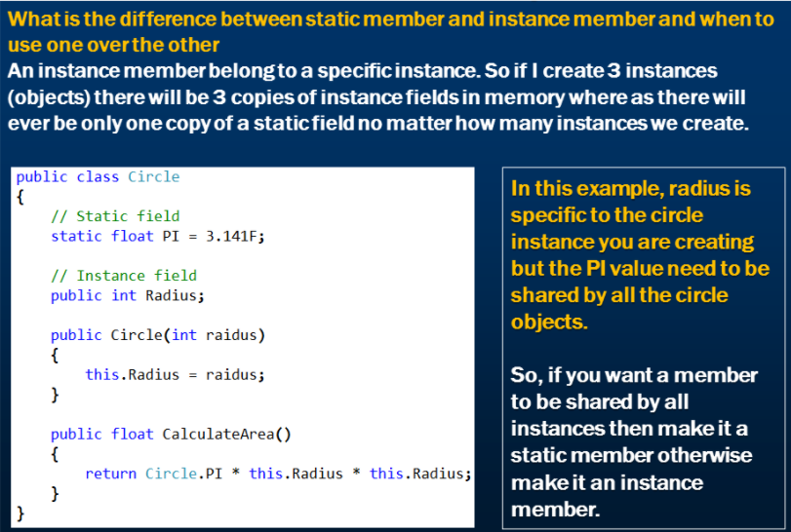

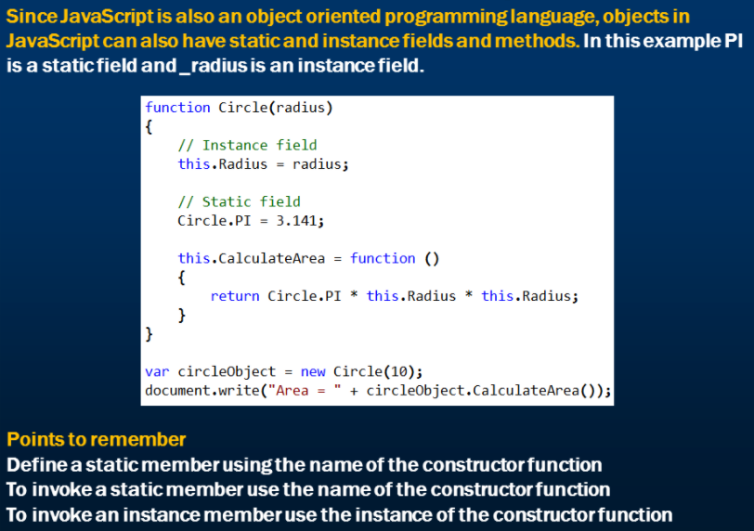

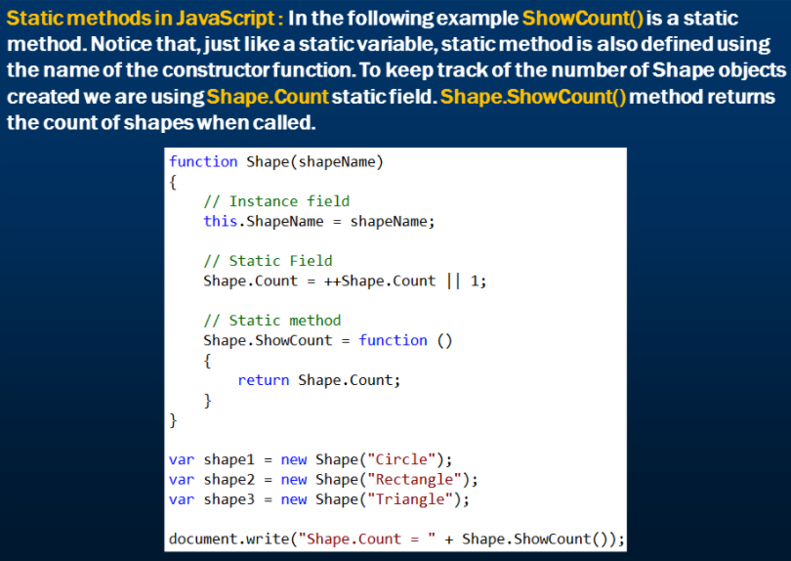

# Prototype in JavaScript

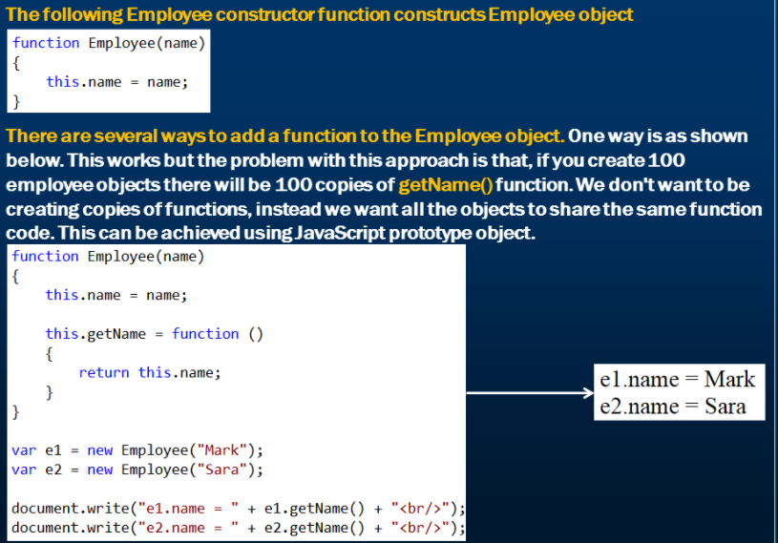

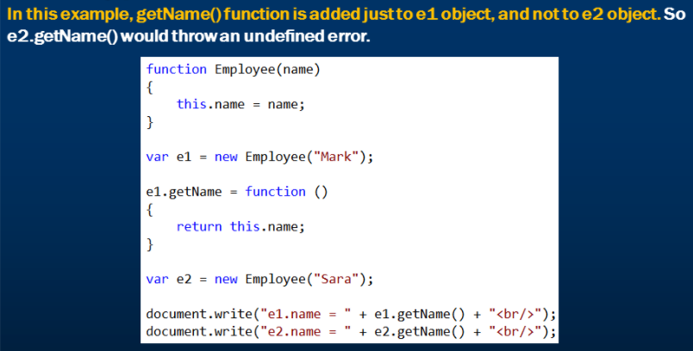

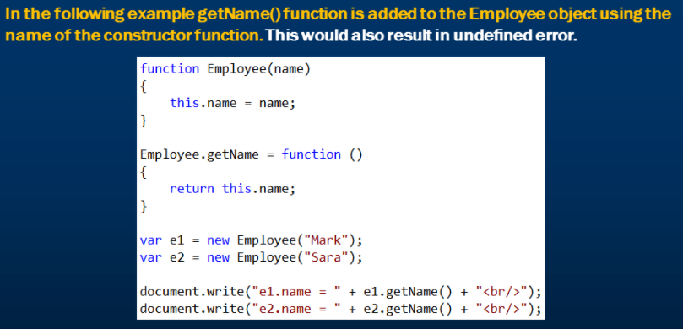

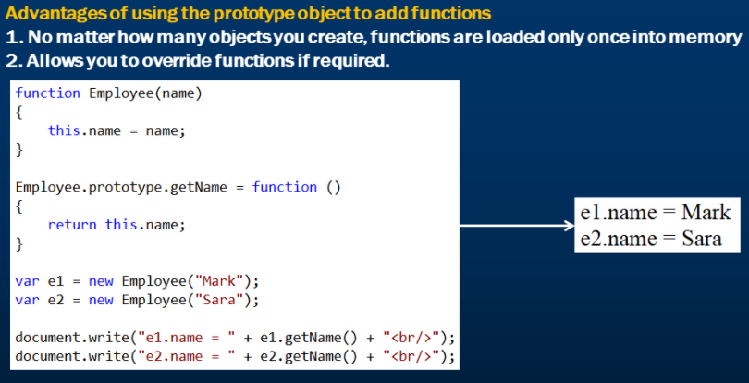

# Overriding JavaScript functions

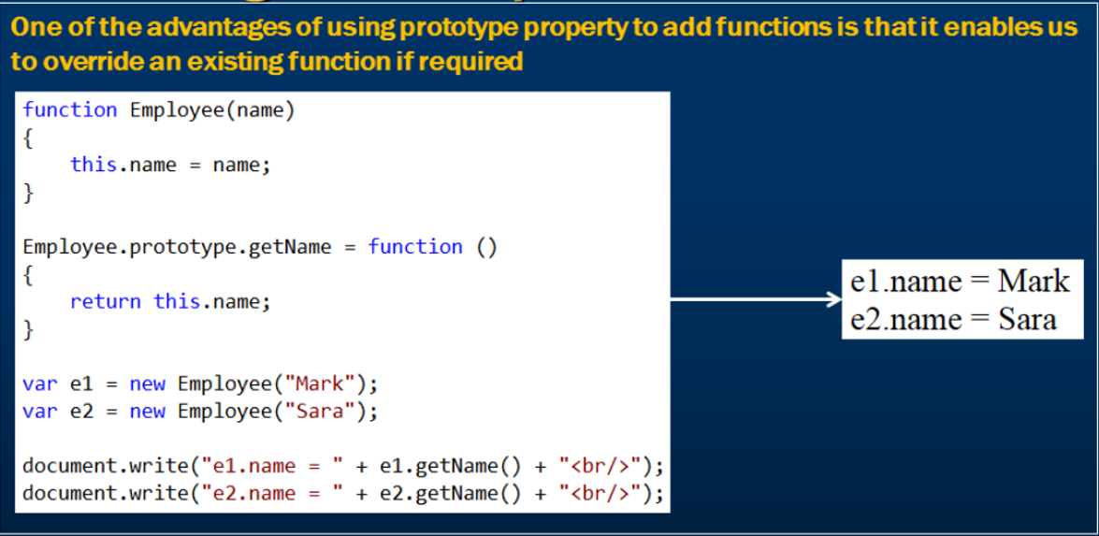

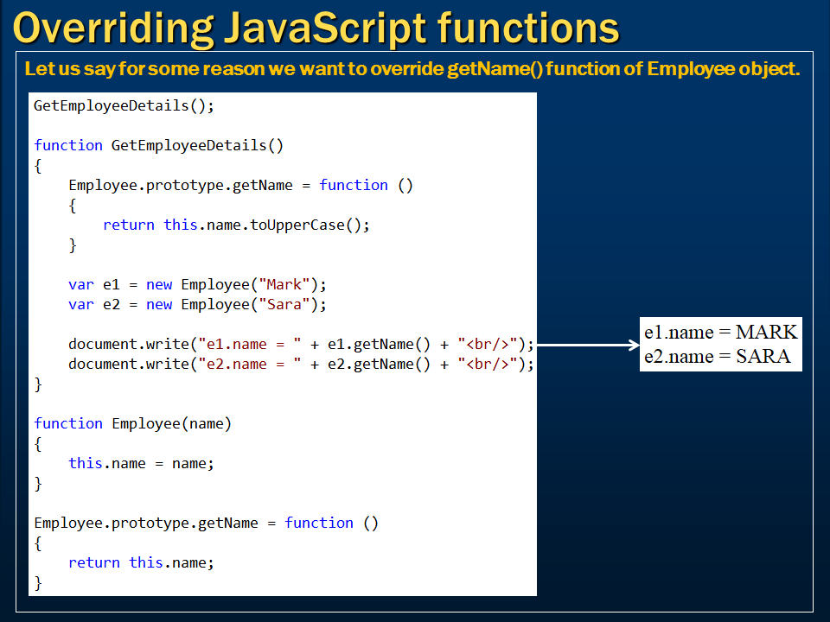

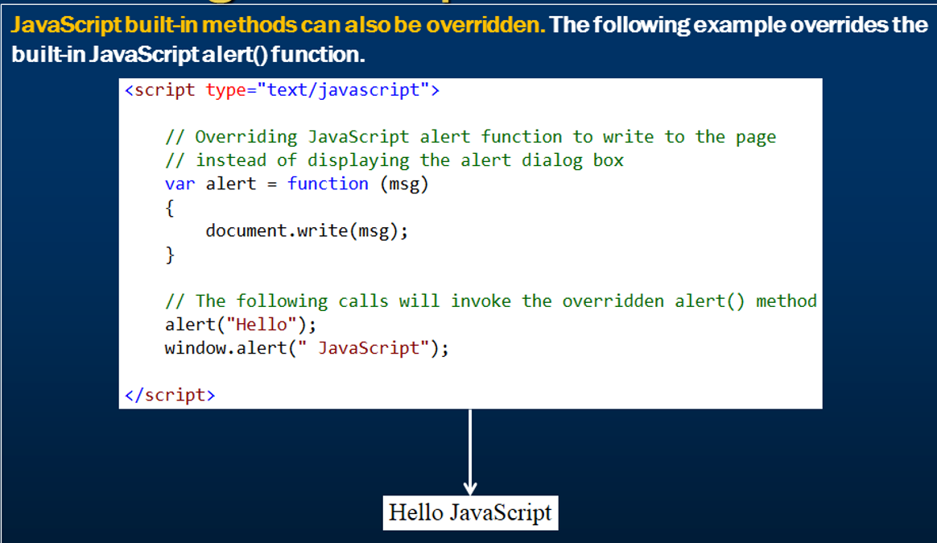

# Inheritance in JavaScript

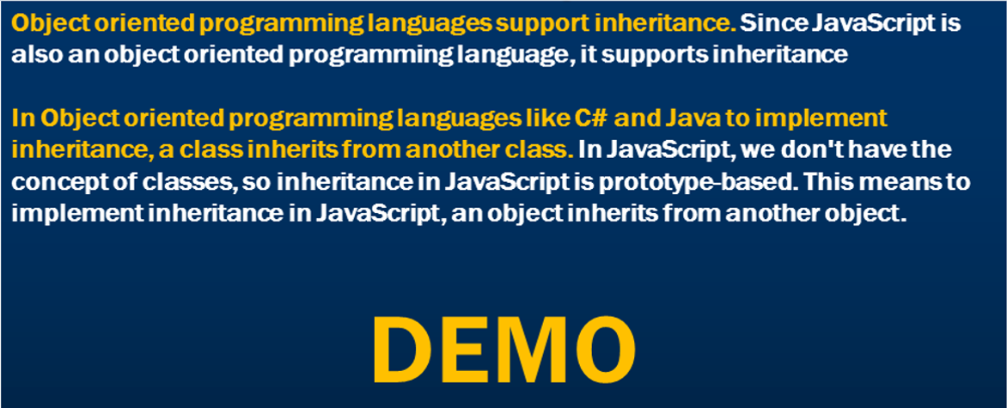

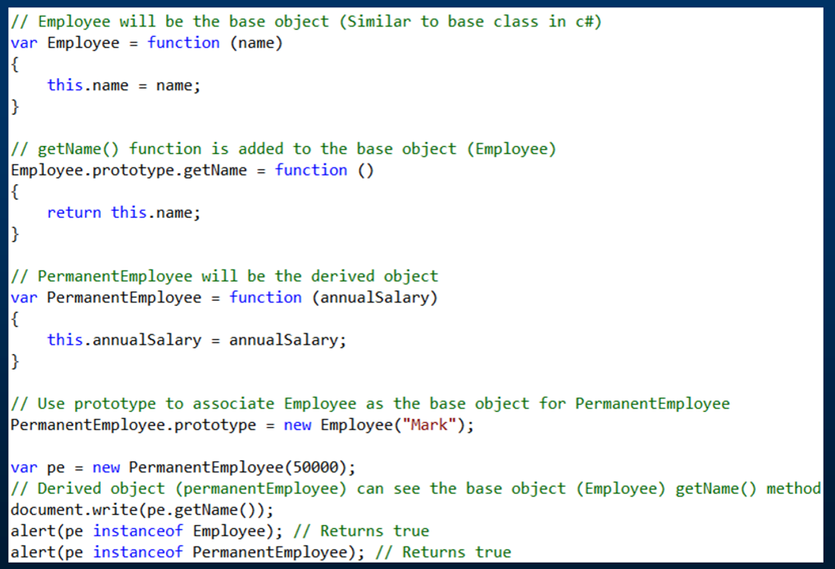

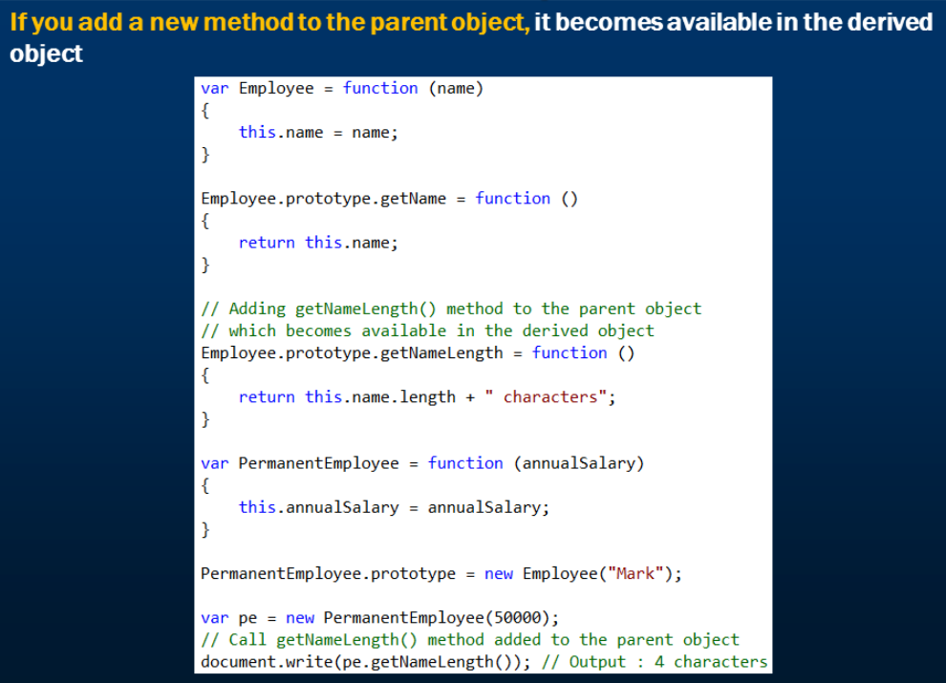

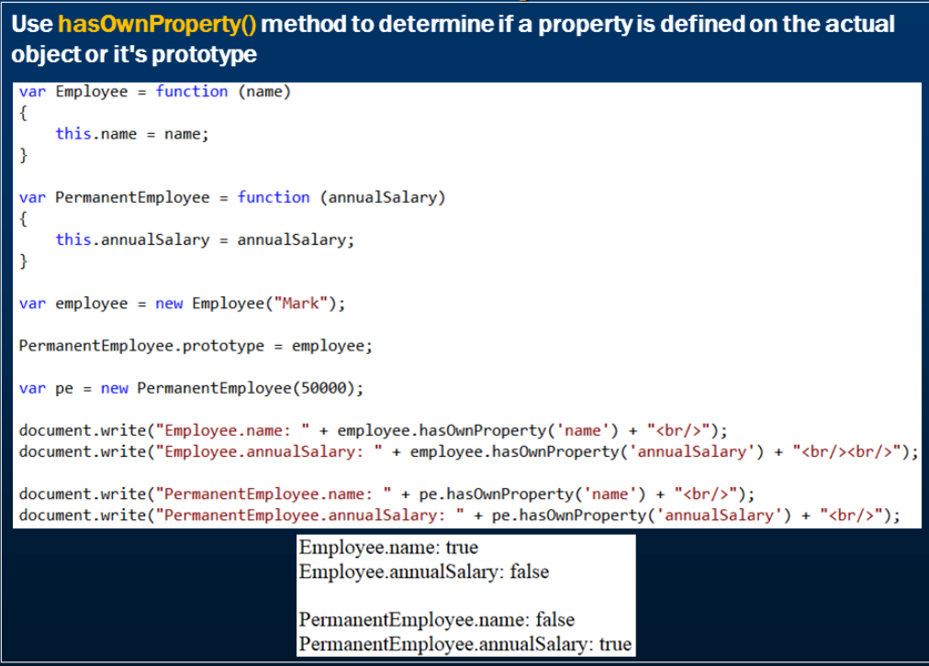

# Abstract classes in JavaScript

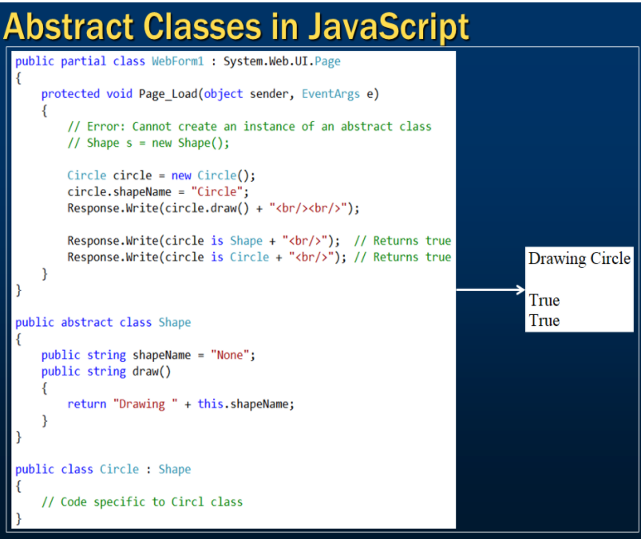

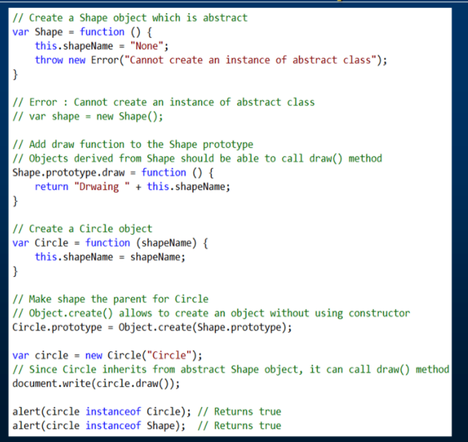

# Polymorphism in JavaScript

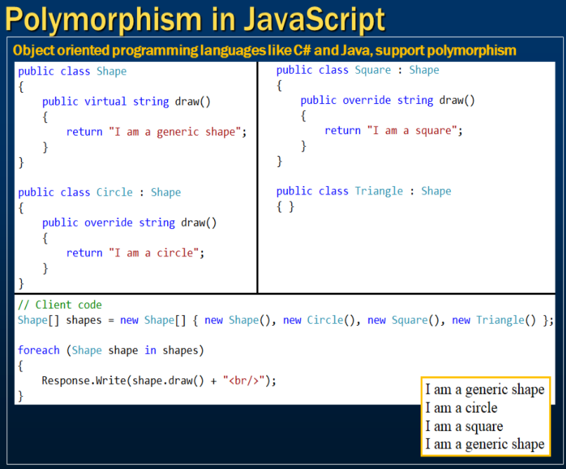

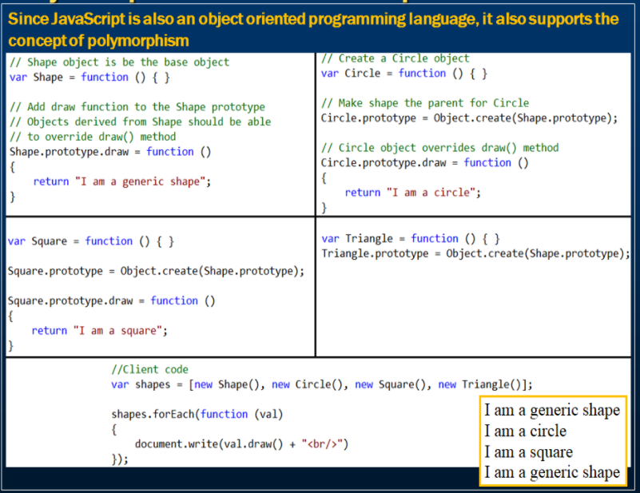

# Object reflection in JavaScript

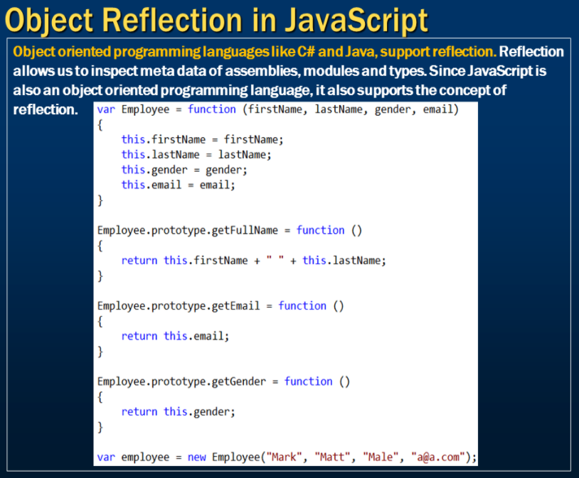

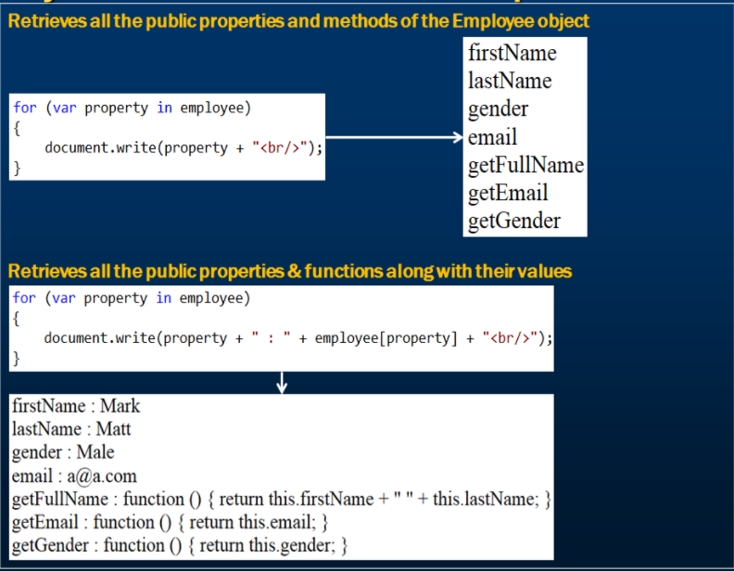

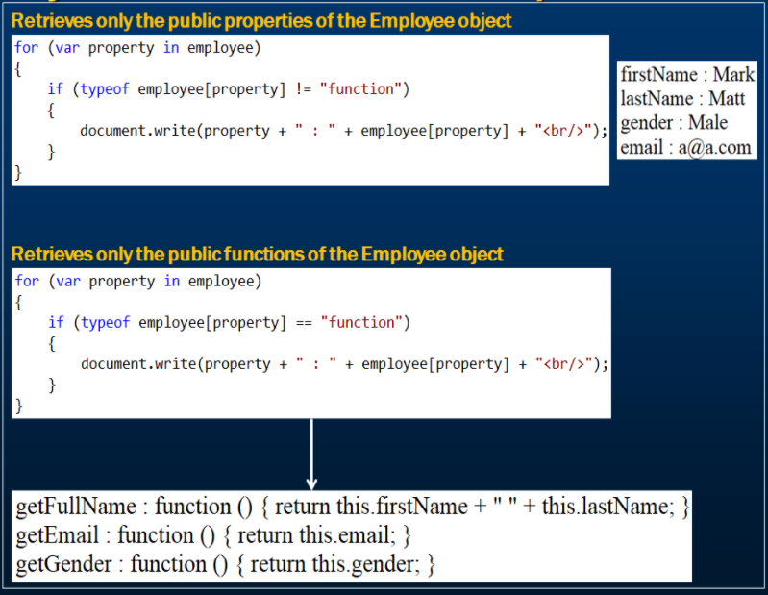

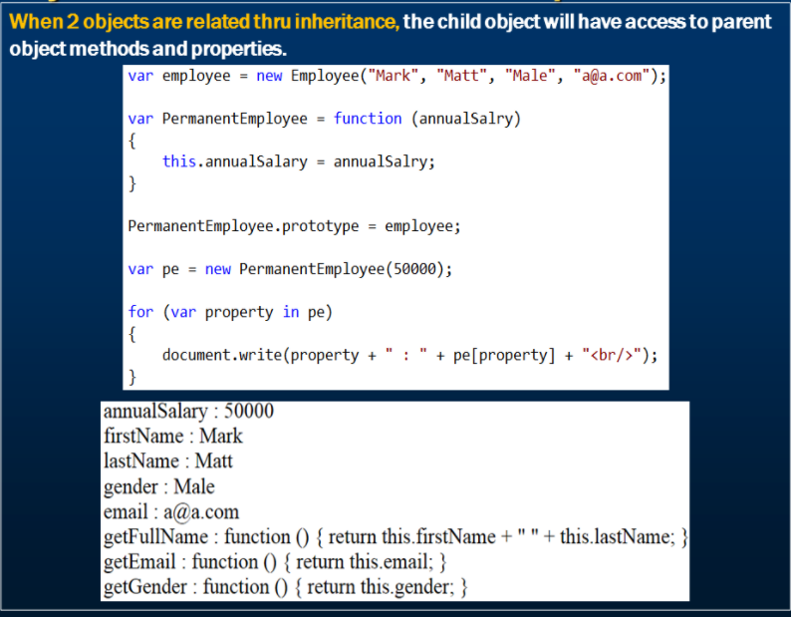

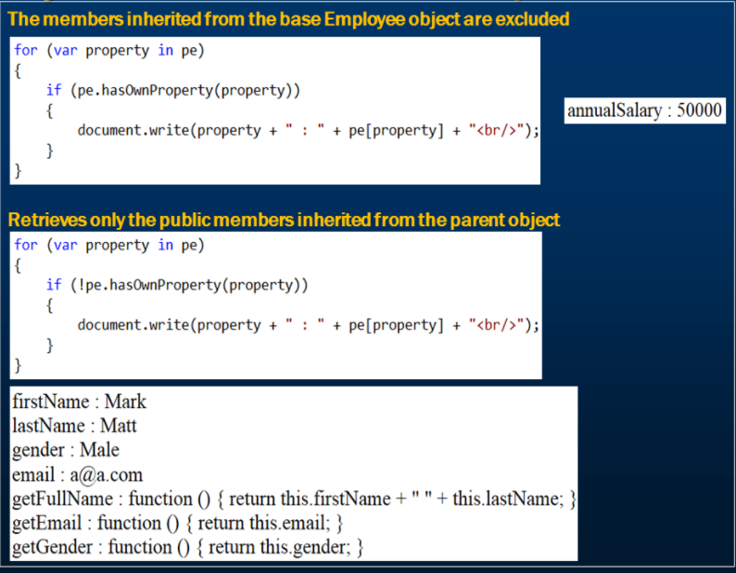

# Strict Mode in JavaScript

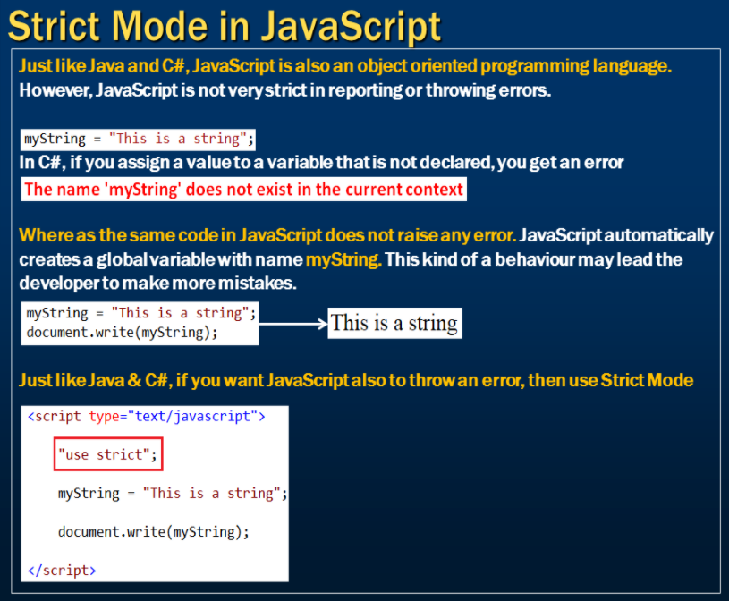

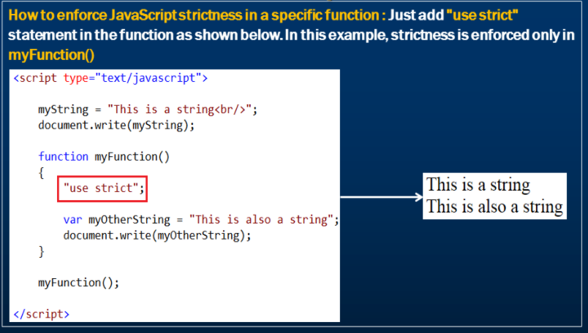

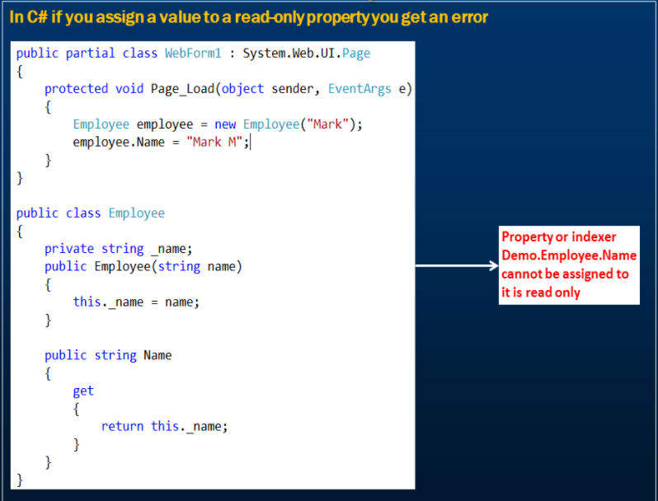

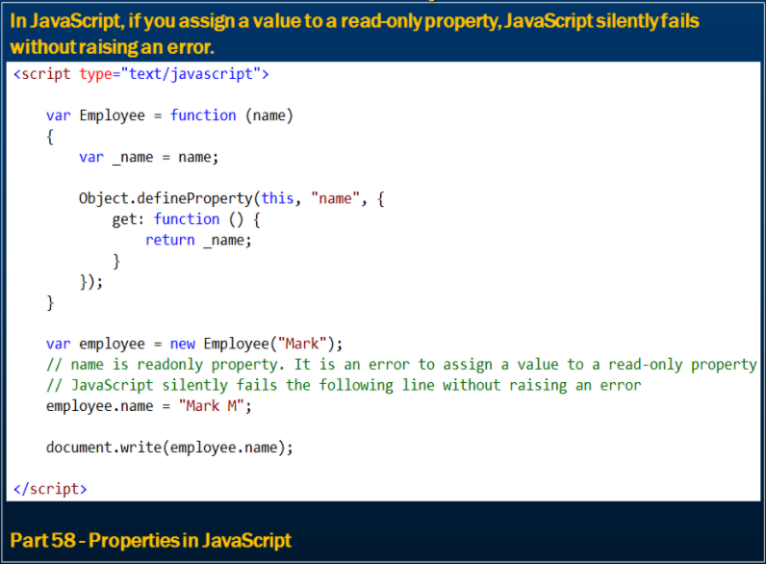

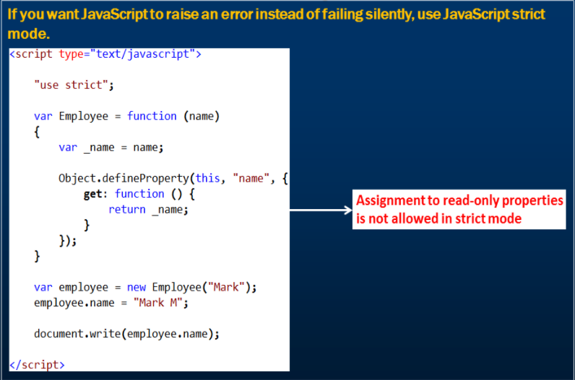

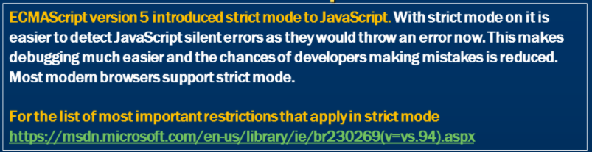

# JavaScript Cookies

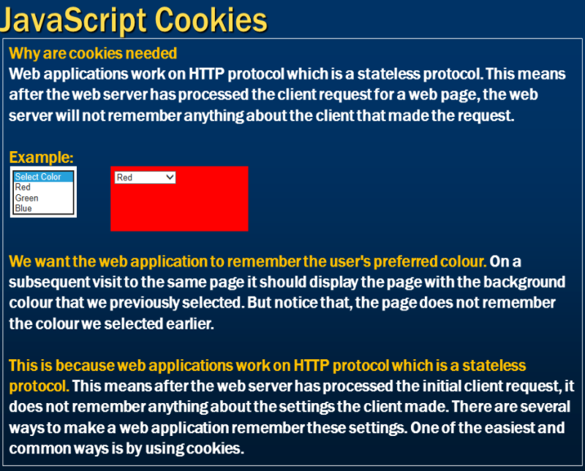

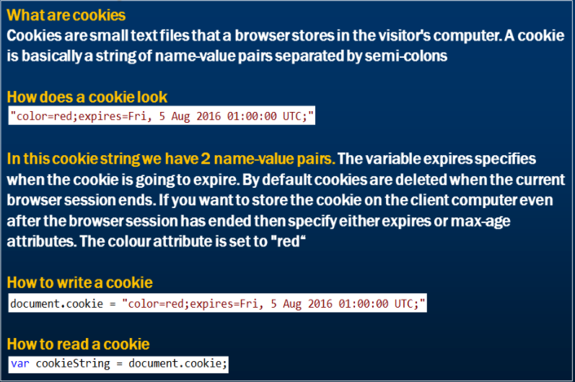

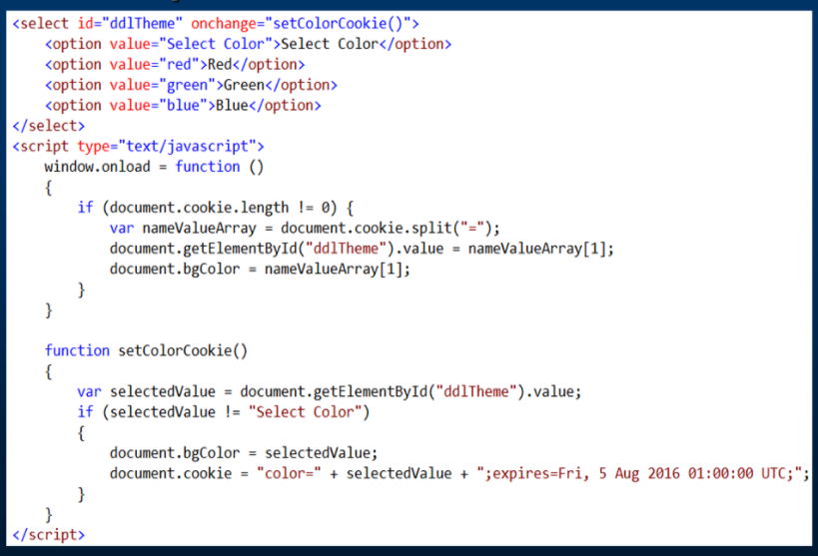

# JavaScript cookie attributes

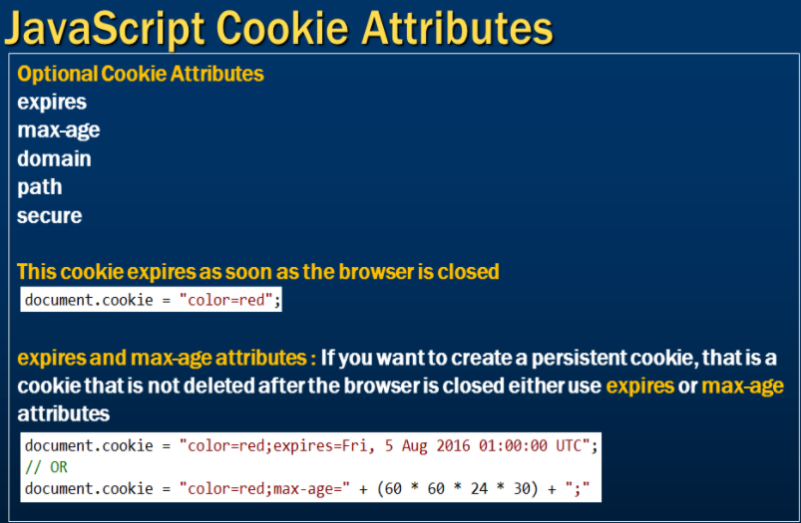

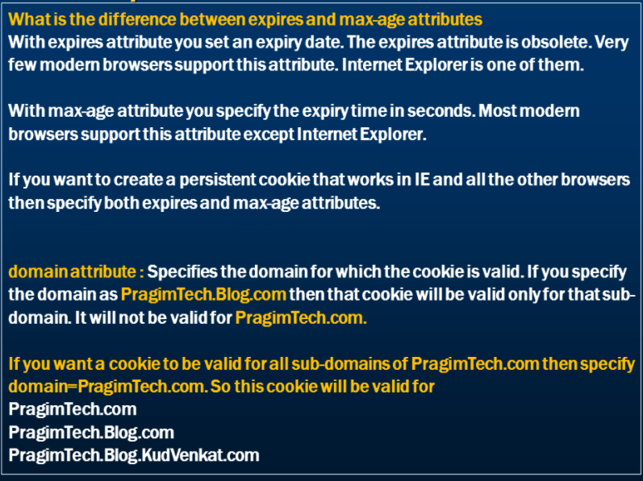

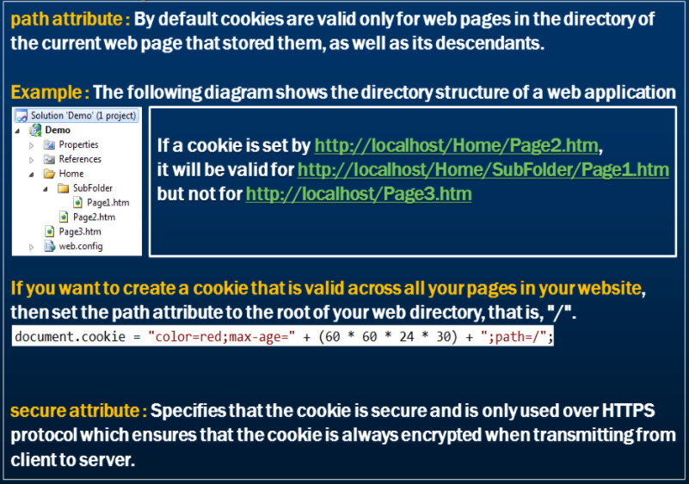

# Store multiple key value pairs in a cookie

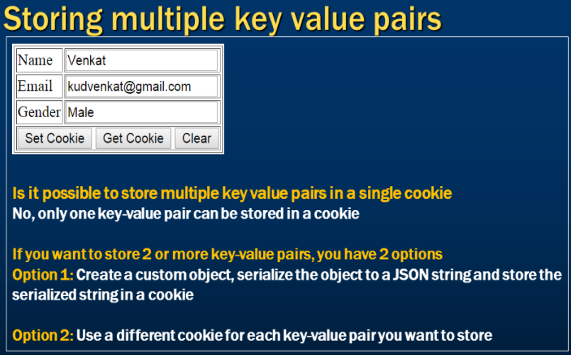

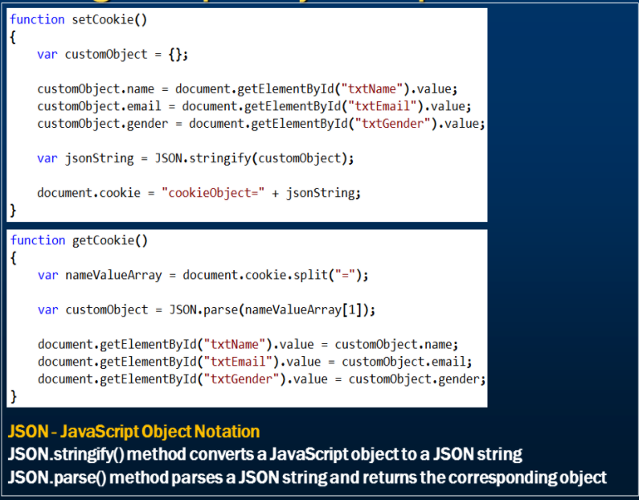

# Set and get multiple cookies in JavaScript

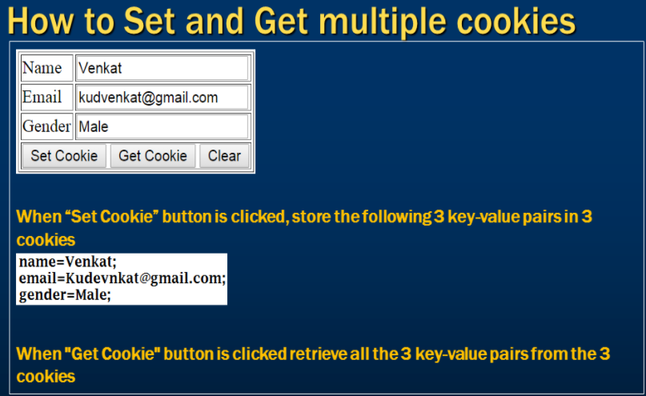

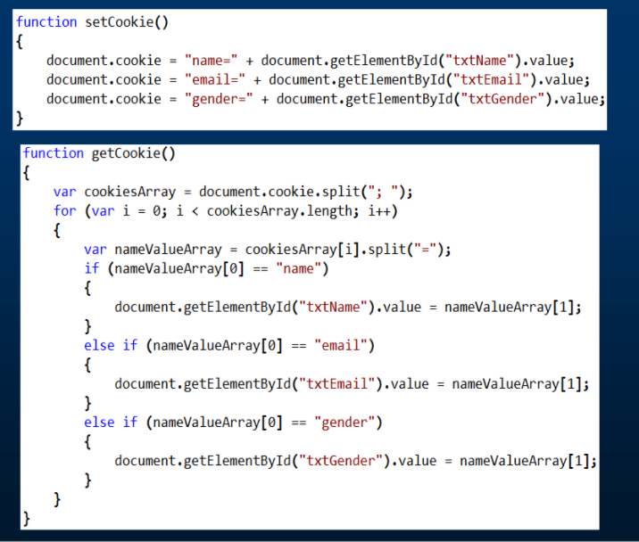

# Update and delete cookies

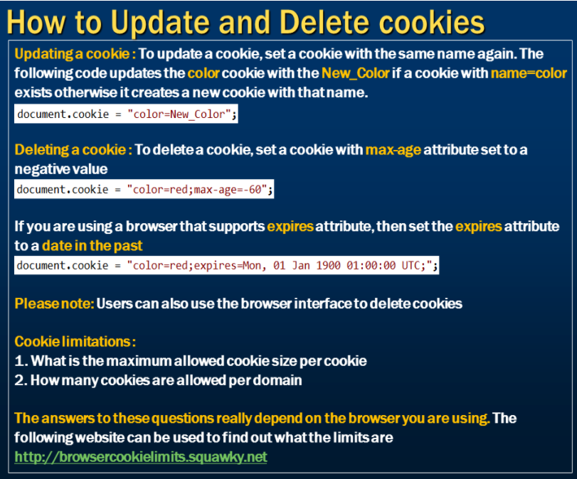

# How to check if cookies are enabled

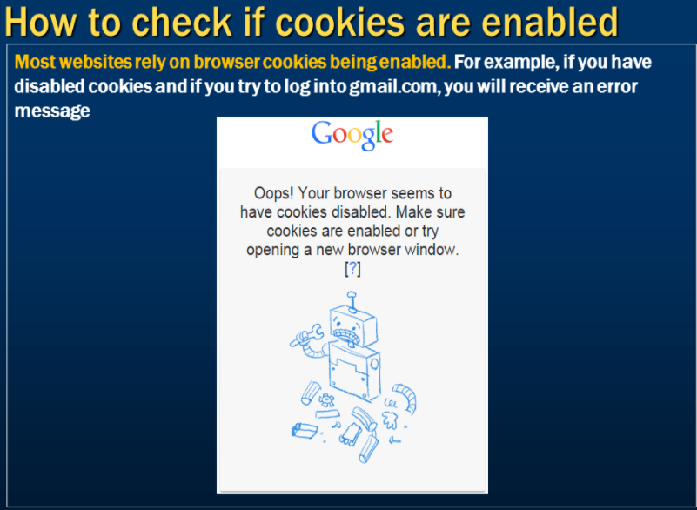

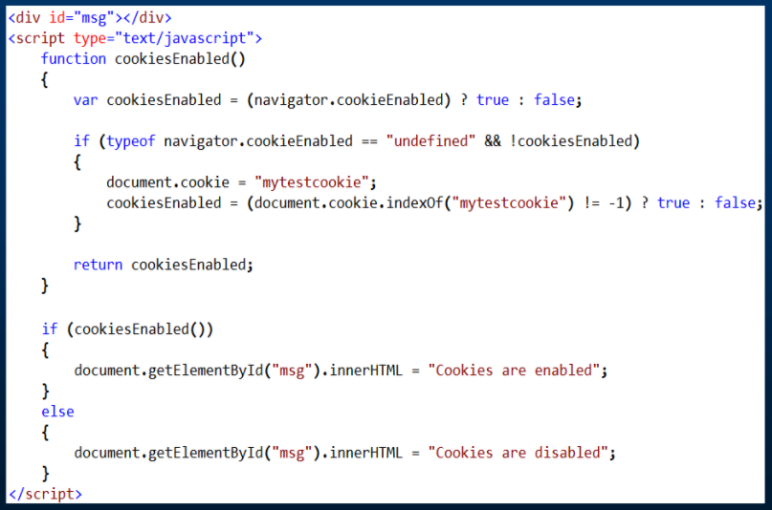

# How to check if JavaScript is enabled

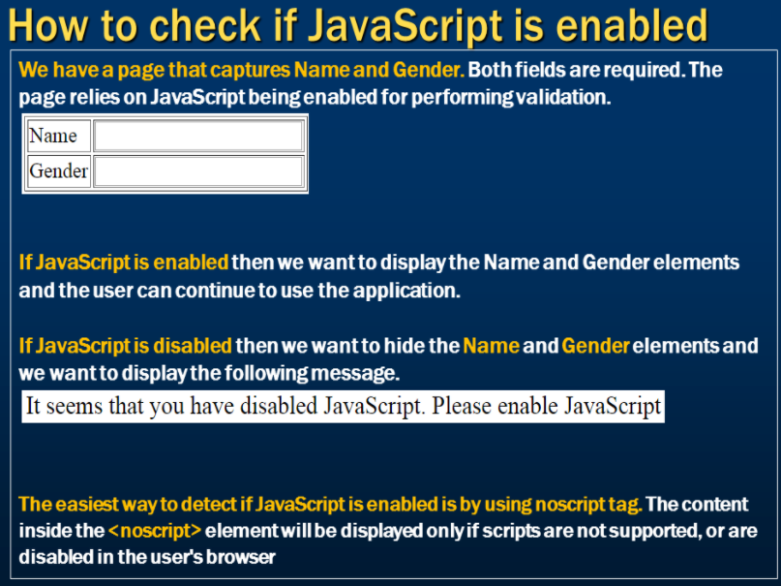

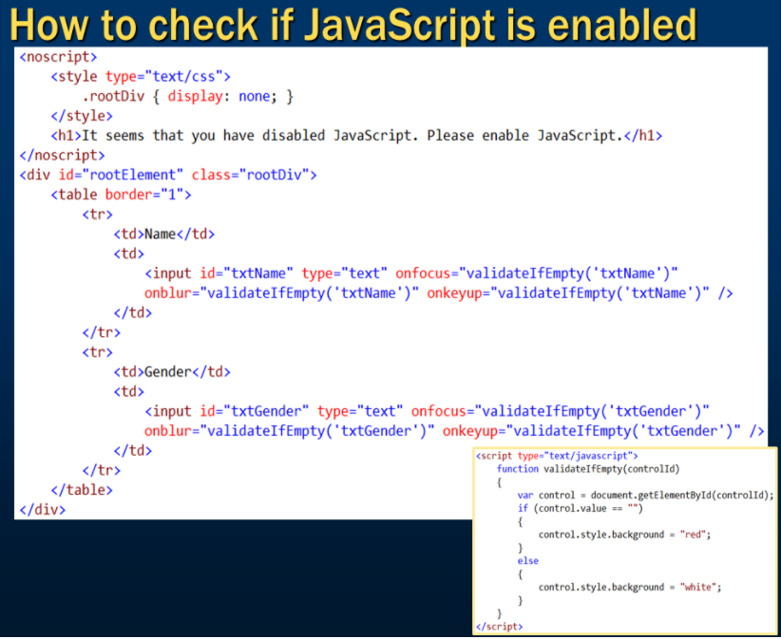

# window location in JavaScript

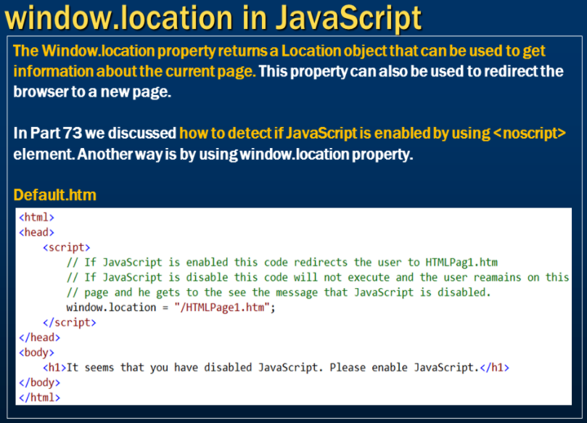

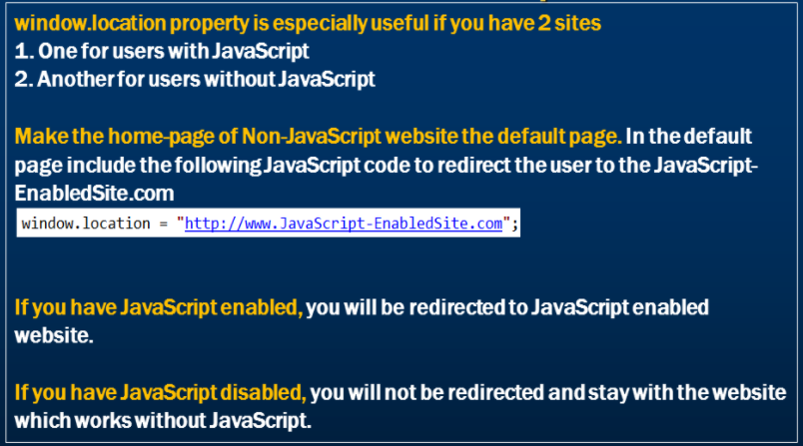

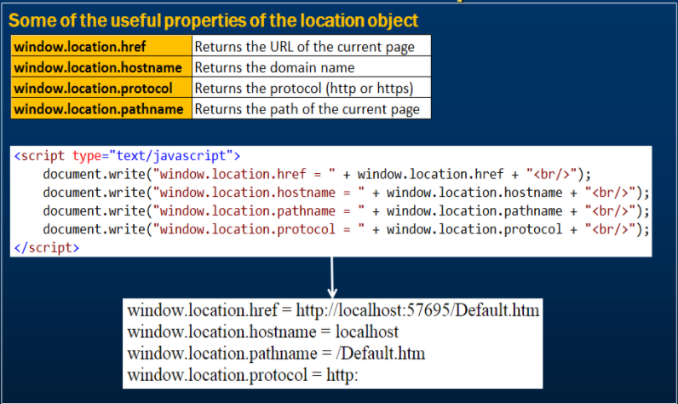

# Debugging JavaScript in chrome

